

Labkit

for

WSO2 Identity Server 5.2.0

Developer Fundamentals

Email: training@wso2.com

Table of Contents

Lab: Getting Started with WSO2 IS

Lab: Adding a User

Demo: User Dashboard Walkthrough

Demo: Password Recovery

Lab: Customizing Automated Emails Sent to Users

Lab: Configure WSO2 IS to Use an LDAP Server

Lab: Configure a Secondary User Store

Lab: Invoking the Admin Services

Lab: User Account Approval Workflow

Lab: Single Sign On using the Identity Server for Authentication

Lab: Federated Authentication for a Service using Social Media Integration

Lab: Inbound Provisioning

Lab: Building a XACML Policy through the IS Wizard

Demo: Secure an API in WSO2 APIM

Demo: Saving Access Tokens in Separate Tables

Lab: Changing the Default Keystore

Demo: Viewing Audit Logs

# 

# 

# Lab: Getting Started with WSO2 Identity Server

Training Objective

Verify that a WSO2 Identity Server (IS) is installed, patched and running.

Business Scenario

Experia Travels is a fast growing airline, which uses a number of internal web applications used by internal and external parties including those that contain sensitive and confidential information. Each application needs to have users, roles and permissions configured in order to maintain access control and information security. Experia have decided to use IS to simplify their user management, reduce identity provisioning time, guarantee secure online interactions and deliver a single sign on environment.

High Level Steps

* Install WSO2 IS
* Overview of the key directories in WSO2 IS
* Key configuration files

Detailed Instructions

Install WSO2 IS

The primary prerequisite for Before installing the product, ensure that the installation prerequisites have been met. Refer to the documentation [1] for detailed instructions. If prerequisites are fulfilled, instructions on installing the product can be found for:

* Linux or OS X at [2]
* Windows [3]

[1] <https://docs.wso2.com/display/IS520/Installation+Prerequisites>

[2] <https://docs.wso2.com/display/IS520/Installing+on+Linux+or+OS+X>

[3] <https://docs.wso2.com/display/IS520/Installing+on+Windows>

### 

### 

Overview of the Key Directories in WSO2 IS

Open <IS_HOME>. The structure is as follows.

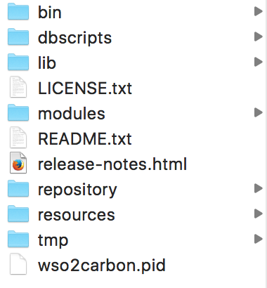

**bin** - This folder contains all the executable files including those scripts that are used to start/stop the application on Linux and Windows environments e.g.,:wso2server.sh and wso2server.bat.

**dbscripts** – A collection of database scripts required to create the Carbon database and the WSO2 IS specific database on a variety of database management systems.

**lib** –The lib directory houses all the jar files that will be converted to OSGi bundles at startup and copied to the dropins directory.

**modules** – All the host objects belonging to the Jaggery module are declared within the modules folder in a file called module.xml.

**repository** – The main repository for all kind of deployments and configurations in Carbon. This includes all default services, created APIs, Carbon configurations etc.

**resources** – Contains additional resources that may be used by WSO2 IS.

**tmp** – Will contain temporary files that are created when a product is run. These files will be cleared from time to time based on housekeeping tasks.

Key Configuration Files

|  |  |
| --- | --- |
| **File** | **Description** |
| <IS_HOME>/repository/conf/carbon.xml | The carbon server configuration file |
| <IS_HOME>/repository/conf/datasources/master_datasources.xml | The main configuration file for carbon datasources. **Registry** and **User** **Manager** refer the datasource configuration defined in this file. |
| <IS_HOME>/repository/conf/identity/identity.xml | The main configuration file that governs identity related functionality. |
| <IS_HOME>/repository/conf/log4j.properties | The **log4j** configuration file used by **WSO2 Carbon**. |
| <IS_HOME>/repository/conf/registry.xml | The **Carbon** registry configuration file. This will be used when the **WSO2 Embedded Registry** is used. |
| <IS_HOME>/repository/conf/user-mgt.xml | The **User Manager** configuration file used for configuring user management details. |
| <IS_HOME>/repository/conf/security/secret-conf.properties | The secret manager configuration that is used by the **Secret Vault** component. |

Expected Outcome

Refer to the documentation on **Running the Product** [1] to start the server. Access the management console as mentioned under **Running the Management Console** [2] to verify that the installation is correct.

[1] <https://docs.wso2.com/display/IS520/Running+the+Product>

[2] <https://docs.wso2.com/display/IS520/Running+the+Product#RunningtheProduct-Runningthemanagementconsolerun>

# 

# Lab: Setting up Analytics

Training Objective

Set up analytics for WSO2 Identity Server in order to monitor session and authentication statistics.

Business Scenario

The System Administrators of Experia Travels need to set up analytics for the WSO2 Identity Server in order to provide information requested by upper management.

High Level Steps

* Downloading and installing analytics
* Enabling analytics in the WSO2 Identity Server
* Configuring event publishers.

Detailed Instructions

<https://docs.wso2.com/display/IS520/Prerequisites+to+Publish+Statistics>

# Lab: Adding a User

Training Objective

Add a new user from the Management Console and set a new role to the user.

Business Scenario

The System Administrators of Experia Travels need to create users and role and assign the created roles to users.

High Level Steps

* Create a user
* Create a role
* Assign a role to a user

Detailed Instructions

Create a User

A user can be created using the self registration feature in the **User Dashboard** of the WSO2 IS or via the **Admin Console** of the WSO2 IS. For this Lab exercise, we will create the user using the **Admin Console**.

1. Select the **Add** operation under the **Users and Roles** title in the **Identity** section of the **Main** tab in the **Admin Console**.
2. Select the **Add New User** option.

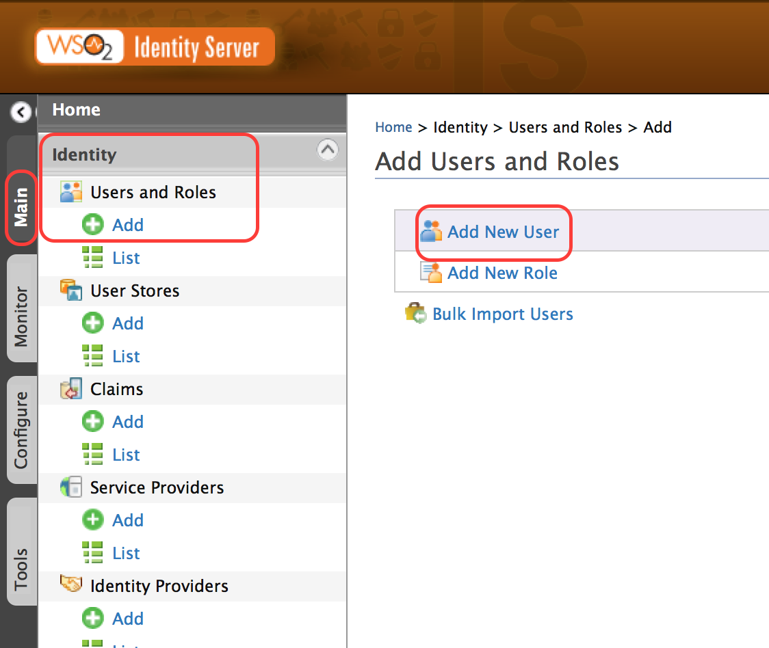

1. Create a user with your own name.

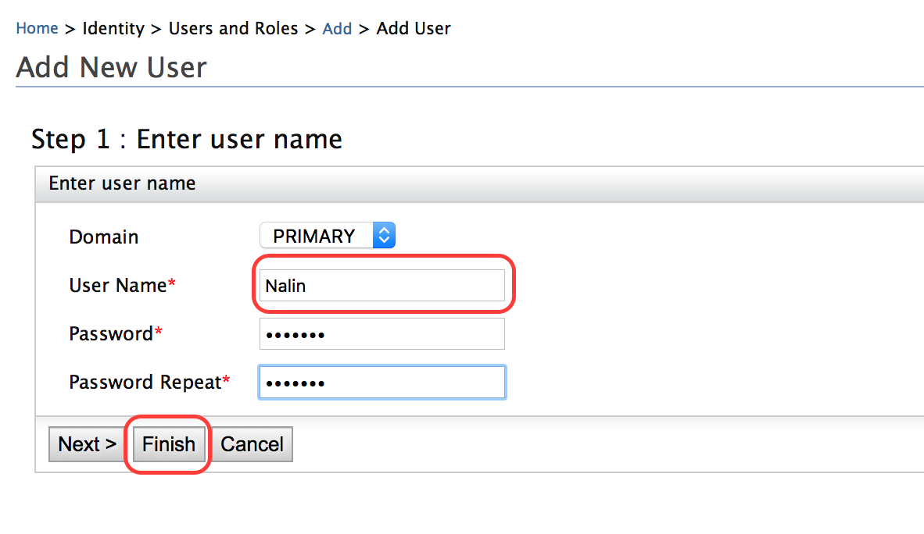

[1] <https://docs.wso2.com/display/IS520/Configuring+Users#ConfiguringUsers-Addinganewuserandassigningroles>

Create a Role

Roles can be created from the **Admin Console**.

1. Select the **Add New Role** option.

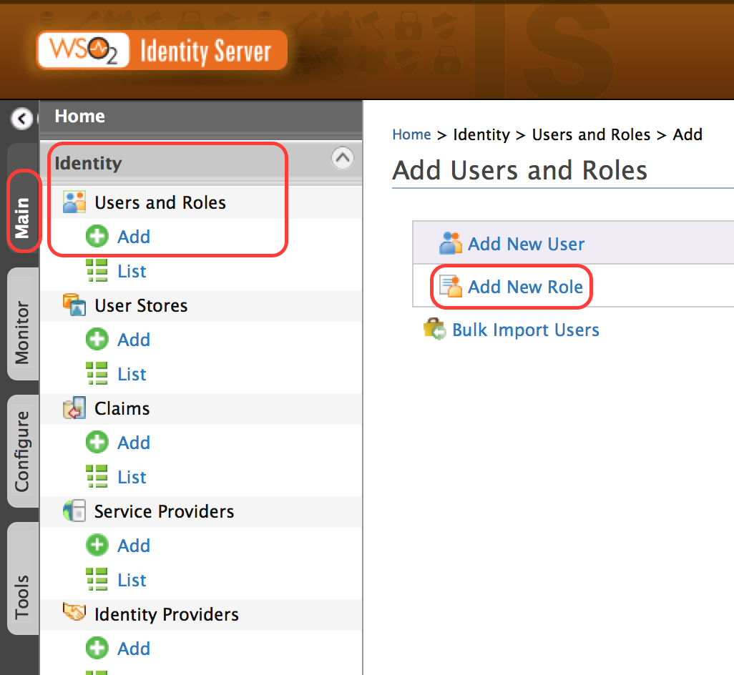

1. Give a name for the role.

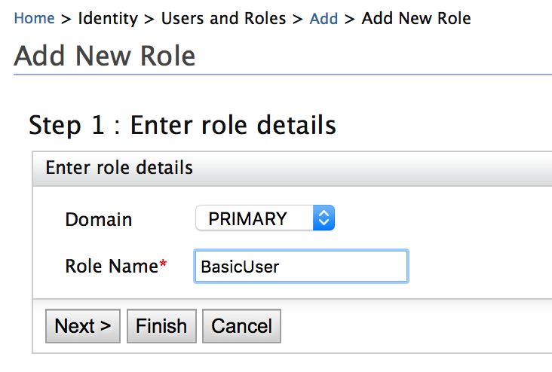

1. The next step allows the selection of IS related permissions.
2. Select the permission to log into the WSO2 IS.

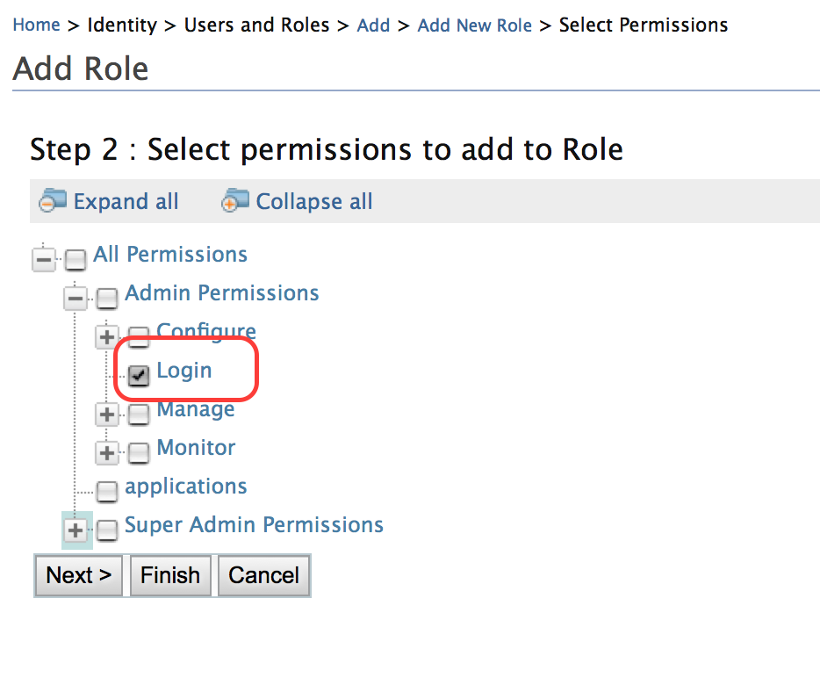

1. For additional information refer to the documentation found at [1].

[1] <https://docs.wso2.com/display/IS520/Configuring+Users#ConfiguringUsers-Addinganewuserandassigningroles>

Assign a Role to a User

Roles can be assigned as part of the user creation process. Optionally, the users can be modified and roles assigned to them.

1. In order to select the user to be modified, list the users in WSO2 IS.

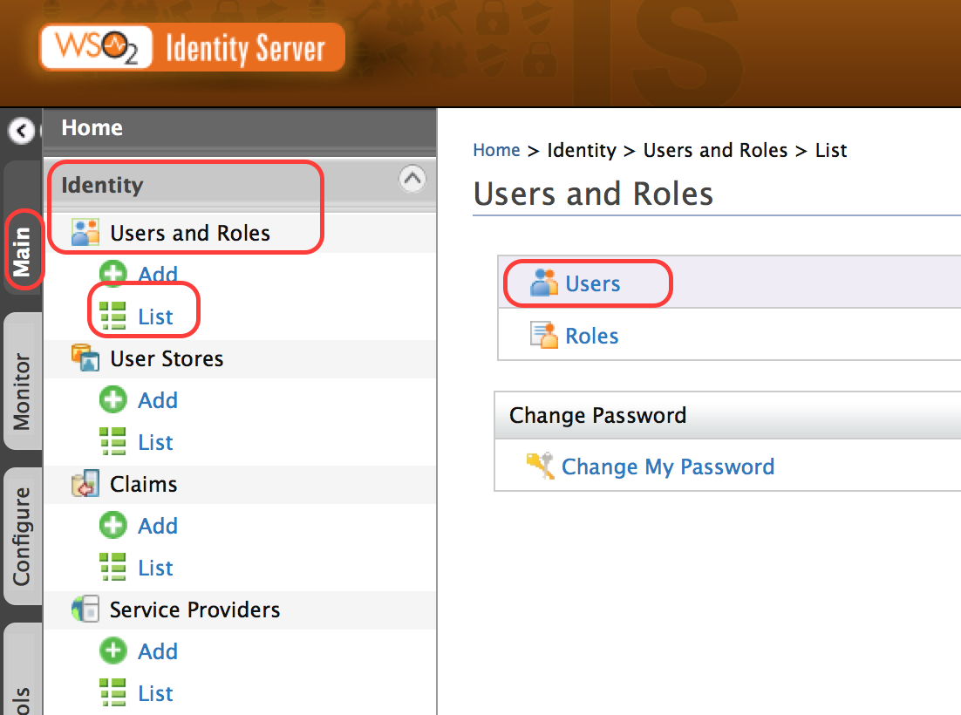

1. Select the **Assign Role** option.

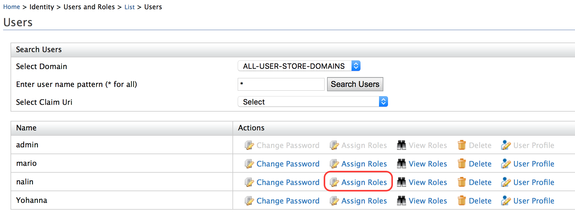

1. Assign the newly created role to the user.

Expected Outcome

It should be possible to use the newly created user to log in to the WSO2 IS instance.

# Demo: User Dashboard Walkthrough

Training Objective

Understand the capabilities of the **User Dashboard** in WSO2 IS.

High Level Steps

* Start the User Dashboard
* Create a user
* Edit user profile
* Change password

# Demo: Password Recovery

Training Objective

Understand the configuration options available for user management in WSO2 IS.

High Level Steps

* Update configuration files
* Demo the user experience

# Lab: Customizing Automated Emails Sent to Users

Training Objective

Learn how to send emails from within the Identity Server.

Business Scenario

Experia Travels wishes to enable the one time password feature for a few of their employees.

High Level Steps

* Enable the email sending functionality for IS
* Enable One Time Passwords as an authentication option for IS
* Adding custom claims needed for One Time Password
* Customize email template used to send the One Time Password

Detailed Instructions

Enable the Email Sending Functionality for IS

1. To enable the ability to send emails from within IS, first update the configuration files with the credentials and the connection details of the email service provider.
2. Credentials are in the file axis2.xml at <IS_HOME>/repository/conf/axis2/axis2.xml
3. Edit the MailTransportSender’s configuration to add the credentials.

The xml segment should look like:

<transportSender name="mailto"

class="org.apache.axis2.transport.mail.MailTransportSender">

<parameter name="mail.smtp.from">**user@mail.domain**</parameter>

<parameter name="mail.smtp.user">**user**</parameter>

<parameter name="mail.smtp.password">**password**</parameter>

<parameter name="mail.smtp.host">**host**[1]</parameter>

<parameter name="mail.smtp.port">**port**[2]</parameter>

<parameter name="mail.smtp.starttls.enable">**true**</parameter>

<parameter name="mail.smtp.auth">**true**</parameter>

</transportSender>

[1] for gmail, the value is smtp.gmail.com

[2] for gmail the port is 587

1. Identity Management Event Listener needs to be enabled next in order to allow the IS to invoke mail sending functionality.
2. Modify the identity.xml file at <IS_HOME>/repository/conf/identity/

<EventListener type="org.wso2.carbon.user.core.listener.UserOperationEventListener" name="org.wso2.carbon.identity.mgt.**IdentityMgtEventListener**" orderId="50" enable="**true**"/>

1. Modify the identity-mgt.properties file at <IS_HOME>/repository/conf/identity/ and enable notifications.

Notification.Sending.Enable=true

Notification.Expire.Time=7200

Notification.Sending.Internally.Managed=true

1. Restart the server to enable the email sending functionality in IS.

Enable One Time Passwords as an Authentication Option for IS

By default One Time Passwords (OTP) is not enabled in IS. In order to enable OTP, the authentication policy options have to be modified.

1. Update the identity-mgt.properties file at <IS_HOME>/repository/conf/identity/ and enable OTP

Authentication.Policy.Enable=true

Authentication.Policy.Check.OneTime.Password=true

1. Restart the server to enable the OTP functionality in IS.

Adding Custom Claim Needed for One Time Password

In order to distinguish users with OTP enabled from those who do not, the IS relies on a custom claim.

1. In order to create the OTP claim under http://wso2.org/claims, log in as an admin user into the management console of the IS.
2. Select **Main**> **Claims**-> **Add**> **Add New Claim**.

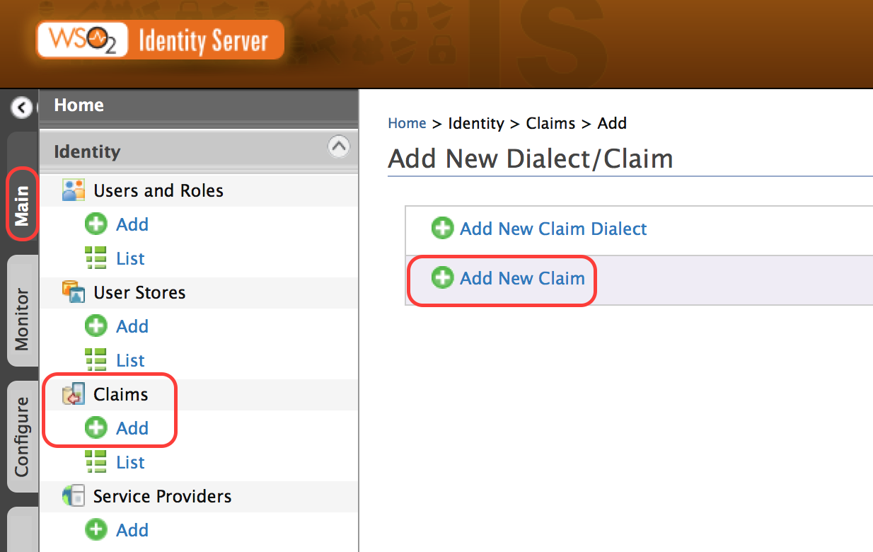

1. Add the claim with a dialect of **http://wso2.org/claims**, claim Uri of **http://wso2.org/claims/identity/otp**, and a Mapped Attribute **OneTimePassword**.

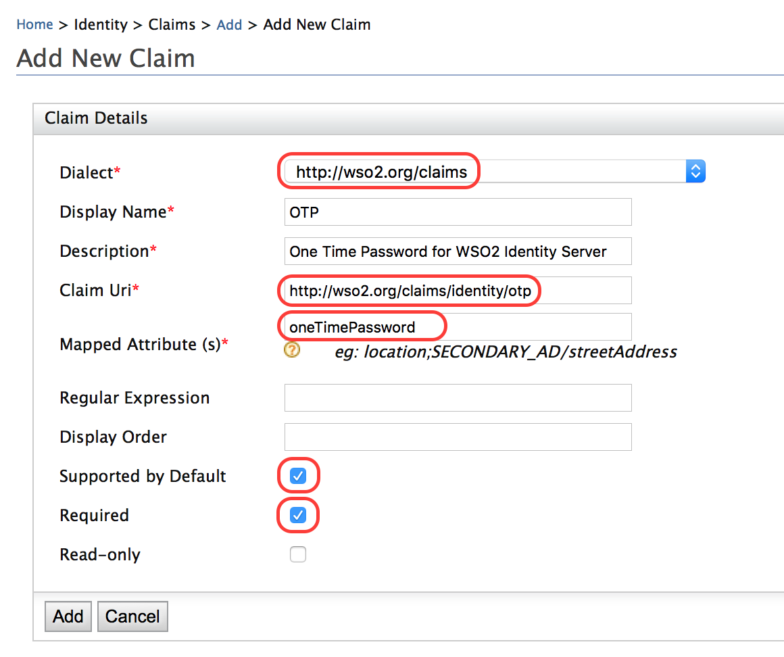

1. Create a user and update the user profile the the value for OTP set to TRUE.

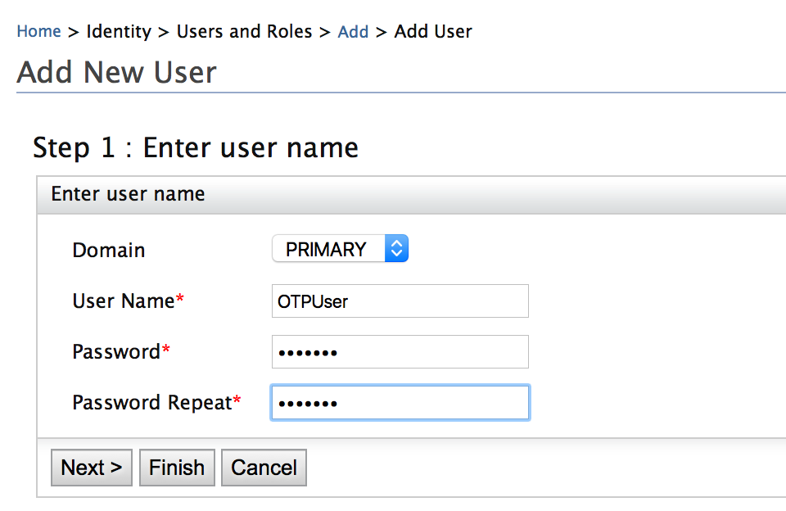

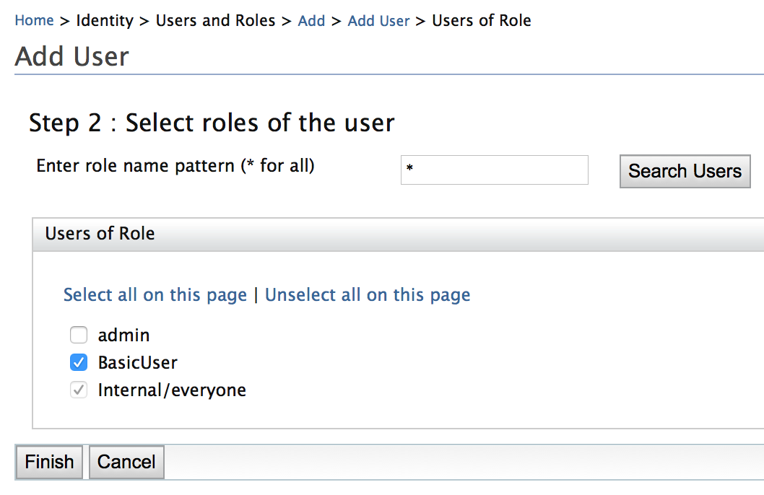

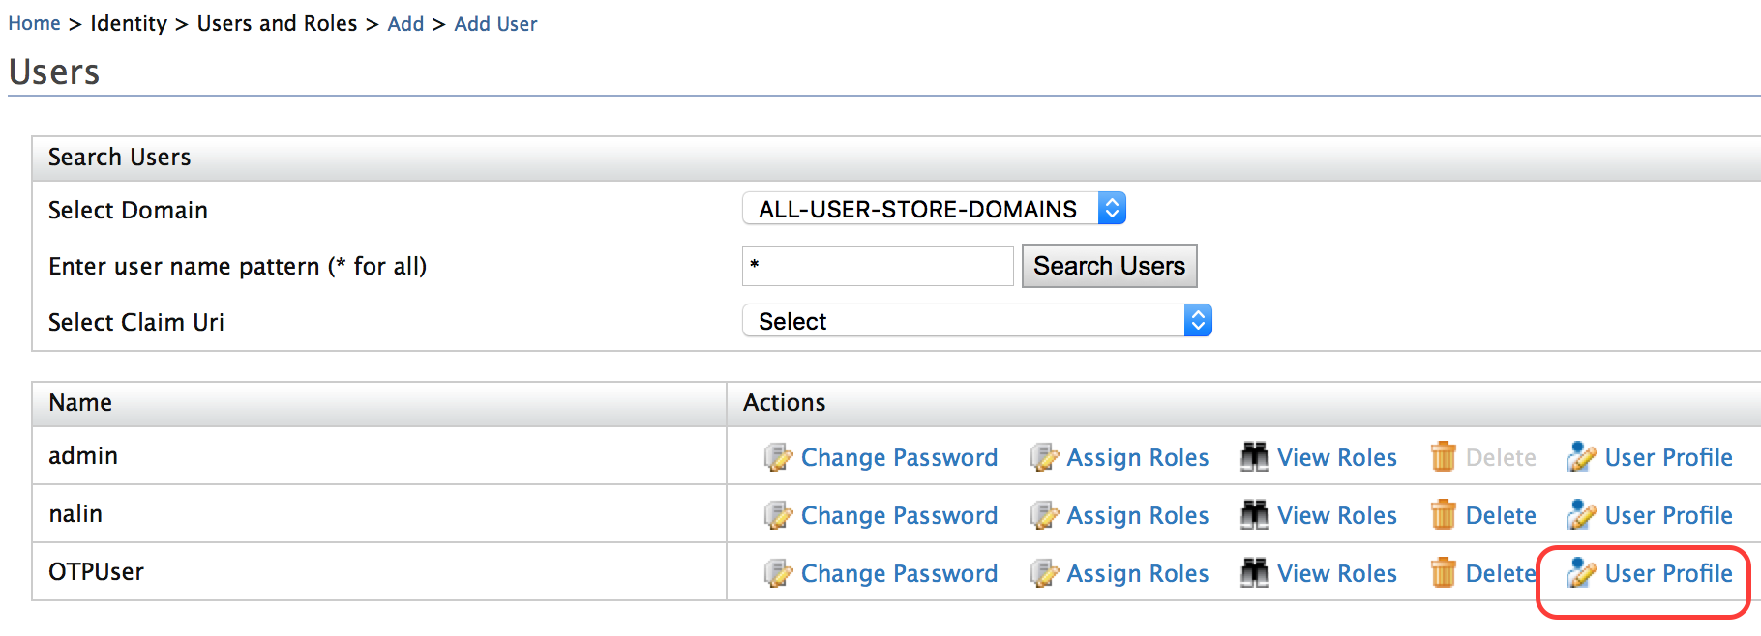

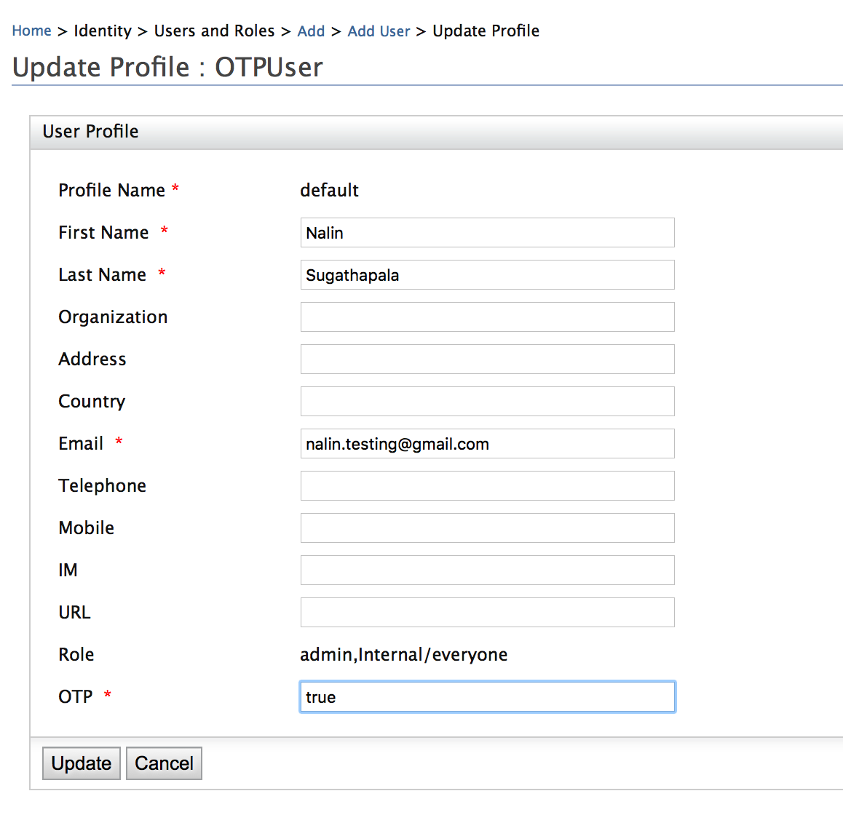

Customize Email Template Used to Send the One Time Password

1. The email templates can be access via **Configure**-> **Email Template**.

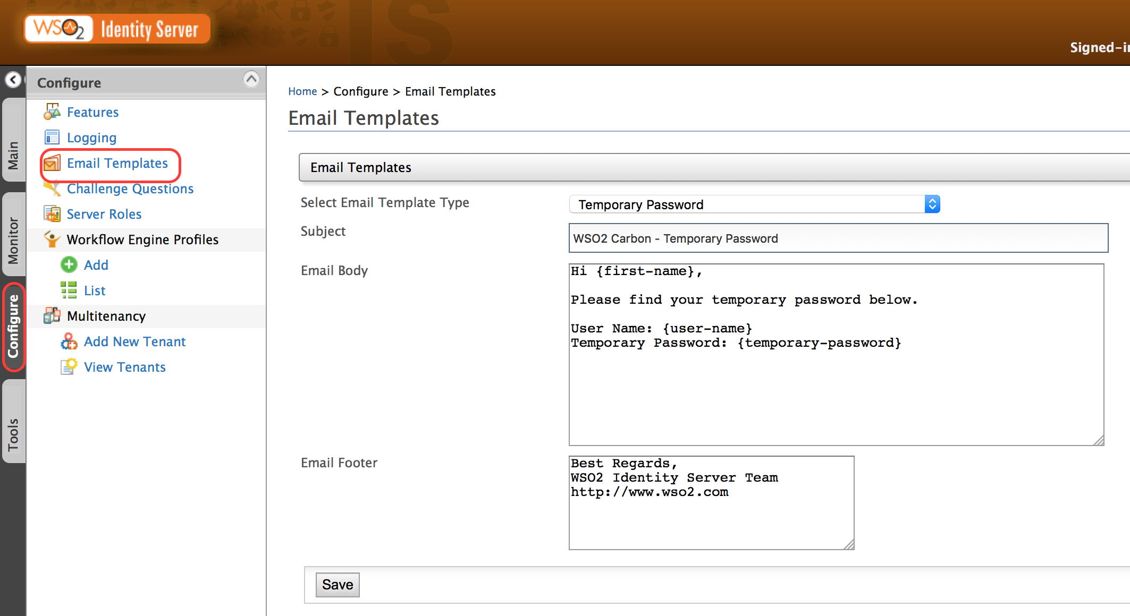

1. Select the Email Template Type **One Time Password**.
2. Edit the content as required.

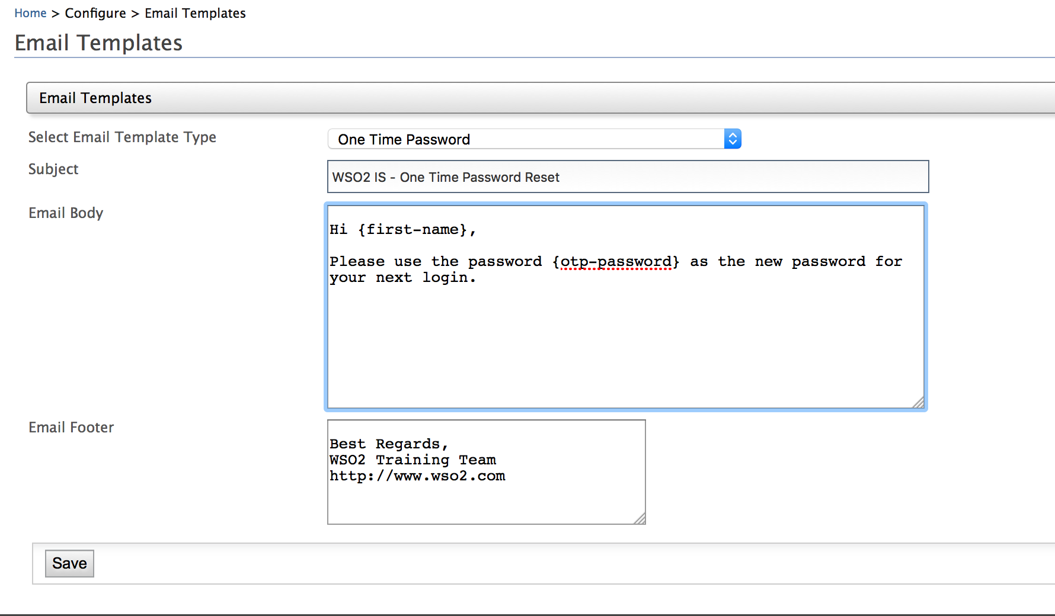

Expected Outcome

1. Log in using the user with OTP enabled.
2. Refer to the console to see the mail being sent.

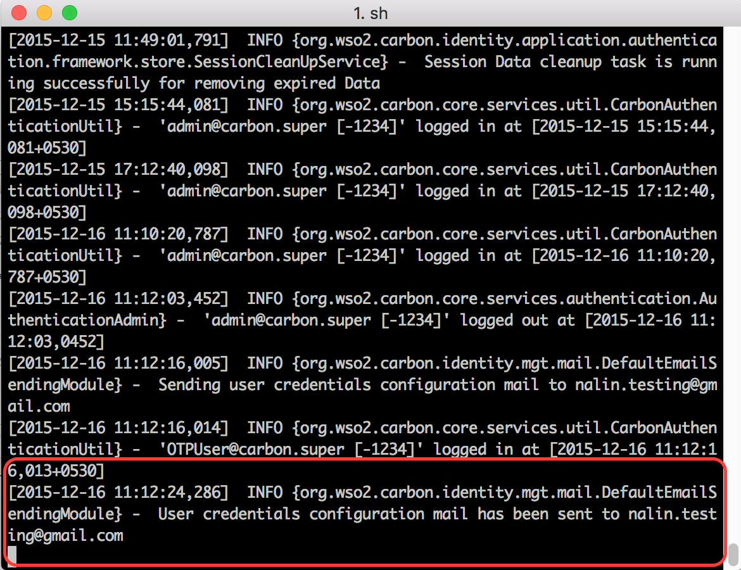

1. Find the email with the password sent to the user.
2. Use the new password to log in to the system and observe steps 2 and 3.

# Lab: Configure WSO2 IS to Use an LDAP Server

Training Objective

Learn how to configure WSO2 IS to use ApacheDS.

Business Scenario

Experia Travels wishes to explore the possibility of using their existing ApacheDS as the primary user store for the WSO2 IS. In order to test the complexity of the implementation, they plan to test using a new installation of ApacheDS as the user store of a secondary installation of the IS.

High Level Steps

* Install ApacheDS
* Configure Apache DS
* Create a WSO2 IS Installation
* Configure the primary user store of the IS

Detailed Instructions

Install and Configure ApacheDS

Download Apache Directory Studio and install the product [1].

[1] <https://directory.apache.org/studio/users-guide/apache_directory_studio/download_install.html>

Configure ApacheDS

1. Open Apache Directory Studio.
2. In the **LDAP Servers** tab, click **New Server**.

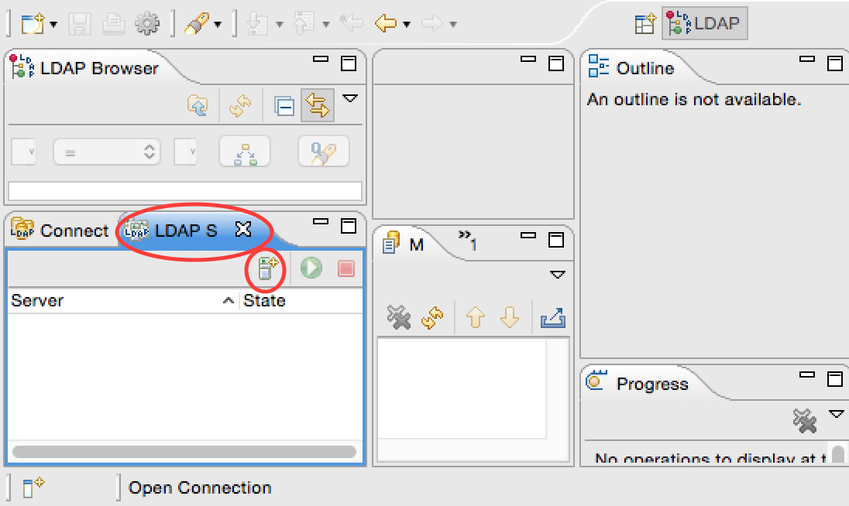

1. Select **LDAP server ApacheDS 2.0.0** and click **Finish**.

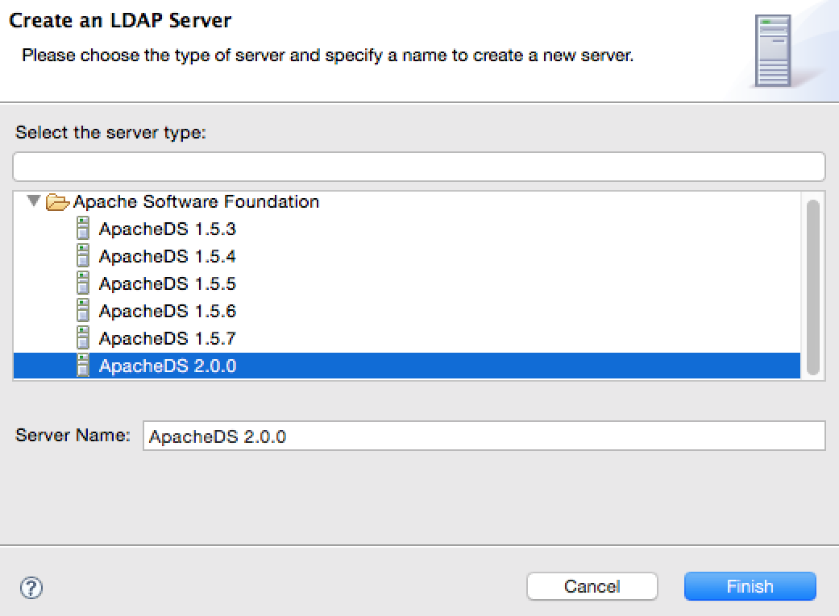

1. Update the LDAP and LDAPS server ports with an offset of 1 in the configuration of the newly created server. This will ensure that the embedded LDAP server running in the prior installation of the Identity Server will not conflict with the current installation.

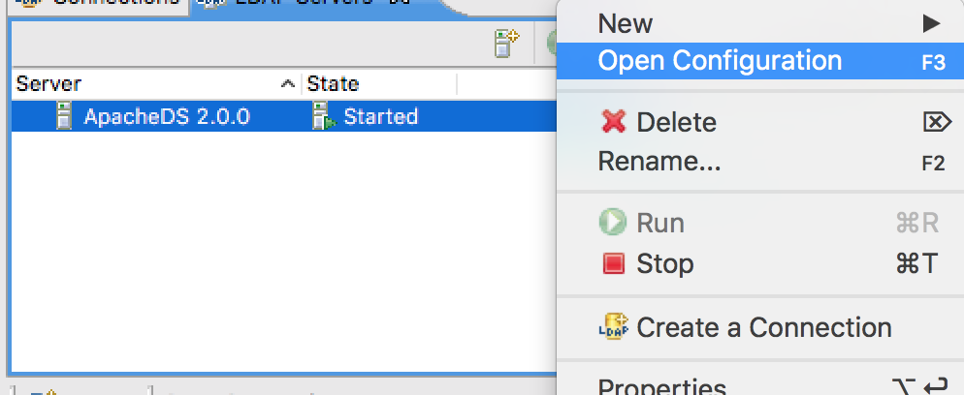

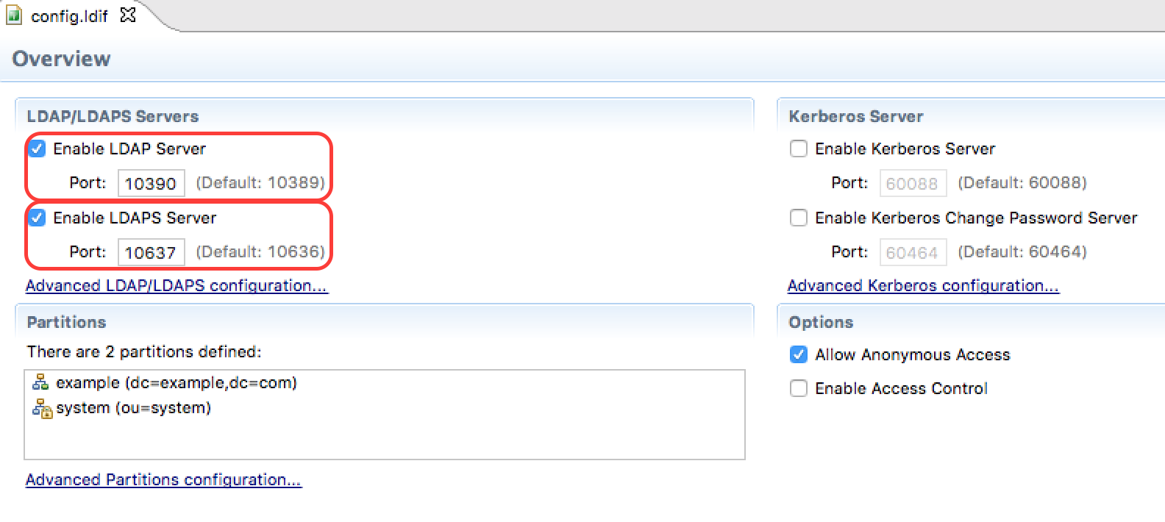

1. Right-click on the server that appears and click **Create a Connection**. A connection with the default settings will be created.

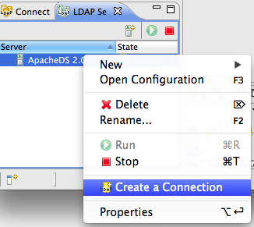

1. Right-click on the server and run.

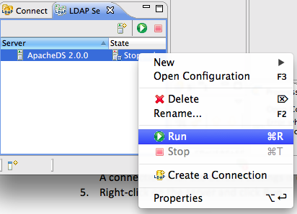

Create a WSO2 IS Installation

1. Create a copy of the current WSO2 IS installation folder. This new folder will act as the second installation, configured to utilize ApacheDS as its primary user store.

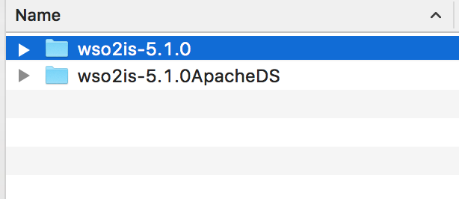

1. Open <IS_HOME>/repository/conf/carbon.xml and add a port offset of 1 to the

<Ports> <Offset> tag inside:

<Ports>

<Offset>1</Offset>  
 (………)

</Ports>

Note that <IS_HOME> refers to the new installation for the duration of the current lab.

Configure the Primary User Store of the IS

To configure the primary user store to a read-write mode for an LDAP directory.

1. Open <IS_HOME>/repository/conf/identity/embedded-ldap.xml and disable the embedded LDAP option. The tag to modify is as follows:

<EmbeddedLDAP>

<Property name=”enable”>false</Property>  
 (………)

</Embedded LDAP>

1. Open <IS_HOME>/repository/conf/user-mgt.xml. Comment out the default user store manager which is uncommented. All user store managers in user-mgt.xml must be commented out at this point. The tag to comment is for the entry (class = "org.wso2.carbon.user.core.ldap.ReadWriteLDAPUserStoreManager")
2. In order to connect to an external ldap a new user store manager needs to be defined in the user-mgt.xml file. For simplicity, the user store for the embedded ldap server can be reused and modified to connect to the external LDAP server.

<!--Using an External LDAP server as the primary user store -->

<UserStoreManager class="org.wso2.carbon.user.core.ldap.ReadWriteLDAPUserStoreManager">

<Property name="TenantManager">org.wso2.carbon.user.core.tenant.CommonHybridLDAPTenantManager</Property>

**<Property name="ConnectionURL">???</Property>**

**<Property name="ConnectionName">???</Property>**

**<Property name="ConnectionPassword">???</Property>**

**<Property name="UserSearchBase">???</Property>**

**<Property name="UserEntryObjectClass">???</Property>**

<Property name="UserNameAttribute">uid</Property>

<Property name="UserNameSearchFilter">(&amp;(objectClass=person)(uid=?))</Property>

<Property name="UserNameListFilter">(objectClass=person)</Property>

<Property name="DisplayNameAttribute"/>

<Property name="ReadGroups">true</Property>

<Property name="WriteGroups">true</Property>

**<Property name="GroupSearchBase">???</Property>**

<Property name="GroupEntryObjectClass">groupOfNames</Property>

<Property name="GroupNameAttribute">cn</Property>

<Property name="GroupNameSearchFilter">(&amp;(objectClass=groupOfNames)(cn=?))</Property>

<Property name="GroupNameListFilter">(objectClass=groupOfNames)</Property>

<Property name="MembershipAttribute">member</Property>

<Property name="BackLinksEnabled">false</Property>

<Property name="UsernameJavaRegEx">[a-zA-Z0-9._-|//]{3,30}$</Property>

<Property name="UsernameJavaScriptRegEx">^[\S]{3,30}$</Property>

<Property name="UsernameJavaRegExViolationErrorMsg">Username pattern policy violated</Property>

<Property name="PasswordJavaRegEx">^[\S]{5,30}$</Property>

<Property name="PasswordJavaScriptRegEx">^[\S]{5,30}$</Property>

<Property name="PasswordJavaRegExViolationErrorMsg">Password length should be within 5 to 30 characters</Property>

<Property name="RolenameJavaRegEx">[a-zA-Z0-9._-|//]{3,30}$</Property>

<Property name="RolenameJavaScriptRegEx">^[\S]{3,30}$</Property>

**<Property name="SCIMEnabled">false</Property>**

<Property name="IsBulkImportSupported">false</Property>

<Property name="EmptyRolesAllowed">true</Property>

<Property name="PasswordHashMethod">PLAIN_TEXT</Property>

<Property name="MultiAttributeSeparator">,</Property>

<Property name="MaxUserNameListLength">100</Property>

<Property name="MaxRoleNameListLength">100</Property>

<Property name="kdcEnabled">false</Property>

**<Property name="defaultRealmName">EXPERIA.COM</Property>**

<Property name="UserRolesCacheEnabled">true</Property>

<Property name="ConnectionPoolingEnabled">false</Property>

<Property name="LDAPConnectionTimeout">5000</Property>

<Property name="ReadTimeout"/>

<Property name="RetryAttempts"/>

</UserStoreManager>

For addditional information on the properties described can be found in the documentation at: <https://docs.wso2.com/display/IS520/Working+with+Properties+of+User+Stores>

1. Right-click on the connection and click Open Configuration. The default settings for LDAP are as follows:

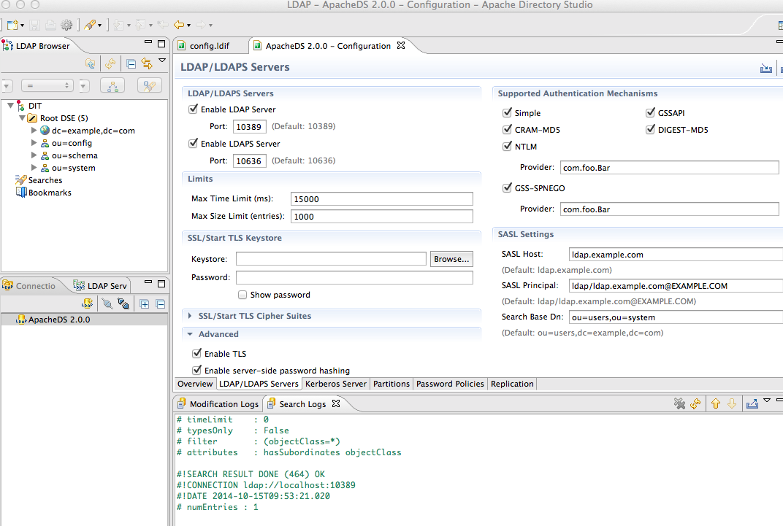

Next, update the following properties for the external Read-Write user store in the user-mgt.xml, as required. The steps are given below.

* ConnectionURL
* ConnectionName
* ConnectionPassword
* UserSearchBase
* UserEntryObjectClass
* GroupSearchBase

1. For the ConnectionURL, begin by updating the connection URL to the user store server if applicable.

<Property name="ConnectionURL">ldap://localhost:10390</Property>

Since the LDAP server will run on the Laptop/PC, the connection URL will be to localhost:10390 where we use the default port configured.



1. For the ConnectionName right-click on the connection, click Properties and then click Authentication and modify the <Property name="ConnectionName"> according to the Authentication Parameter. The connection name is the username given as the Bind DN or user in the Authentication properties of the connection. The user is used to connect to the database and perform various operations. This user does not have to be an administrator in the user store or have an administrator role in the WSO2 product that you are using, but this user MUST have permissions to read the user list and users' attributes and to perform search operations on the user store. This value is the DN (Distinguish Name) attribute of the user.

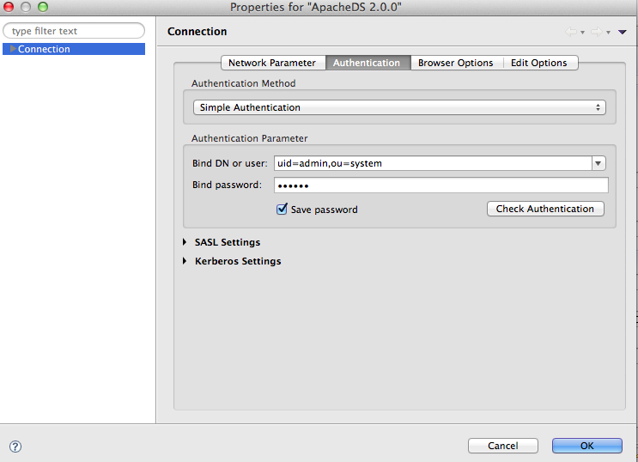

<Property name="ConnectionName">uid=admin,ou=system</Property>

1. Next, add the connection password. This is the password for the user entered in the **ConnectionName** property. Click on the admin user that is created by default to open up the related details.

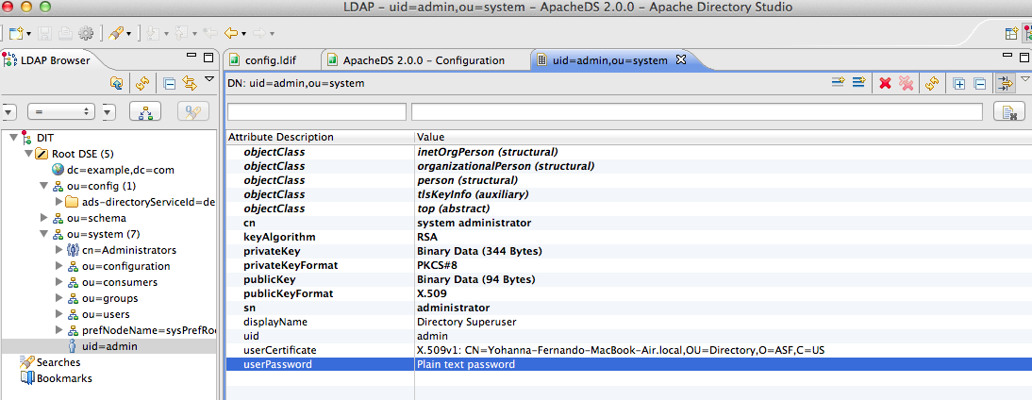

1. Double-click on the user password and click the **Show Current Password Details** check box. The current password is displayed. Modify the property name accordingly.

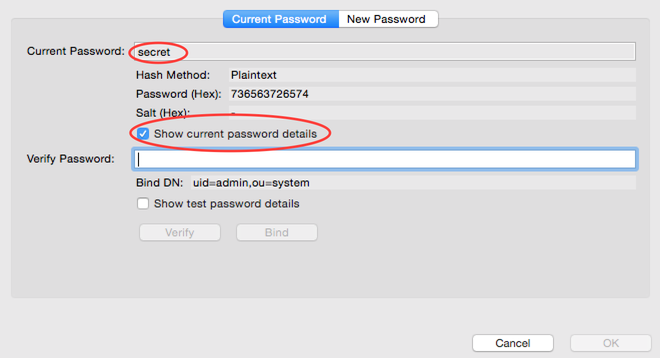

<Property name="ConnectionPassword">secret</Property>

1. Next, update the user search base property. This is the DN of the context or object under which the user entries are stored in the user store. i.e. the "users" container.

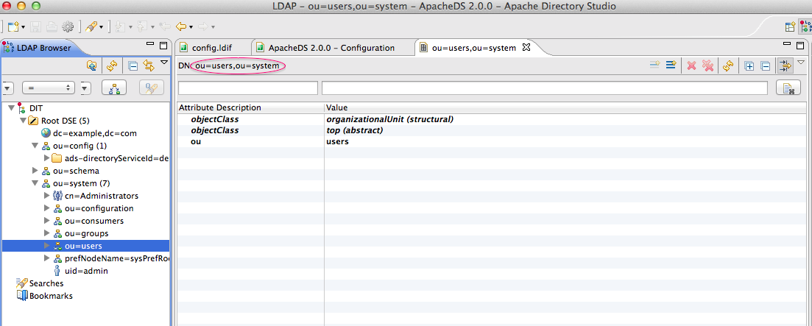

<Property name="UserSearchBase">ou=users,ou=system</Property>

1. To find a suitable UserEntryObjectClass, refer to the documentation on the directory service. For ApaceDS, refer to <https://directory.apache.org/apacheds/basic-ug/2.3.1-adding-schema-elements.html>. The most common value for the UserEntryObjectClass is inetOrgPerson. The entry should look as follows:

<Property name="UserEntryObjectClass">inetOrgPerson</Property>

1. Enter the group search base. This is the DN of the context under which the user entries are stored in the user store.

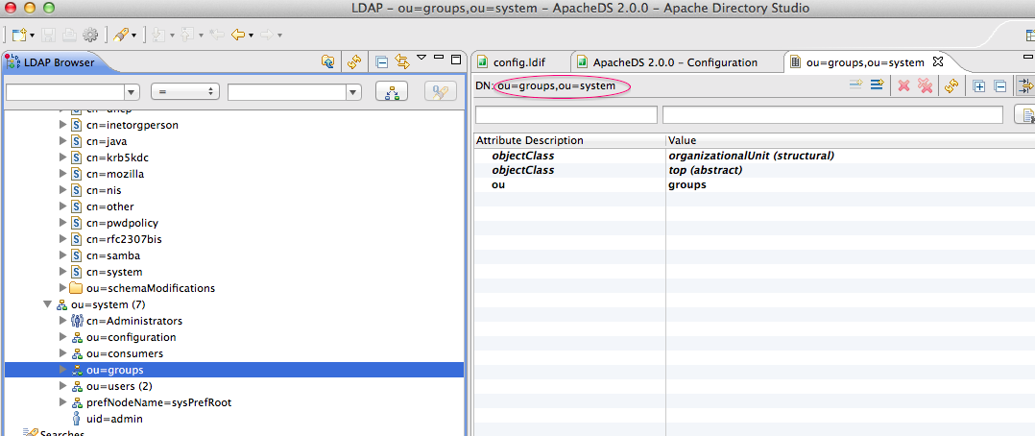

<Property name="GroupSearchBase">ou=groups,ou=system</Property>

1. In order to reduce the complexity constraints of adding a username and password, go to **Password Policies** tab of the configuration window. Change the **Check Quality** option under the **Quality** section to **Disabled**.

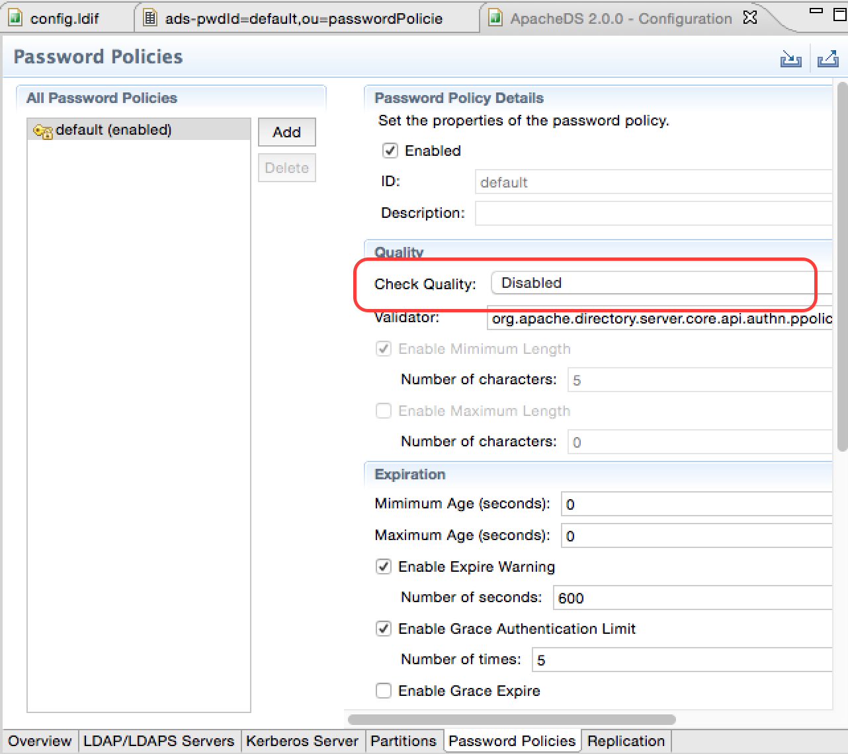

1. Open the user-mgt.xml file, edit the realm configuration as follows:

<UserManager>

<Realm>

<Configuration>

<AddAdmin>true</AddAdmin>

<AdminRole>admin</AdminRole>

<AdminUser>

<UserName>admin</UserName>

<Password>secret</Password>

</AdminUser>

<EveryOneRoleName>everyone</EveryOneRoleName> <!-- By default users in this role sees the registry root -->

<Property name="dataSource">jdbc/WSO2CarbonDB</Property>

</Configuration>

1. Start the IS.

Expected Outcome

1. Log in as with the LDAP username and password (i.e. admin/secret)
2. Create a user in the IS.
3. View the user created and stored in ApacheDS using the Apache Directory Studio.

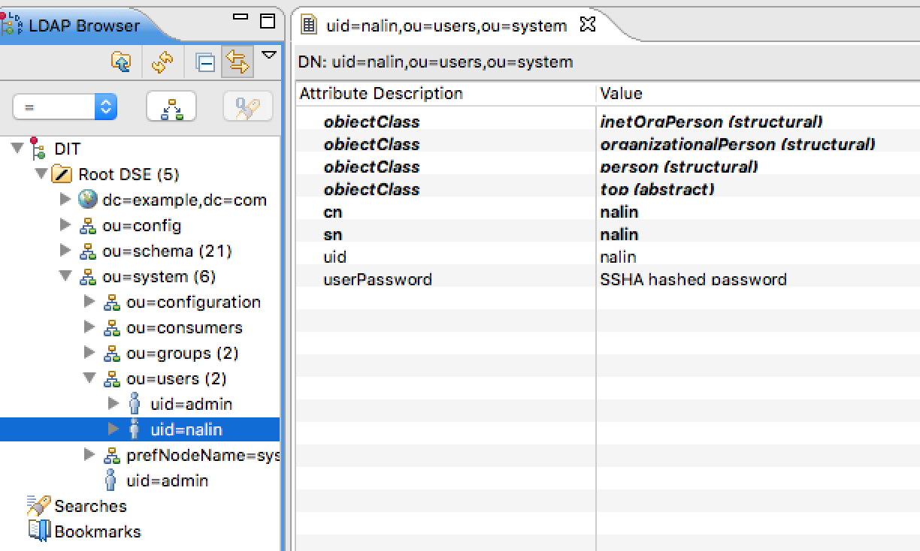

1. The user has now been stored in the ApacheDS that we installed externally to the IS.

# Lab: Configure a Secondary User Store

Training Objective

Adding a secondary user store that can be used to store users in a MySQL database.

Business Scenario

Experia Travels will keep all external users in a separate MySQL database. The database provides storage to a customer relationship management system. The Experia team will maintain and share external user information between the CRM system and the IS.

High Level Steps

* Configure a Database in MYSQL
* Enable JDBC Connectivity for WSO2 IS
* Configure a secondary user store

Detailed Instructions

Configure a Database in MySQL

1. Download and install the latest version of MySQL [1]
2. Connect to MySQL using the Command Line Interface. The command to connect to the MySql promt is:

mysql -u root -p

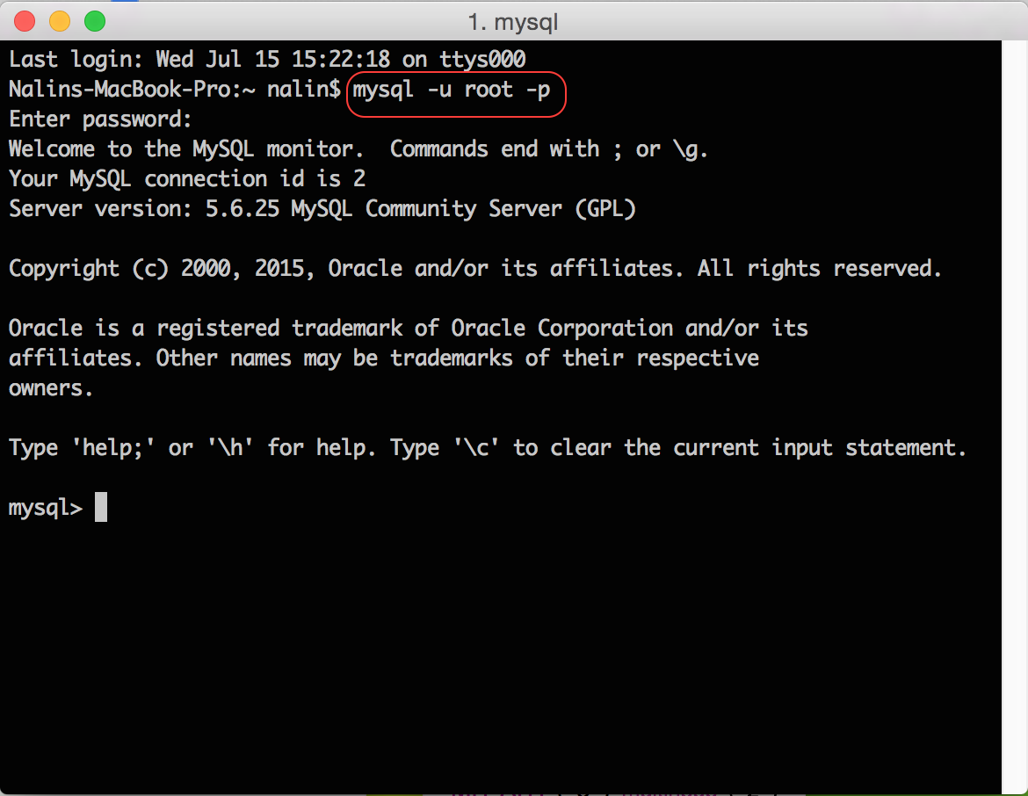

1. Create a database within MySQL to hold the user store. The MySql command to create the database is as follows:

create database JDBC_user_store;

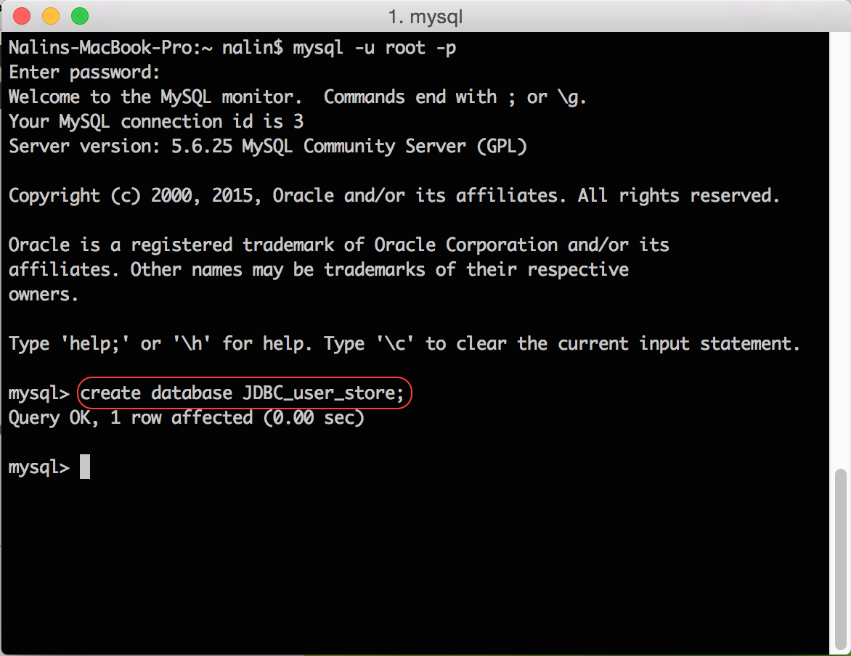

1. Select the new database using the command use <database>.
2. Scripts to create the tables can be found in [IS_Home]/dbscripts/mysql.sql.
3. Deploy the script using the command source [IS_Home]/dbscripts/mysql.sql.

[1] <https://dev.mysql.com/doc/refman/5.7/en/installing.html>

Enable JDBC Connectivity for WSO2 IS

1. Download the JDBC driver from [1].
2. Copy the jar file to [IS_HOME]/repository/components/lib/.
3. Restart the server using the -Dsetup parameter.

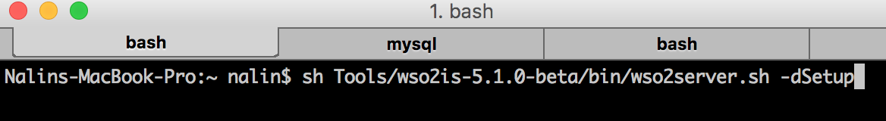

1. For additional information refer to the documentation [2].

[1] <http://dev.mysql.com/downloads/connector/j/>

[2] <https://docs.wso2.com/display/IS520/Setting+up+MySQL#SettingupMySQL-Settingupthedrivers>

Configure a Secondary User Store

1. Click **Main** > **User** **Stores** > **Add**.

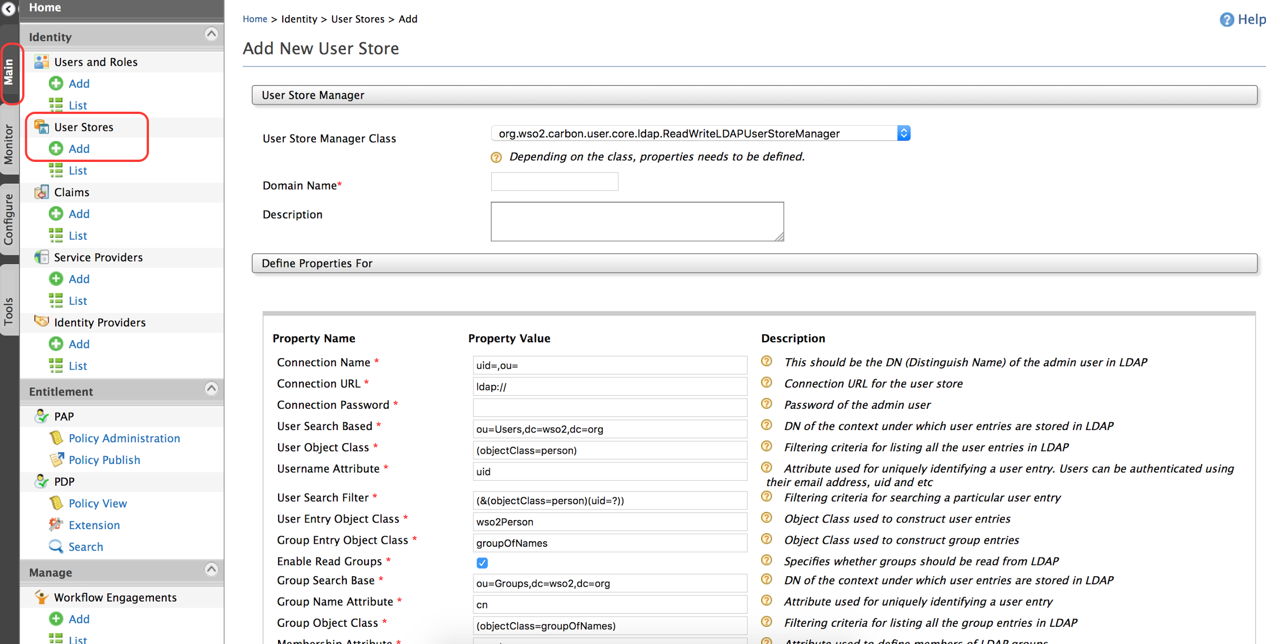

1. The **Add New User Store** page opens.

Note: You cannot update the PRIMARY user store at run time as this is already in use.

1. Select org.wso2.carbon.user.core.jdbc.JDBCUserStoreManager from the **User Store Manager Class** drop-down list.
2. Enter Experia as the domain name.

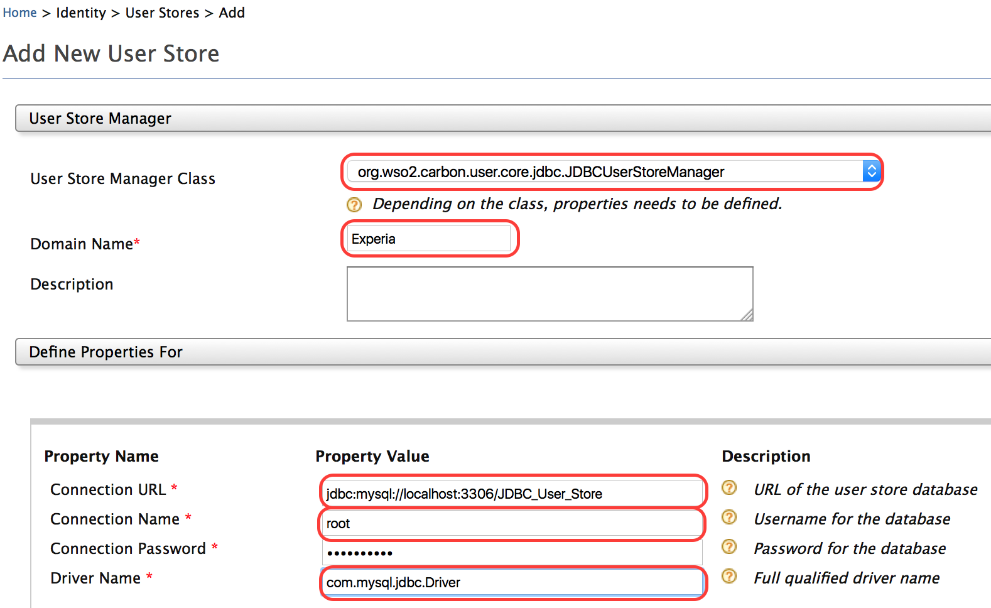

1. Click **Test Connection** to test if the connection is valid.
2. Click **Add** to add the connection.
3. Refresh the page to view the newly added user store.

Expected Outcome

1. The new user store should appear under the list of user stores available for the IS

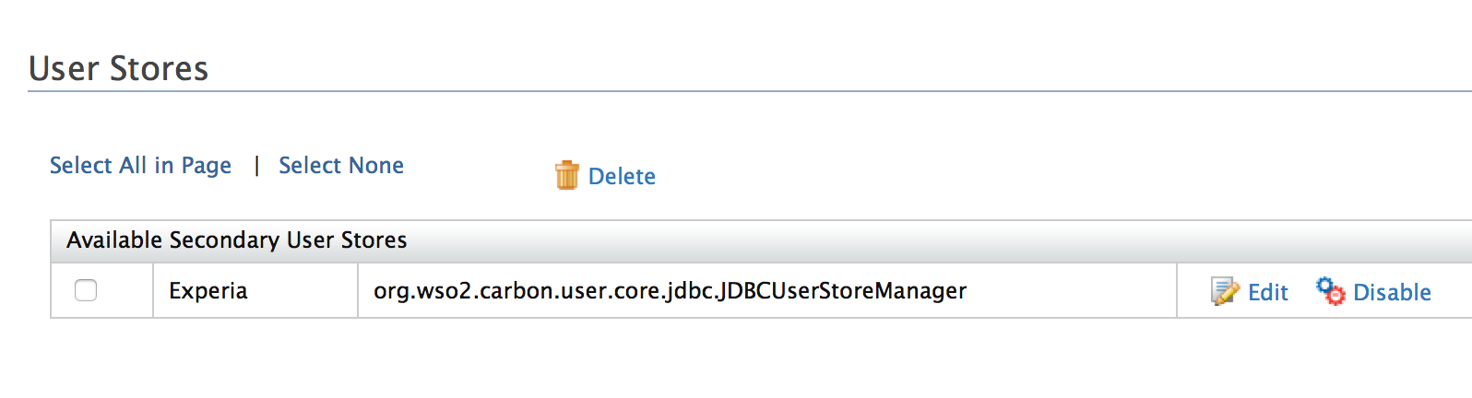

1. It should now be possible to add new users and roles into the user store.

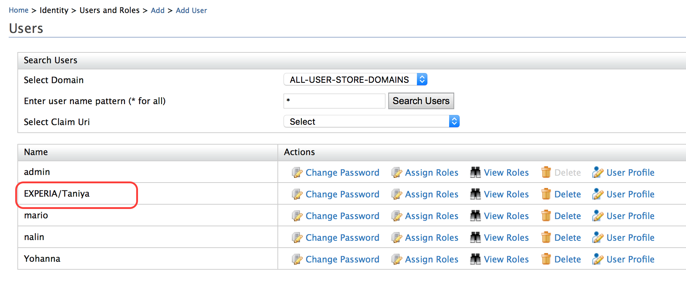

1. All new users and roles added to the user store should appear in the MySQL database.

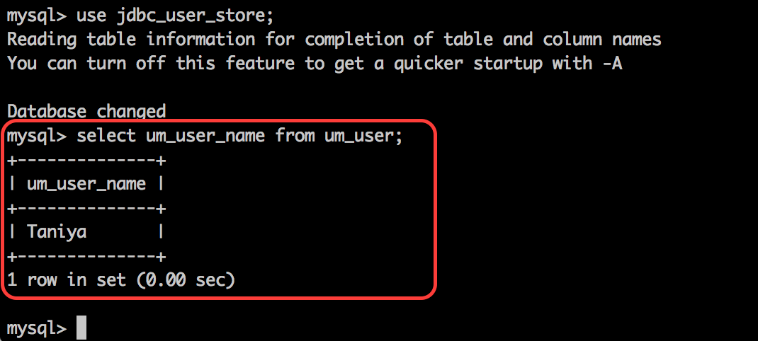

# Lab: Invoking the Admin Services

Training Objective

Invoke the Admin Services exposed by the WSO2 IS to create user accounts as well as lock/unlock user accounts.

Business Scenario

Experia Travels will use third party applications to create users, lock and unlock user accounts. In order to understand the services available, you are expected to simulate client access to the admin services.

High Level Steps

* Enable Admin Services in the Identity Server
* Locate services
* Create a user
* Lock a user account
* Unlock a user account

Detailed Instructions

Enable Admin Services in the Identity Server

1. Stop the IS if it is already running.
2. Edit the carbon.xml file found inside <IS_HOME>/repository/conf/.
3. Changing to <HideAdminServiceWSDLs>**false**</HideAdminServiceWSDLs> will enable the admin services.

Locate Services

The services available can be listed using the OSGI console. In order to list the services:

1. Start the server with the the -DosgiConsole option. Additional details available at [1].

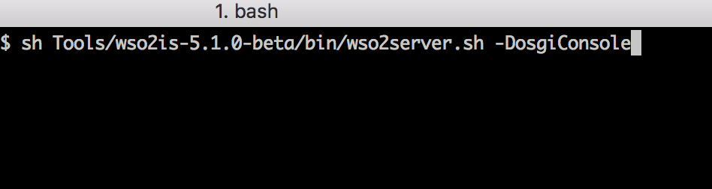

1. Once the server starts, click enter a few times to enter the OSGI prompt.

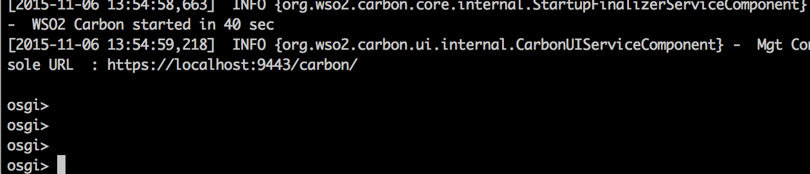

1. The command listAdminServices will list out all the services available.

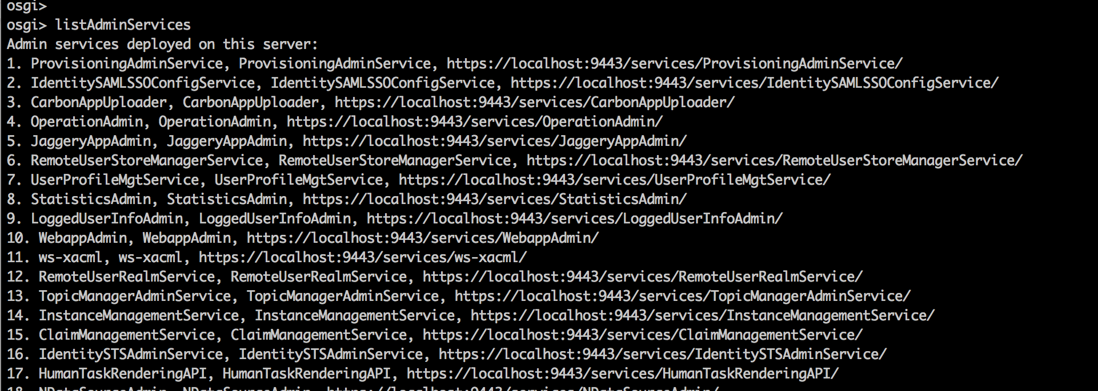

[1] <https://docs.wso2.com/display/IS520/Calling+Admin+Services>

Create a User

The desired service can be called using the SoapUI client.

1. Start the SoapUI client.
2. Create a SOAP project and add the **UserAdmin** WSDL.

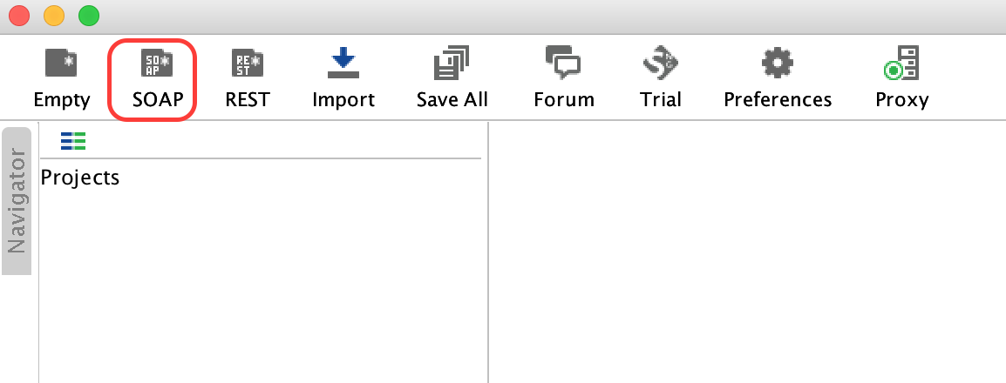

1. The required WSDL files is:
   * <https://localhost:9443/services/UserAdmin?wsdl>

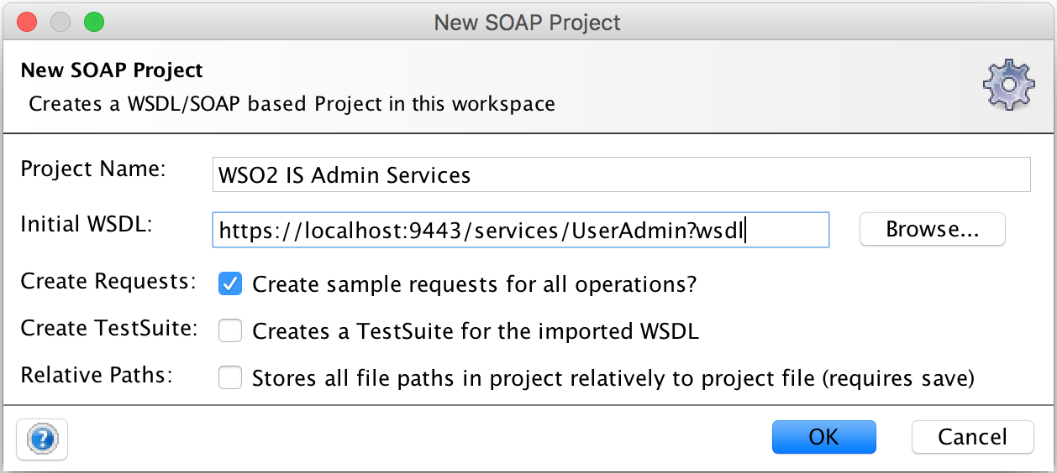

1. The UserAdmin service has the operation **addUser** which is capable of creating a new user.

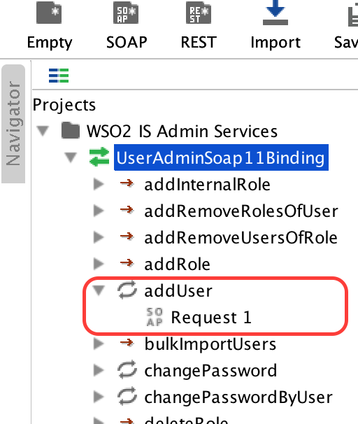

1. The SOAP request should be authenticated by adding the credentials used to access the IS.

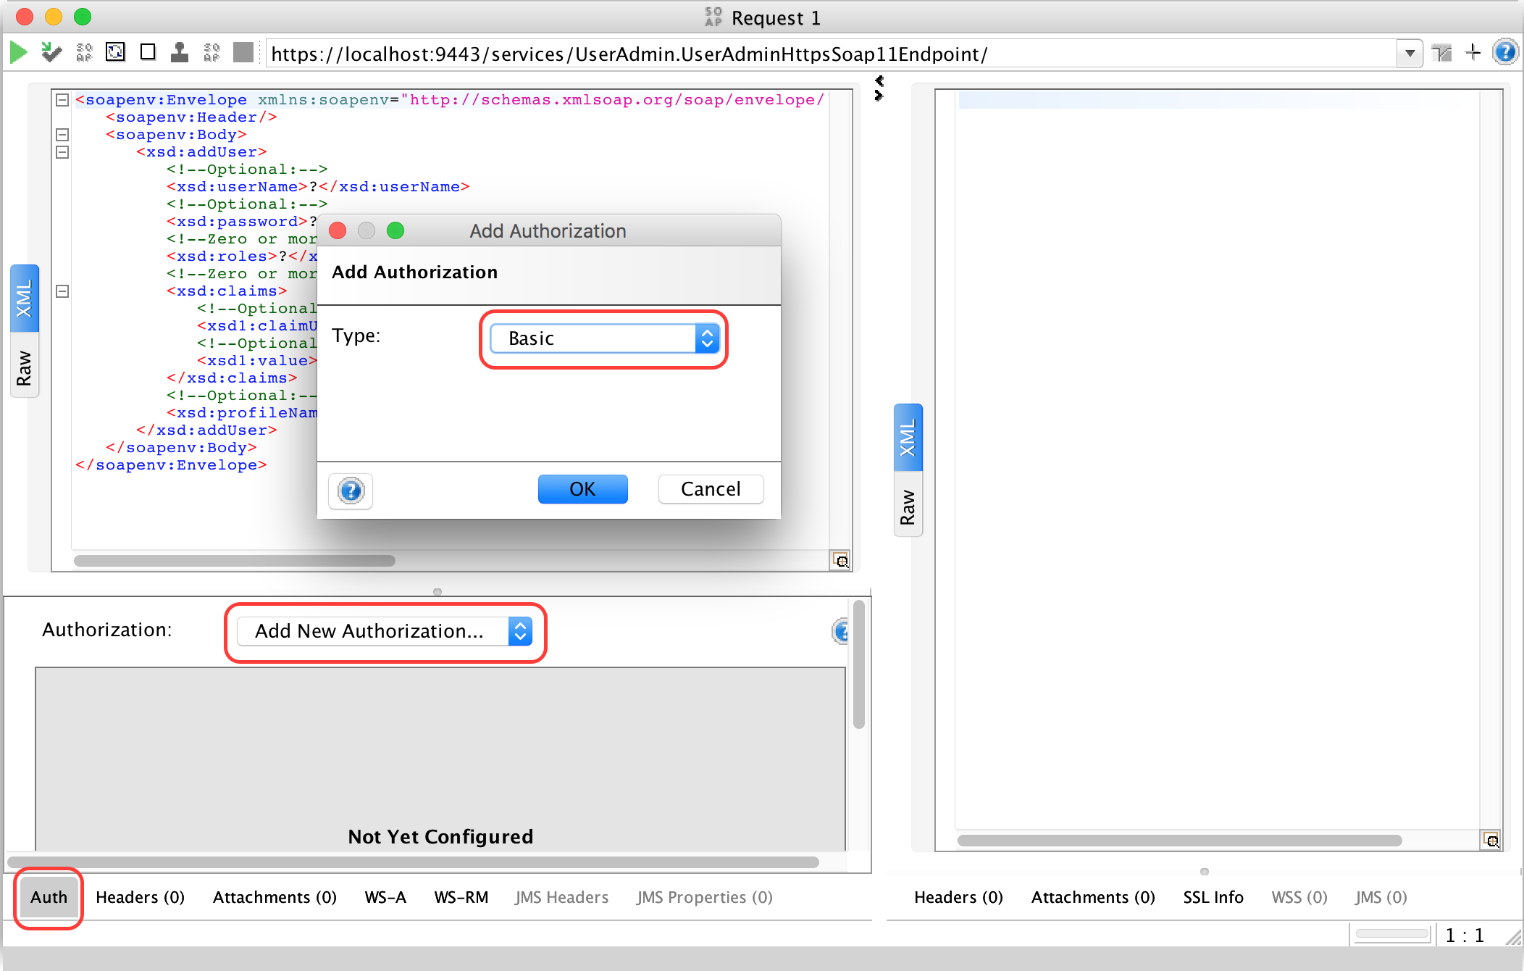

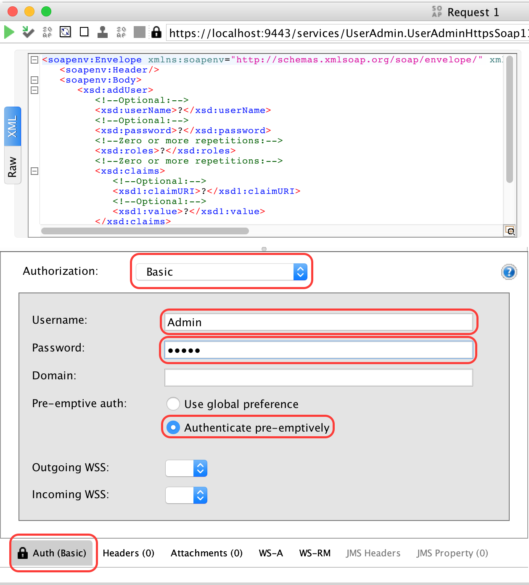

1. Add the user information into the SOAP body and execute.

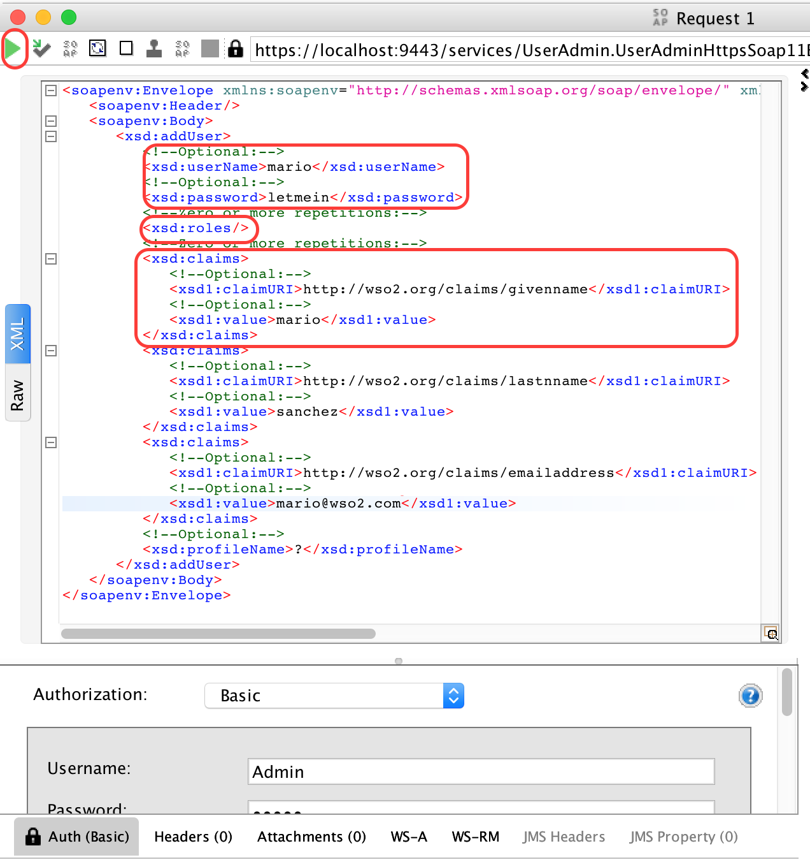

1. The operation can be validated with the SOAP response and by listing the users in the Management Console of the IS.

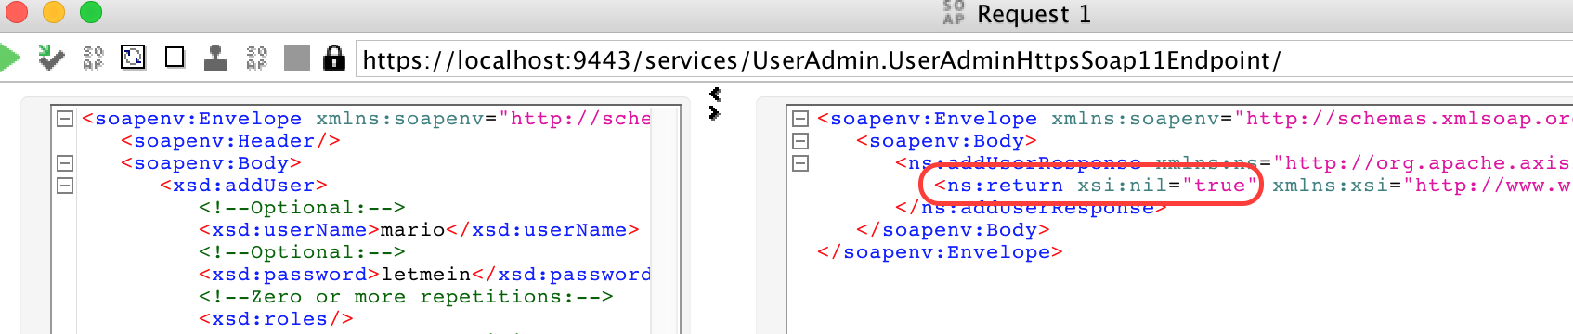

1. Add permission **Admin Permissions > Configure > Login** in order for the user to login. This will be useful for the next step when studying the services to lock and unlock a user account.

Lock a User Account

The steps will be similar to creating a new user, except the service to be called is different.

1. Add a new WSDL for the new service to be accessed.

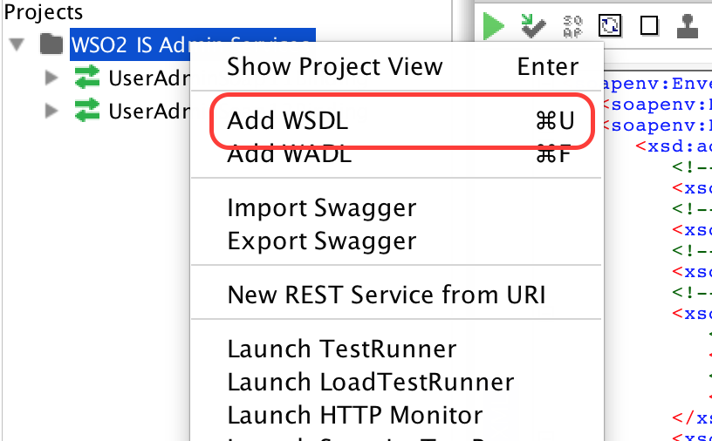

1. Add the WSDL. <https://localhost:9443/services/UserIdentityManagementAdminService?wsdl>
2. Call the operation **lockUserAccount** and give the credentials as explained above.

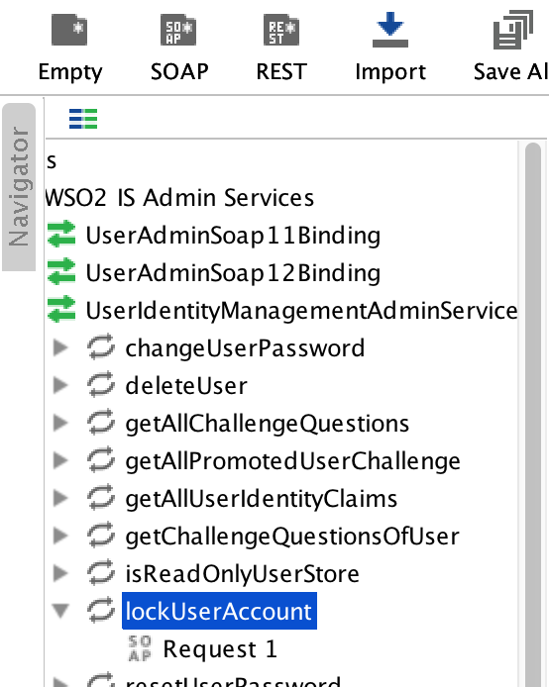

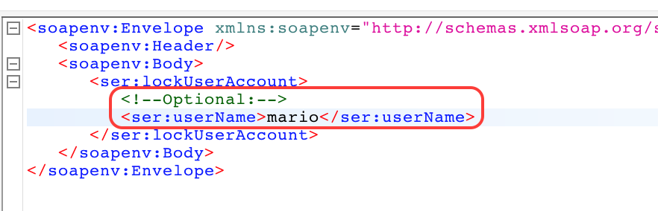

1. Lock the user using the operation and check functionality by attempting to log in to the Management Console using the locked user account.

Unlock User Account

The operation to unlock the user account is also bundled with the service UserIdentityManagementAdminService. Call the operation as described in the Lock User Account section above.

# Lab: User Account Approval Workflow

Training Objective

Use the workflow feature in the Identity Server.

Business Scenario

Experia Travels wishes to introduce human workflows when creating new users in its internal systems controlled by the Identity Server. The workflow requires a manager and either the head of HR or the General Manager to approve all new users. Any Manager needs approve first to be followed by either the Head of HR or General Manager.

High Level Steps

* Creating New Users and Roles Used by the Workflow
* Adding a New Workflow
* Engaging the Workflow in Operations

Detailed Instructions

Creating New Users and Roles Used by the Workflow

1. Create three new role and name them, **manager**, **head_hrm** and **group_manager**
   1. Add permission **Admin Permissions** > **Manage** > **Human Task** > **View Task List** in order to allow the users to view the pending approvals widget
   2. Add permission **Admin Permissions** > **Manage** > **Identity** > **Workflow Management** > **BPS Profiles** > **View** in order to allow these users to approve the workflow
   3. Add permission **Admin Permissions > Configure > Login** in order for them to login
2. Create and associate two users with the manager role as well as a user each for head_hrm and general_manager roles

Adding a New Workflow

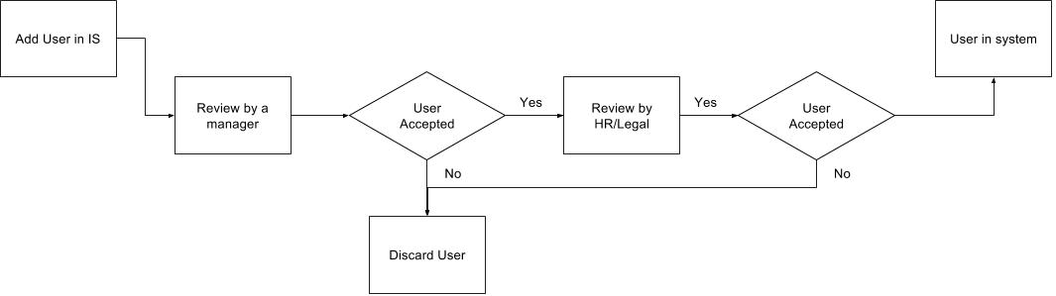

1. Add a new workflow by going to **Main** > **Manage** > **Workflow Definitions** > **Add**

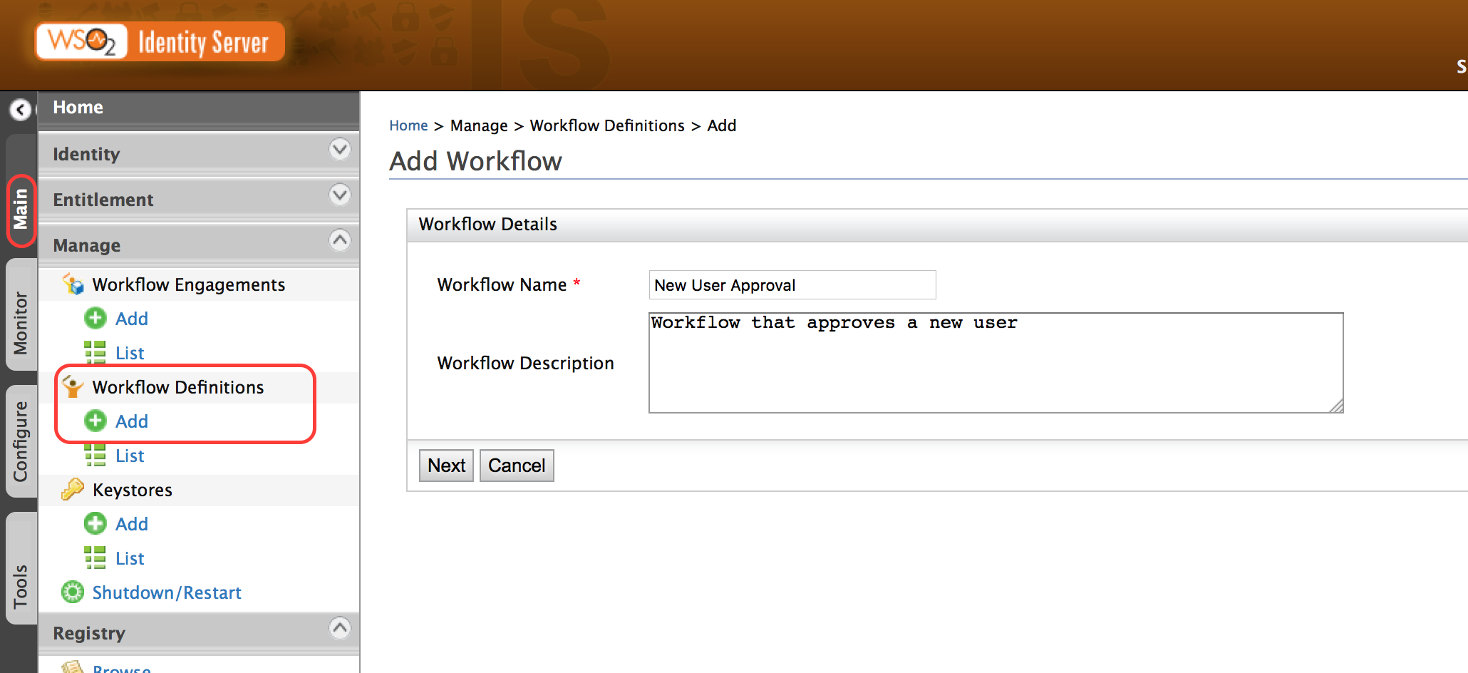

1. Add the workflow in the next step

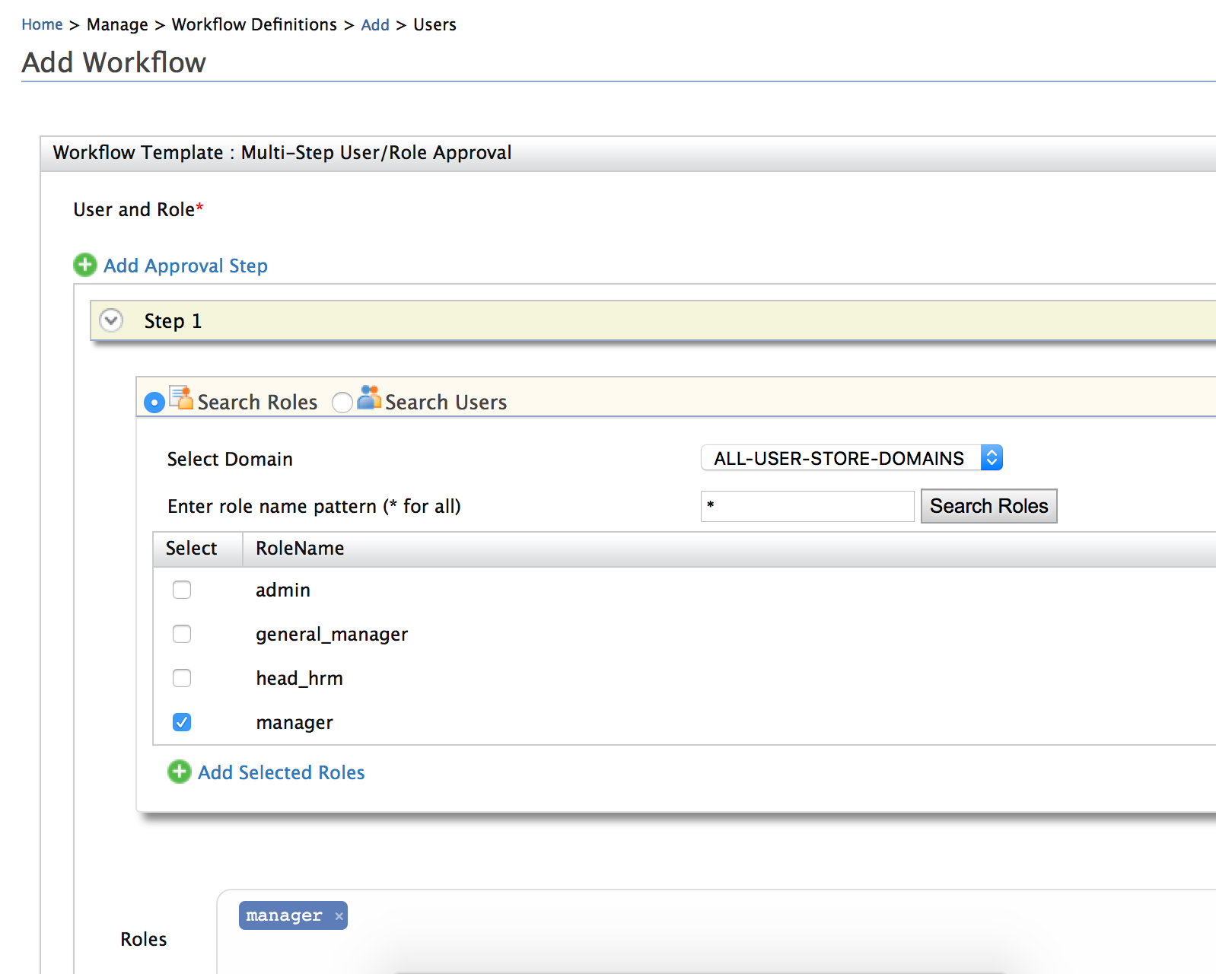

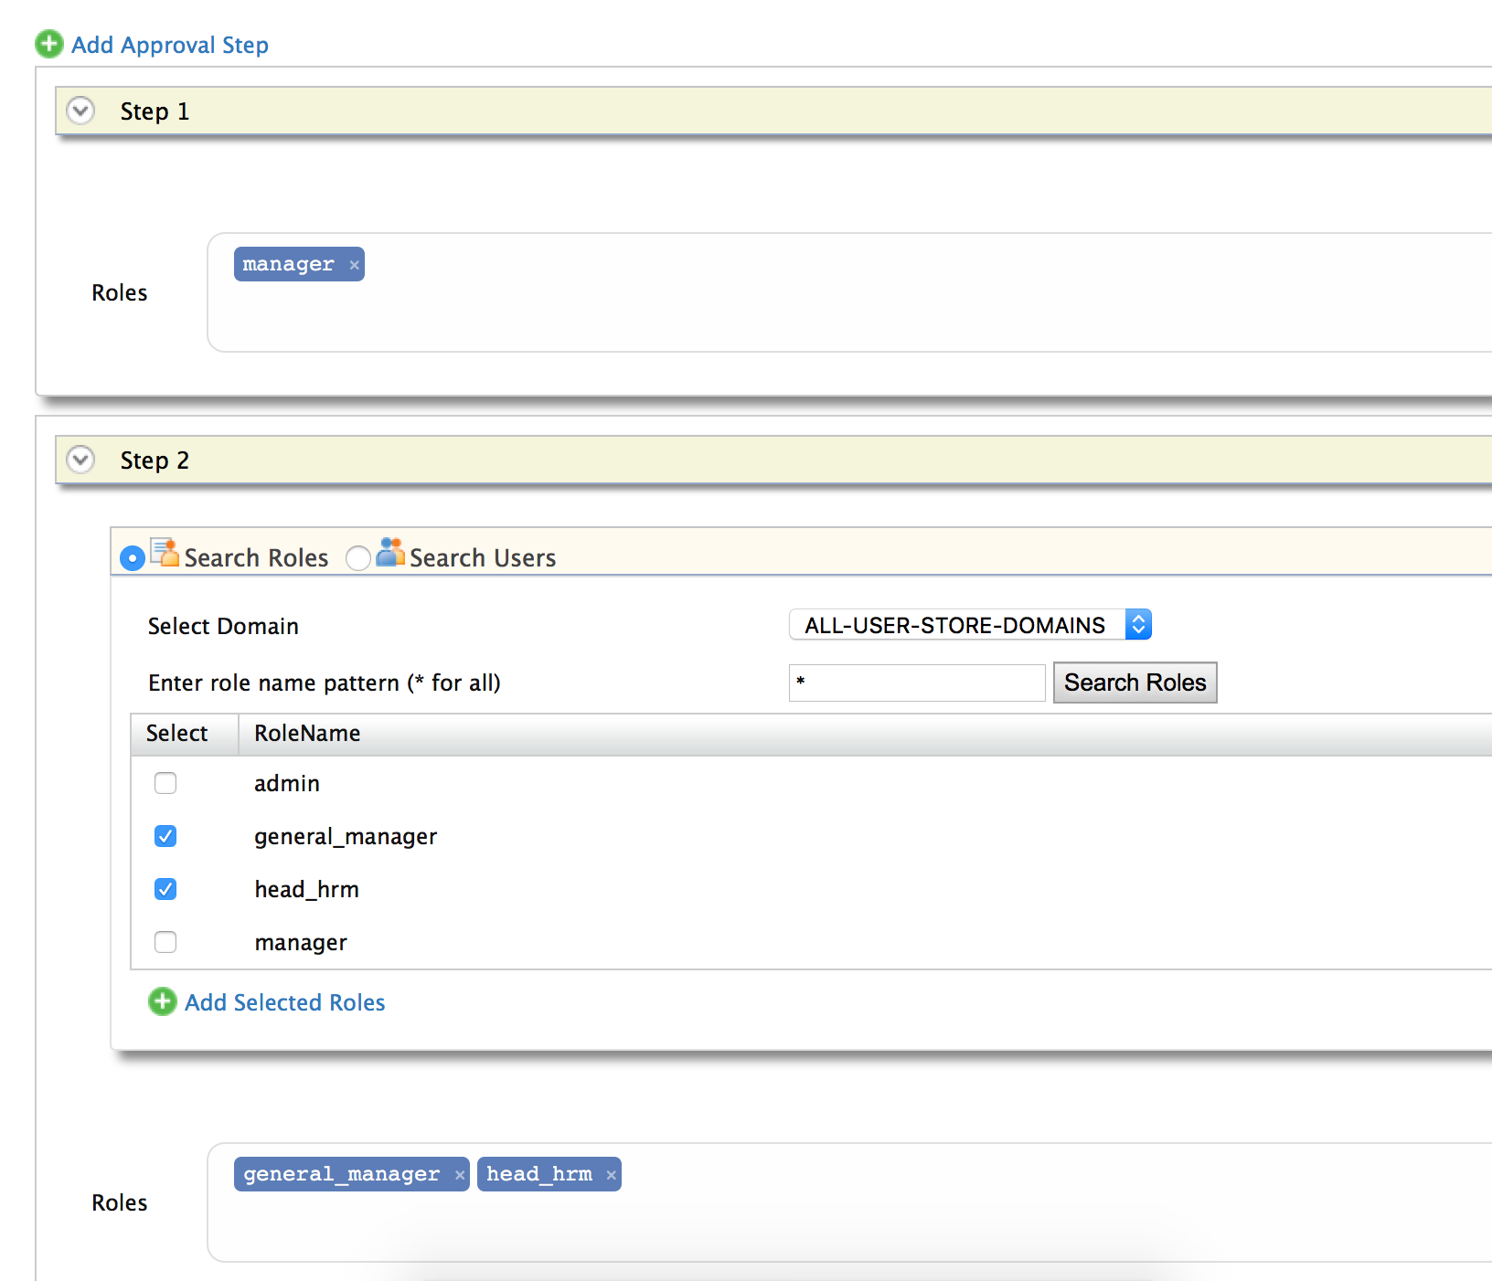

1. Use **Add Approval Step** to add multiple steps in the workflow
2. In the final step, select the built in BPS engine as the BPS profile and give a unique name to the Task

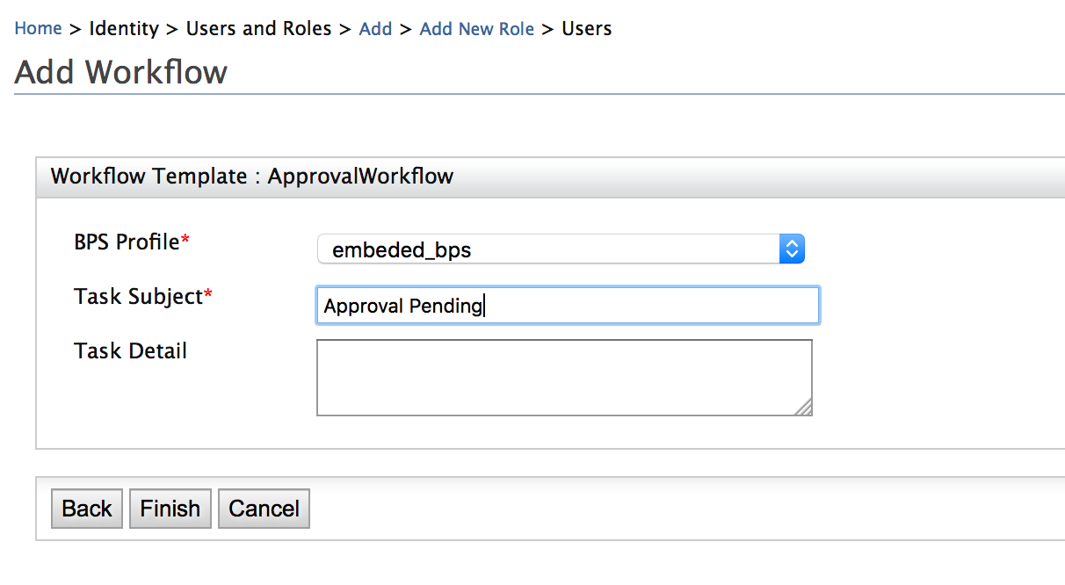

1. Click **Finish** to save the workflow.

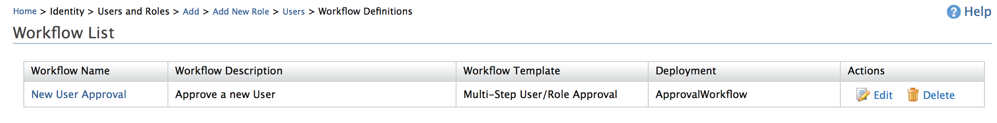

Engaging the Workflow Operations

The final step in adding a workflow to the Identity Server is to engage the workflow.

1. Add a new engagement by going to **Main**> **Manage** > **Workflow Engagements** > **Add**

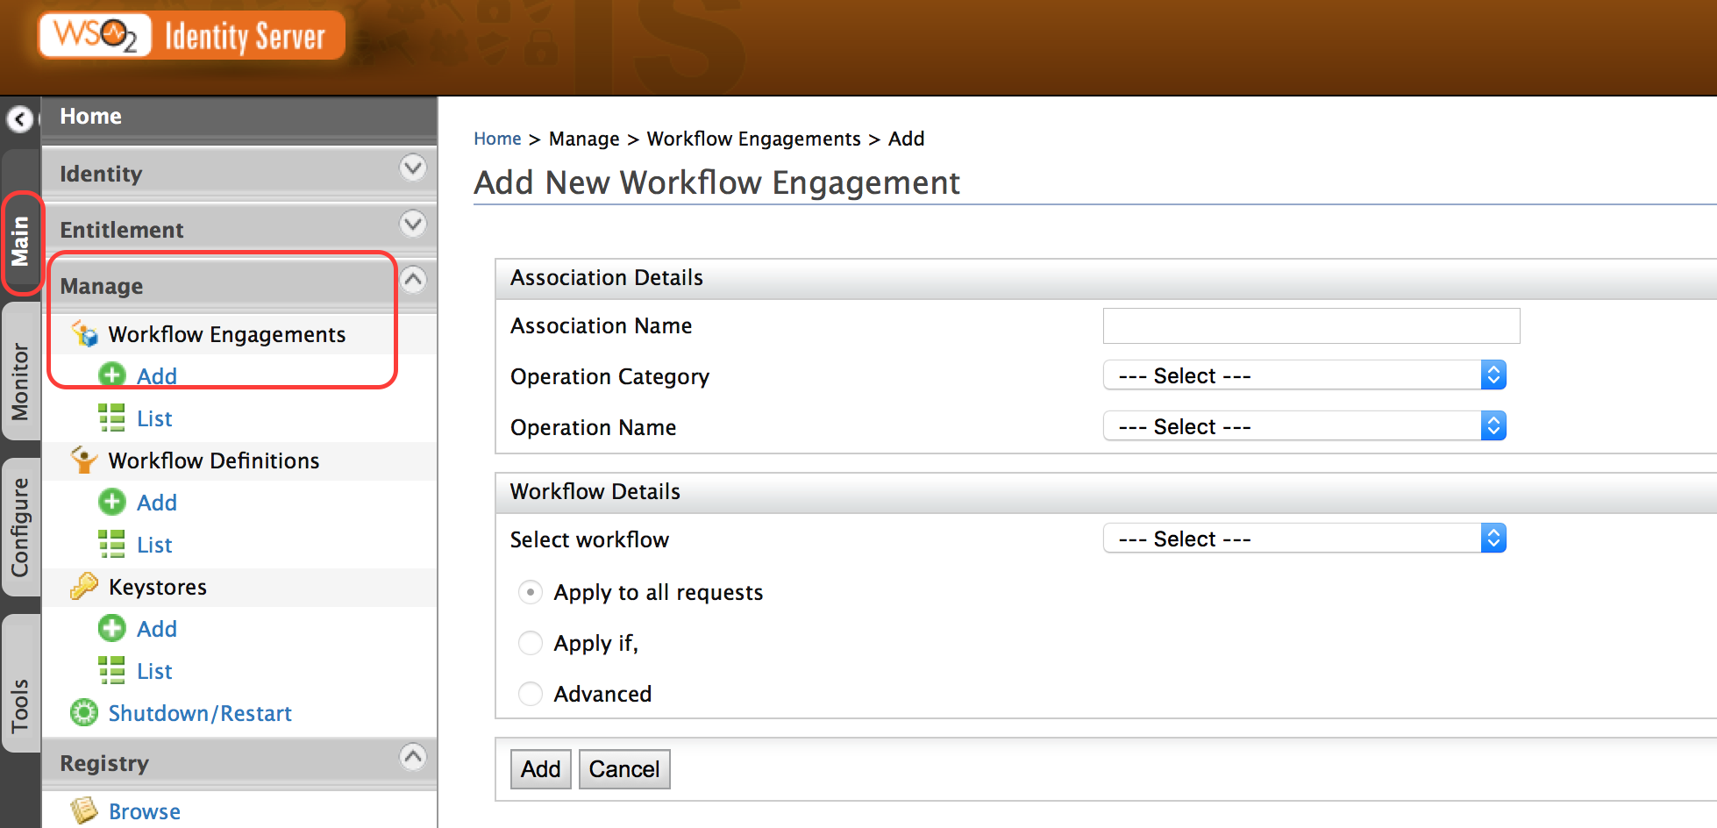

1. After giving a unique name to the workflow engagement, select the **Operation Category** as **User Store Operations** and the **Operation Name** as **Add User** since we need the workflow to approve new users

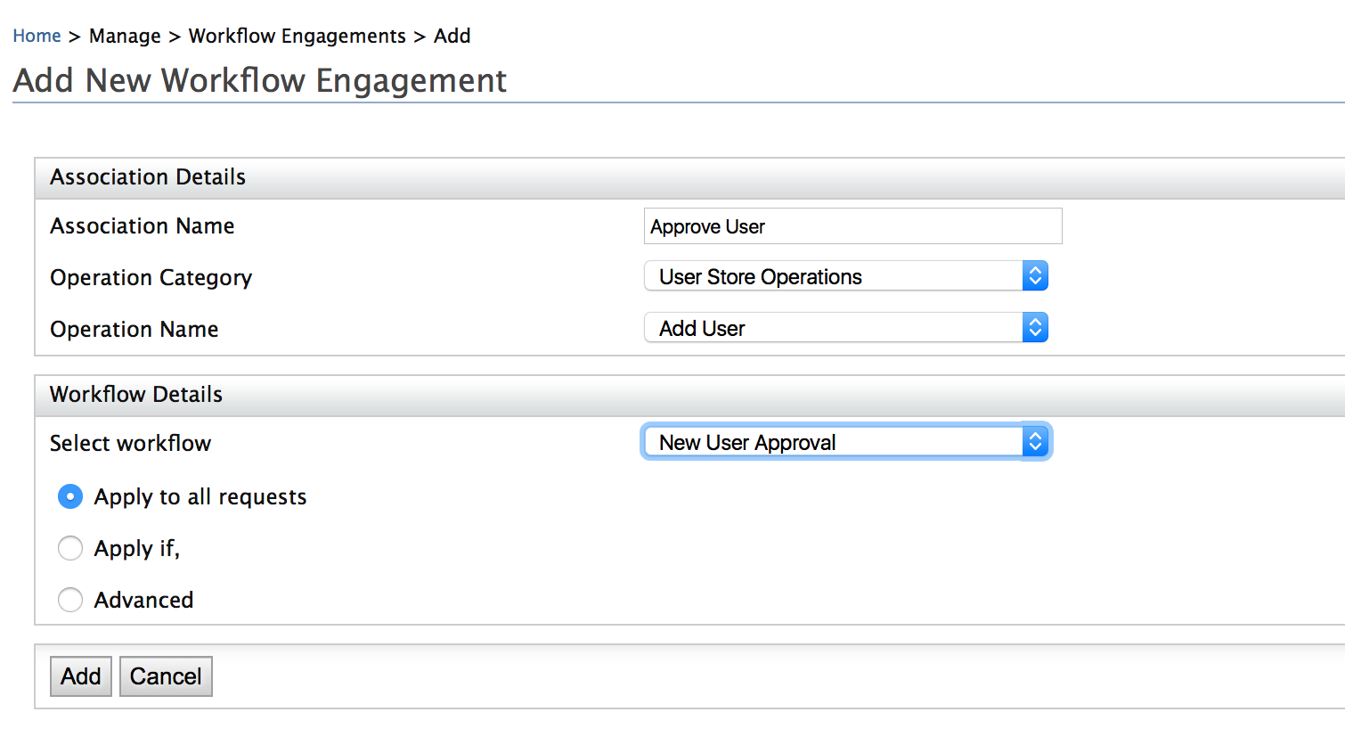

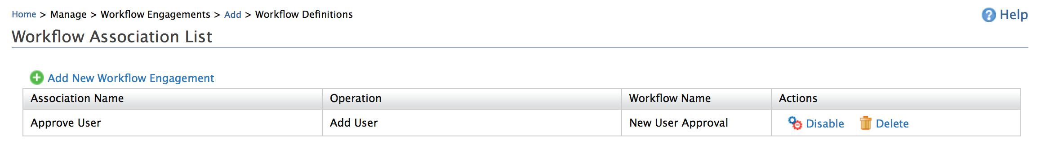

Expected Outcome

When creating a new user, the workflow will not engage, requesting approval from the users with the required permission.

1. Create a new user

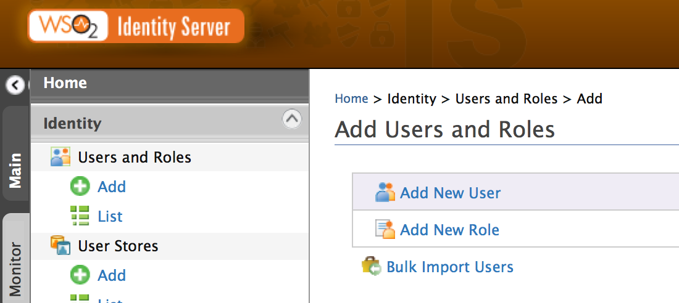

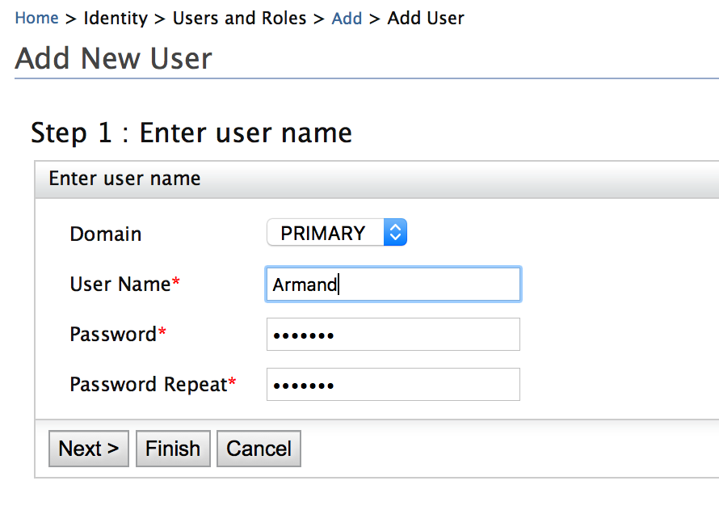

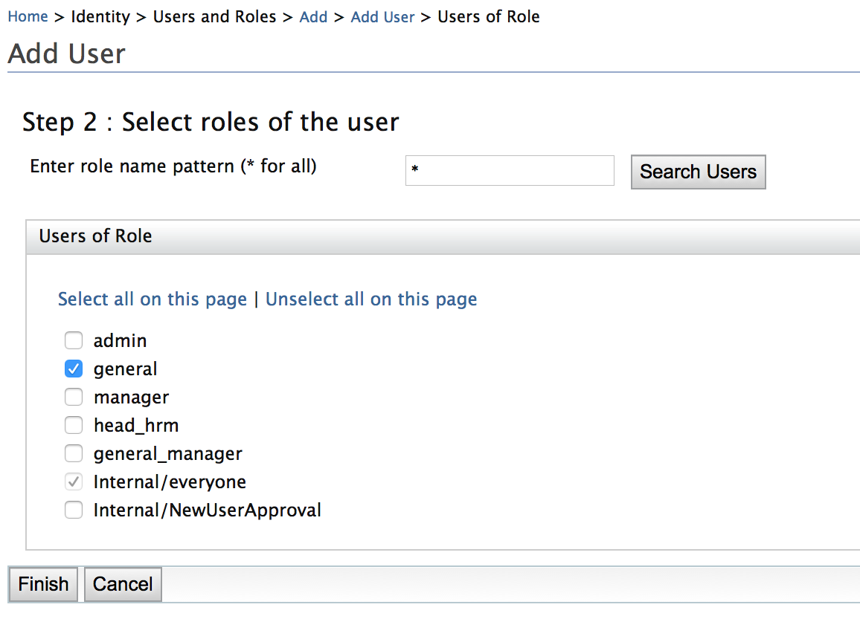

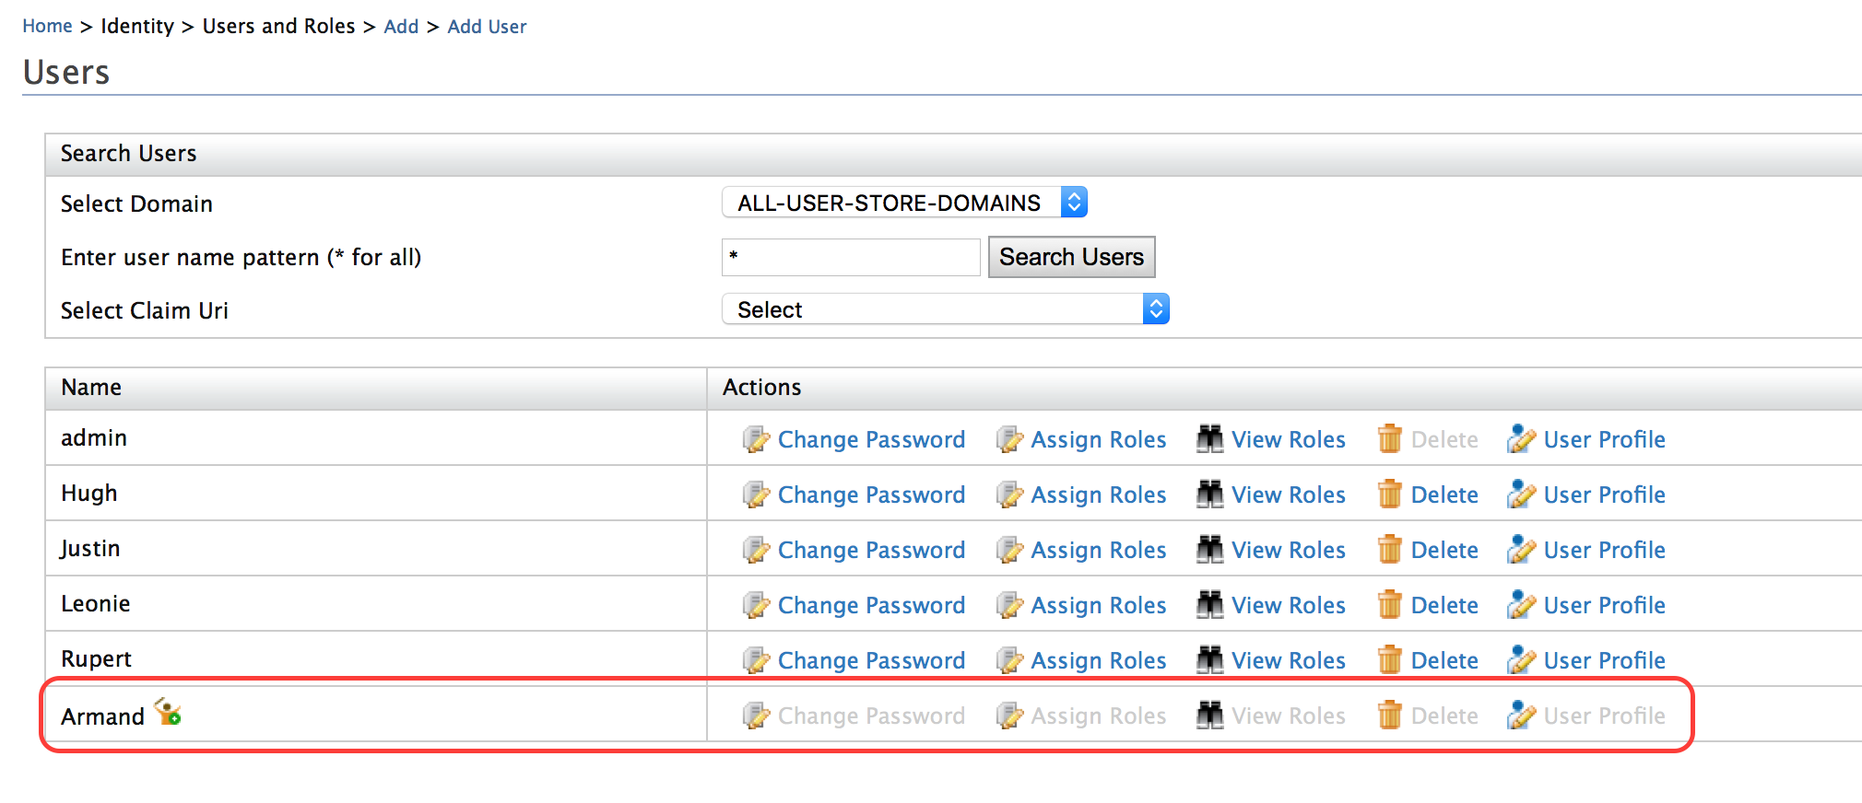

1. User with manager credentials should be able to approve the account creation.

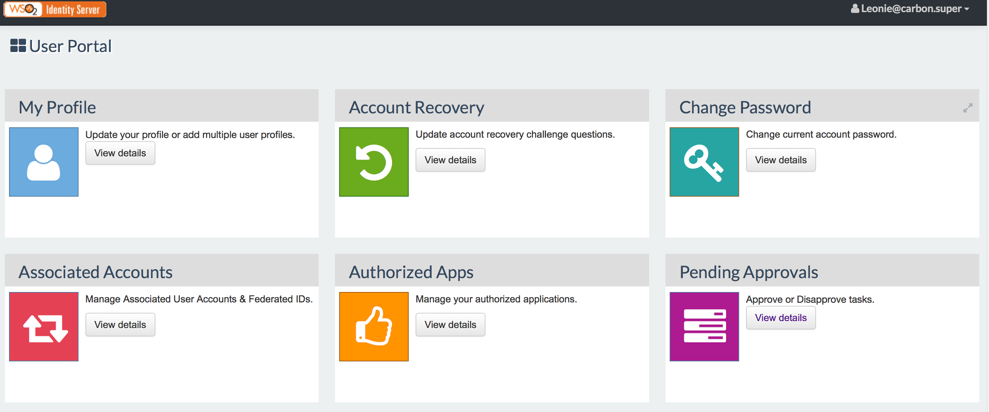

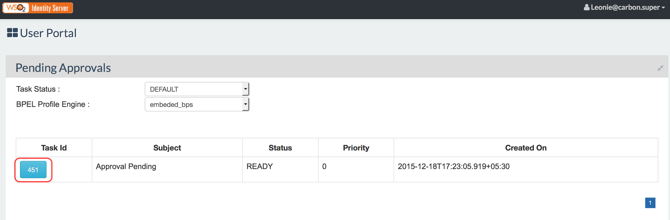

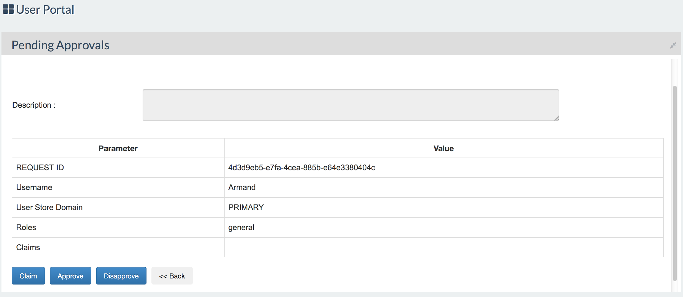

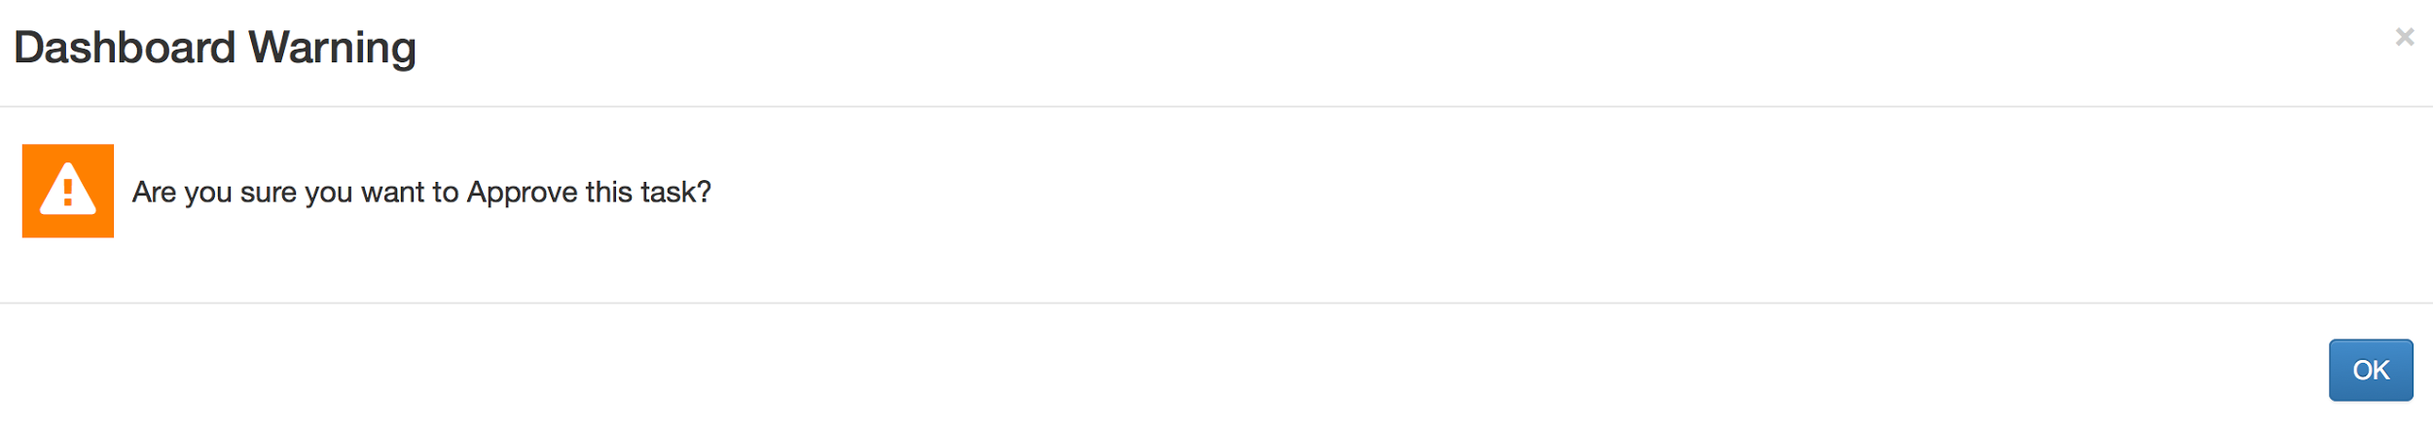

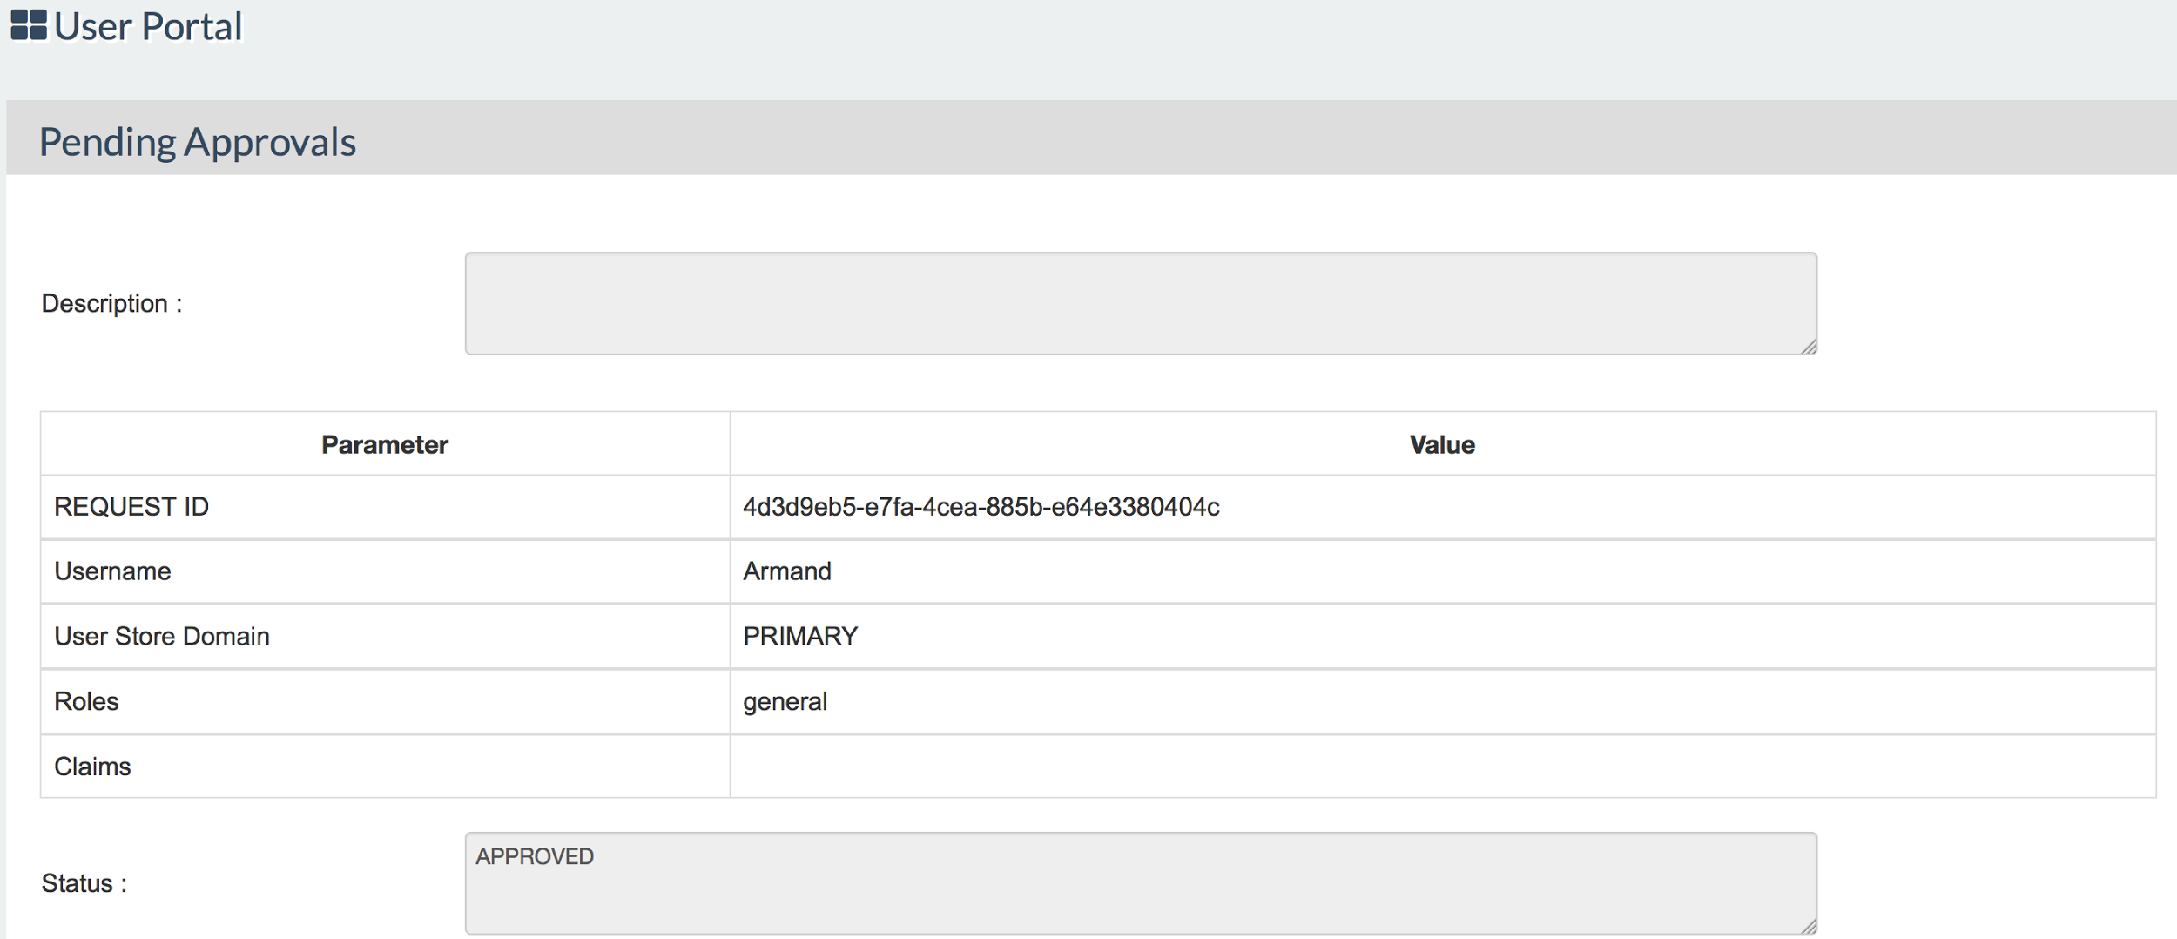

1. As the second step, a user with either head_hr or the general_manager role needs to approve.

# Lab: Single Sign On using the Identity Server for Authentication

Training Objective

Showcase the web single sign on capabilities of WSO2 IS.

Business Scenario

Experia Travels uses Salesforce[1] to address their CRM needs and Freshdesk[2] for customer support. The technical team at Experia Travels would like to enable single sign on using WSO2 IS as the identity provider and for Salesforce and Freshdesk as service providers, simplifying the login mechanism for Experia Travels workforce.

[1] <http://www.salesforce.com/>

[2] <https://freshdesk.com/>

High Level Steps

* Enable SSO for Freshdesk
* Enable SSO for Salesforce

Detailed Instructions

Enable SSO for Freshdesk

In order to enable SSO for Freshdesk, the Freshdesk instance needs to be updated for SSO via WSO2 IS while Freshdesk needs to be registered as a service provider for the IS.

**Configuring Freshdesk**

1. Create a Freshdesk account.
2. Use the user (who should be an admin user) created to log into Freshdesk.
3. View the **Profile Settings** page

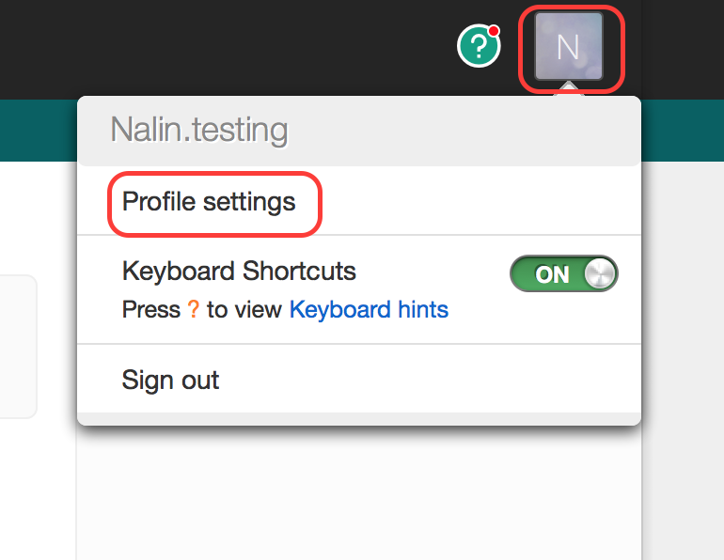

1. View the **Admin** tab.
2. Under the **General Settings**, select the **Security** option.

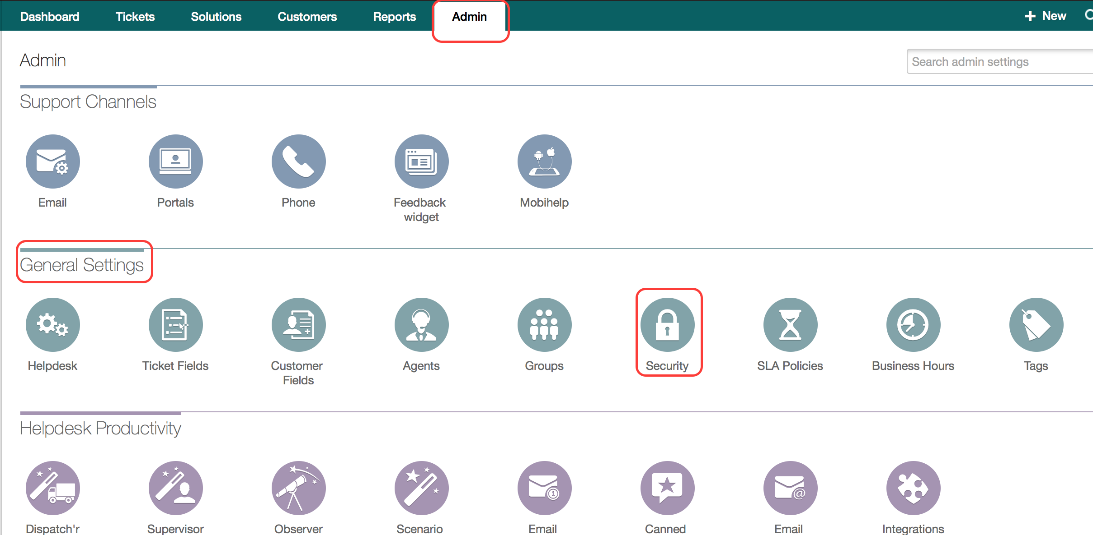

1. Enable SSO and provide the information requested.

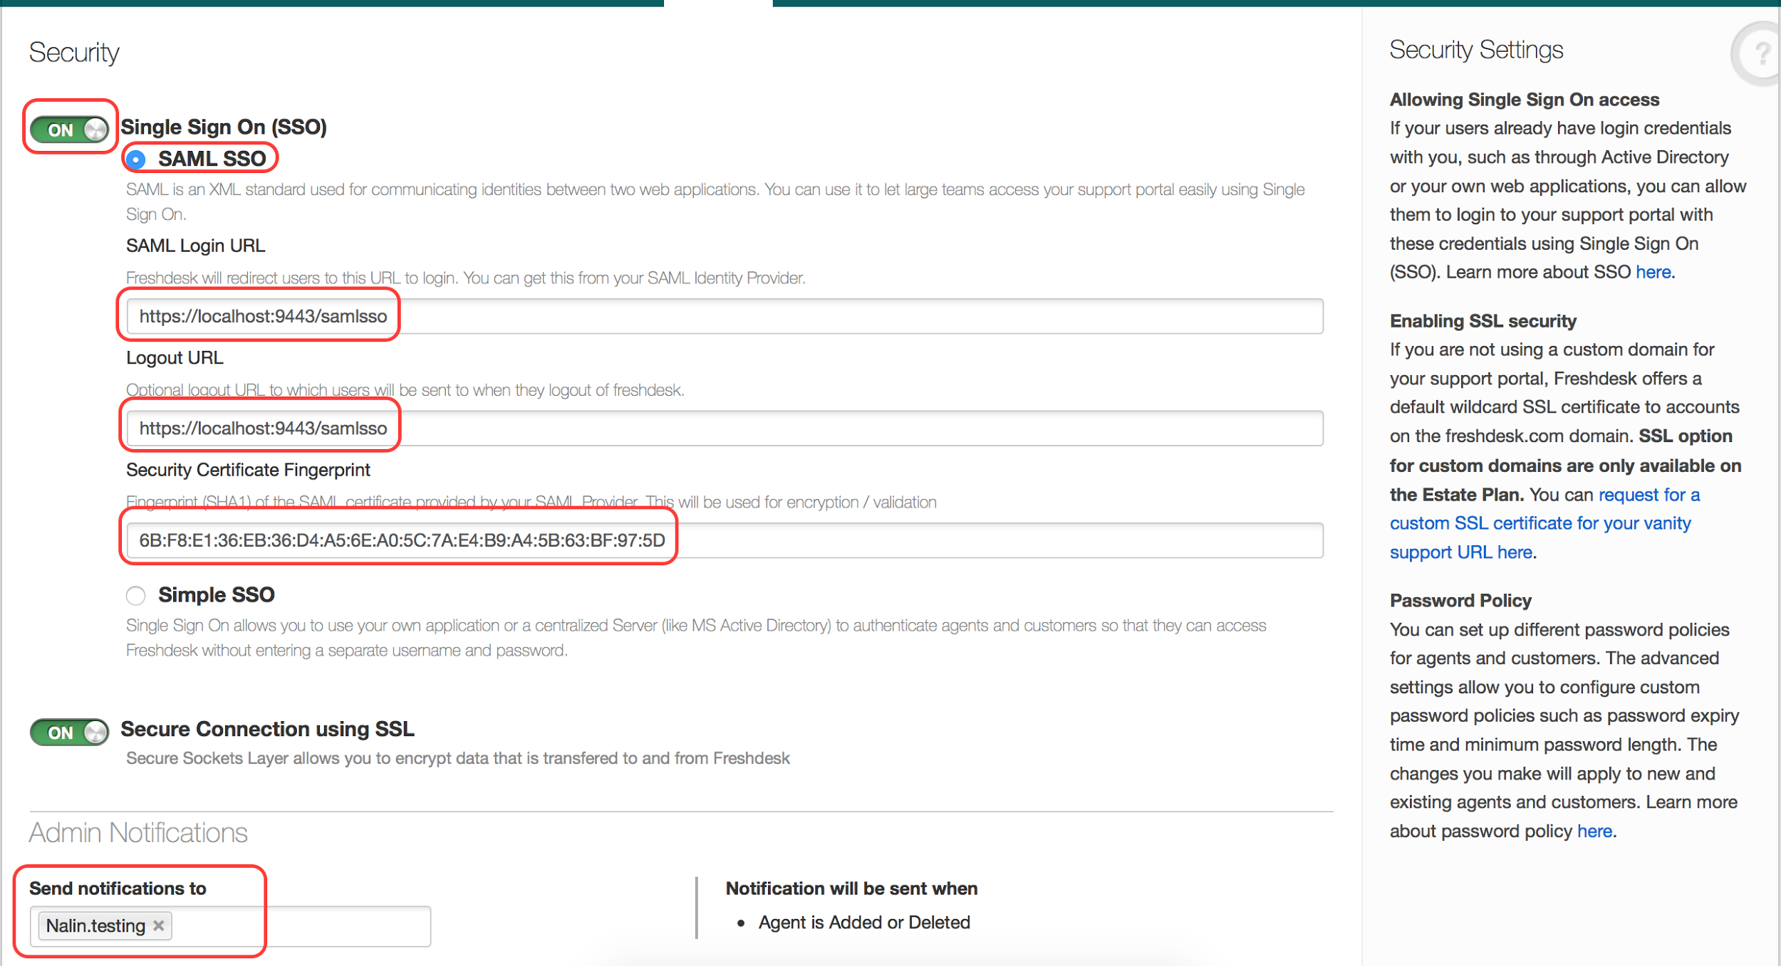

*SAML Login URL*: The value is https://<server>:<port>/samlsso where <server> is the server hosting the IS and the <port> is the port on which the ISis listening.

*SAML Logout URL*: The URL to be notified when the user logs out. For the IS, this is the same as the login URL

*Security Certificate Fingerprint*: Use the command to find the SHA1 security fingerprint. Here the keystore used is wso2carbon.jks with the password wso2carbon found inside <IS_HOME>/repository/resources/security.

*Send notifications to*: can be set to the admin user, i.e., the main user created.

1. Save the setting and all subsequent authentication will be done by the IS.

**Configuring WSO2 IS**

1. Add a service provider.

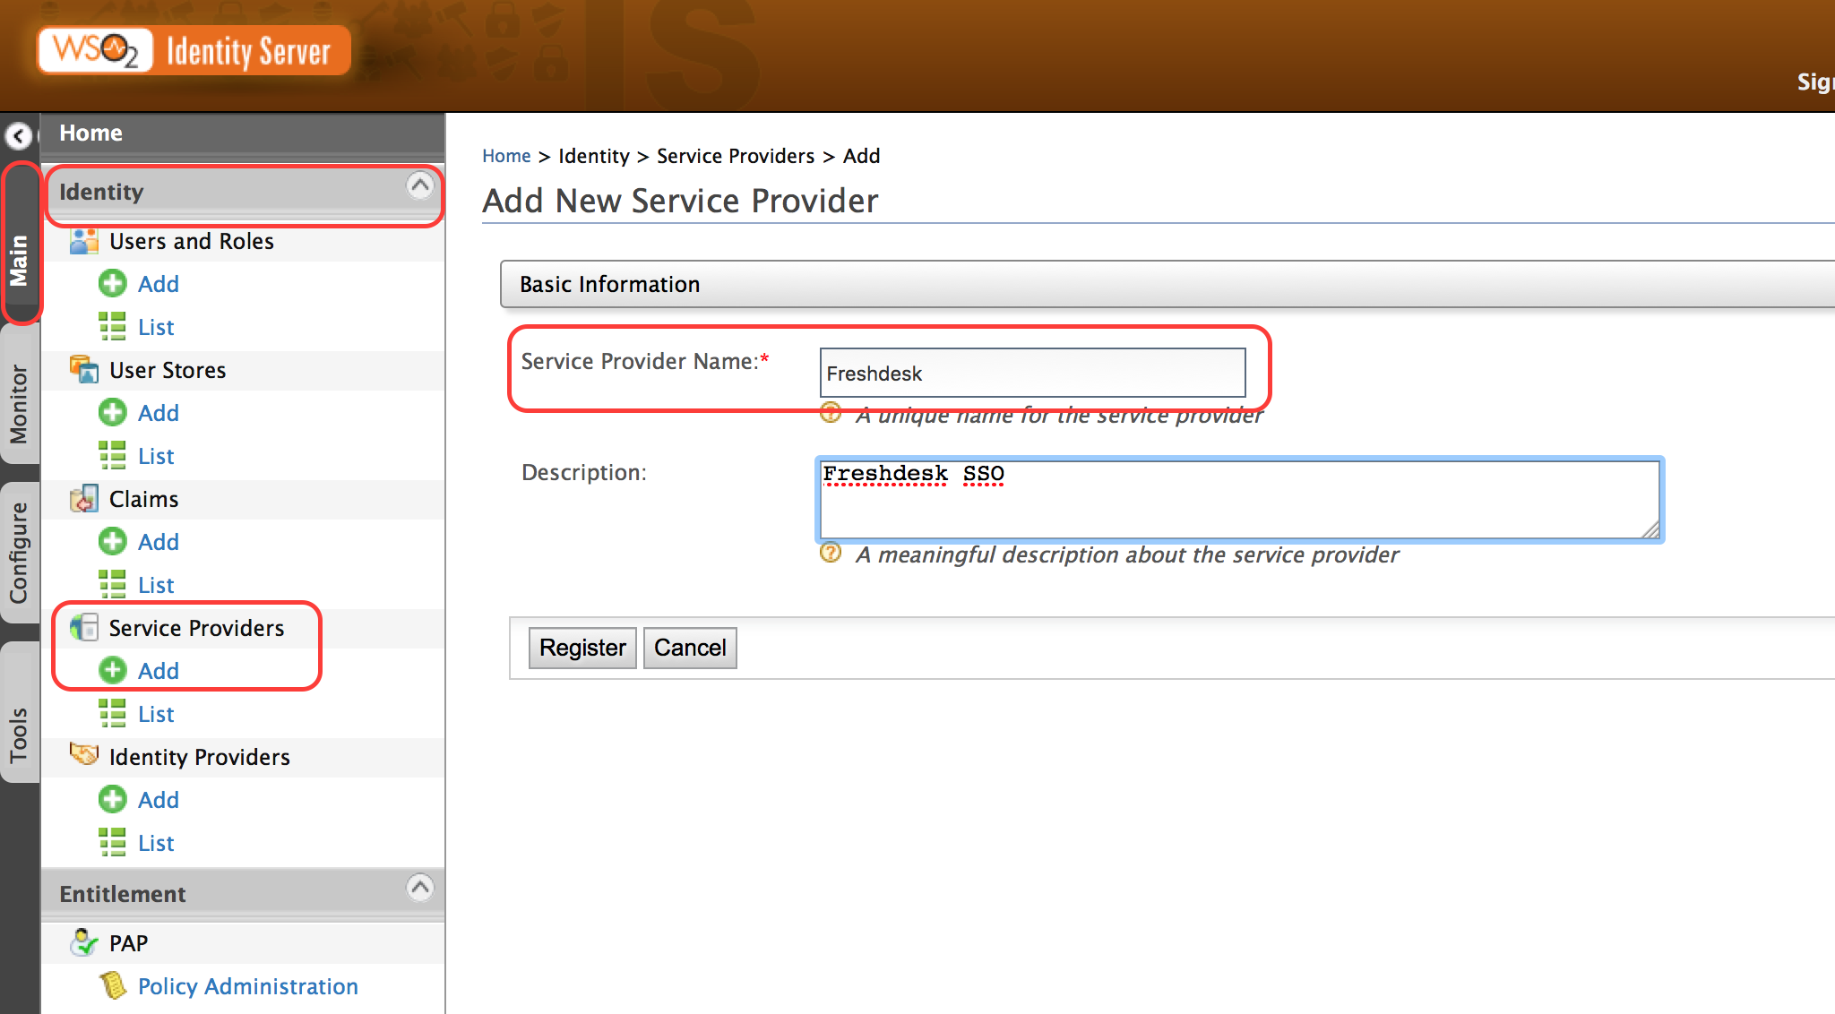

1. Click **Register** and under **Claim Configuration** set the **Subject Claim URI** to <http://wso2.org/claims/emailaddress>.

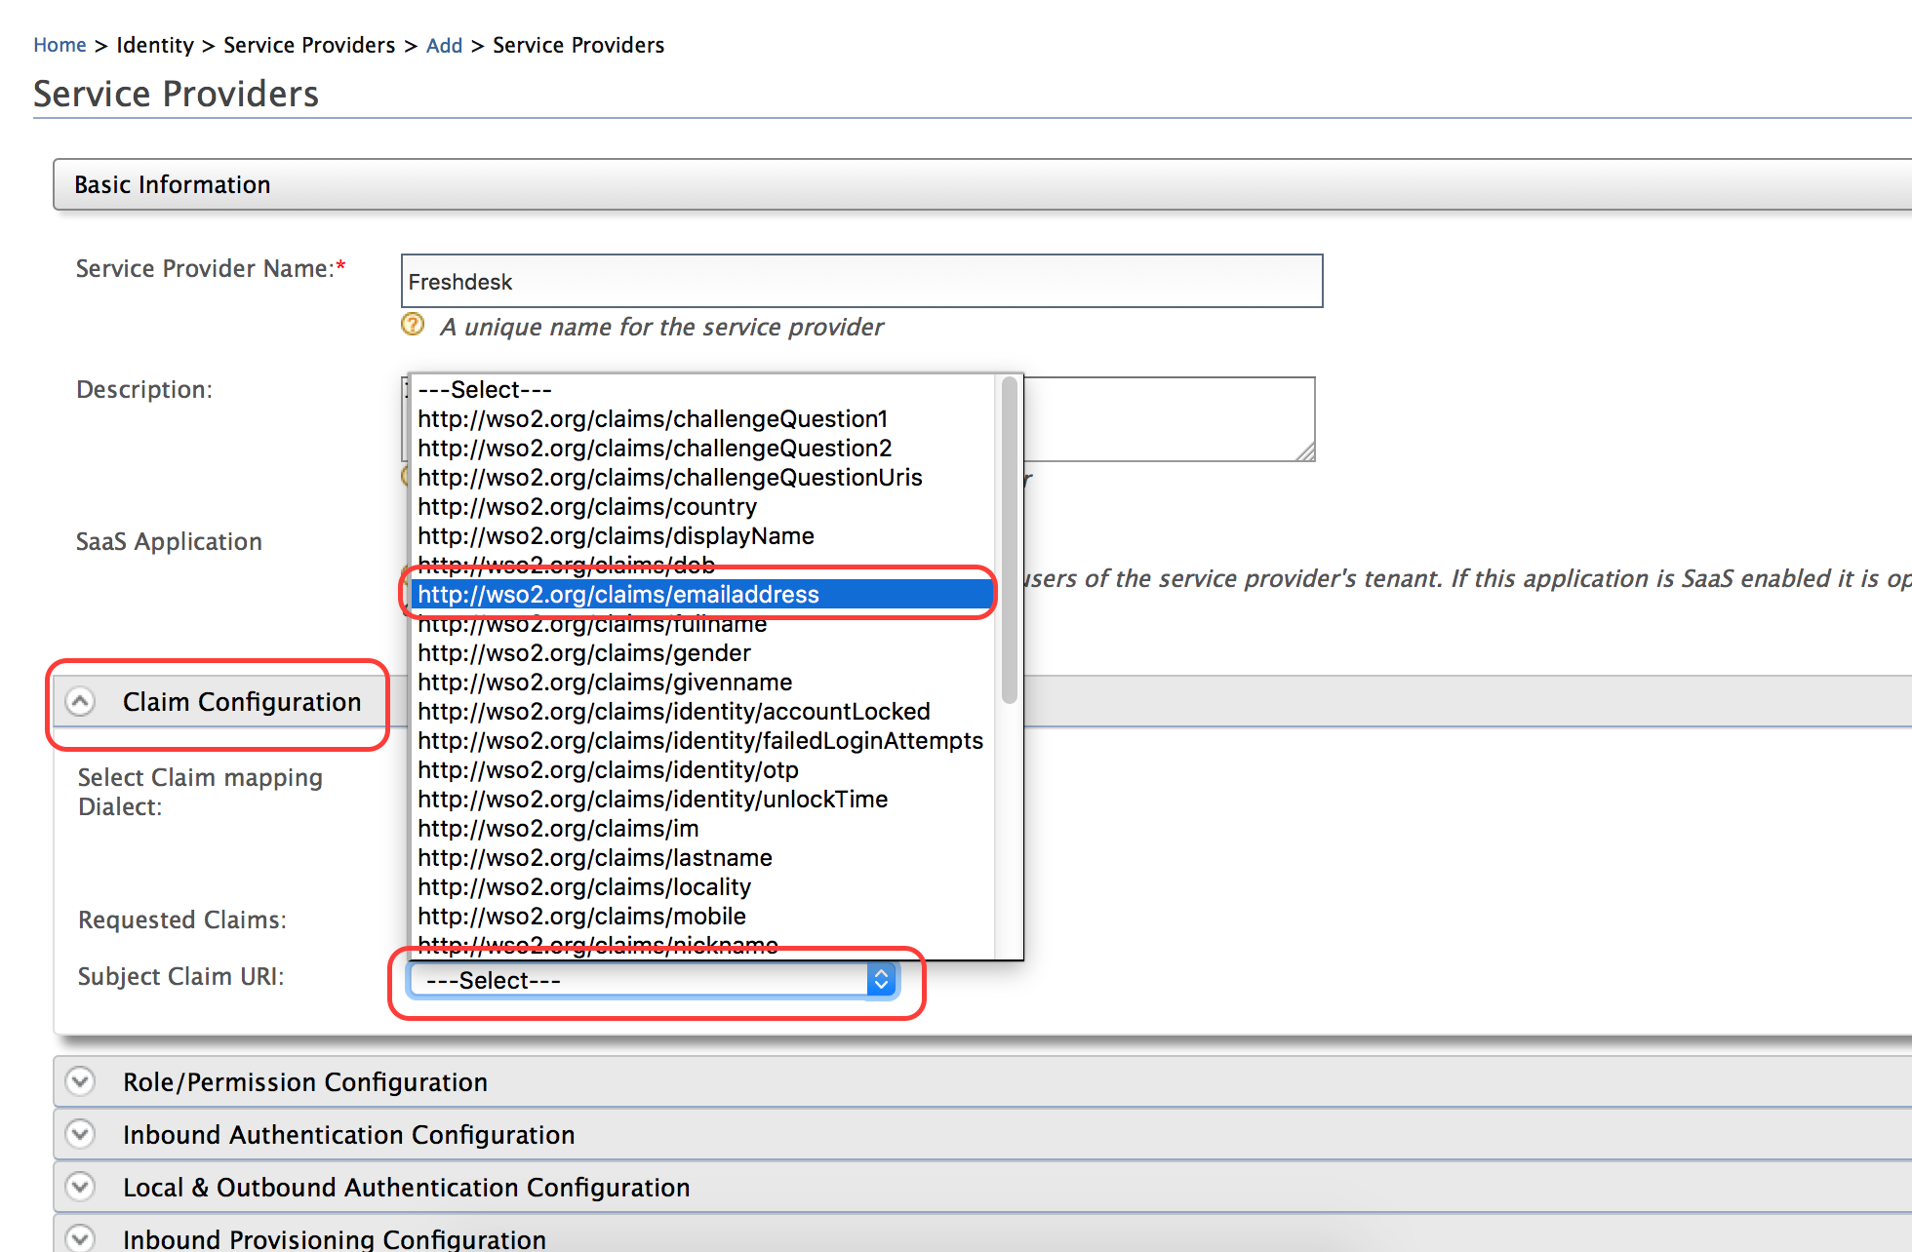

This allows a user with a username that is not an email address but with a valid email address as an attribute to be authenticated by the IS and used to log into Freshdesk. Freshdesk users are identified by the email address.

1. Select the **Configure** option listed under **SAML2 Web SSO Configuration** within **Inbound Authentication Configuration**.

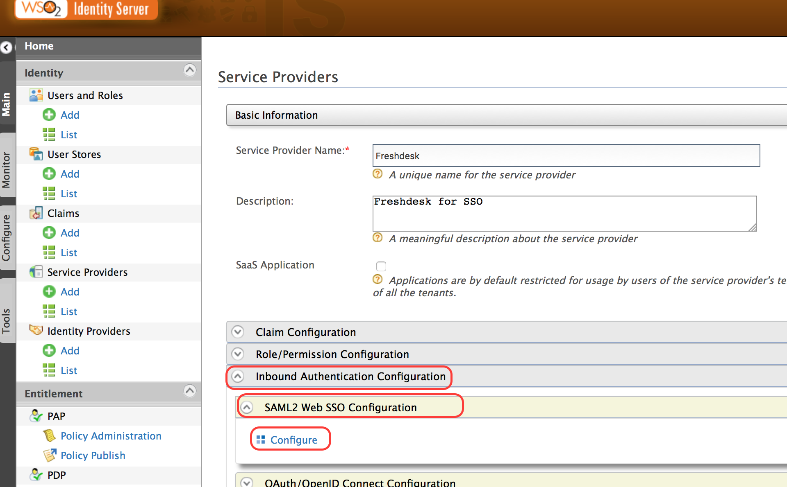

1. Configure with the following values:

*Issuer*: The link to the request issuer. In the current context, it should be https://<your domain>.freshdesk.com

*Assertion Consumer URL*: The URL to which the user is redirected after authentication https://<your domain>.freshdesk.com/login/saml

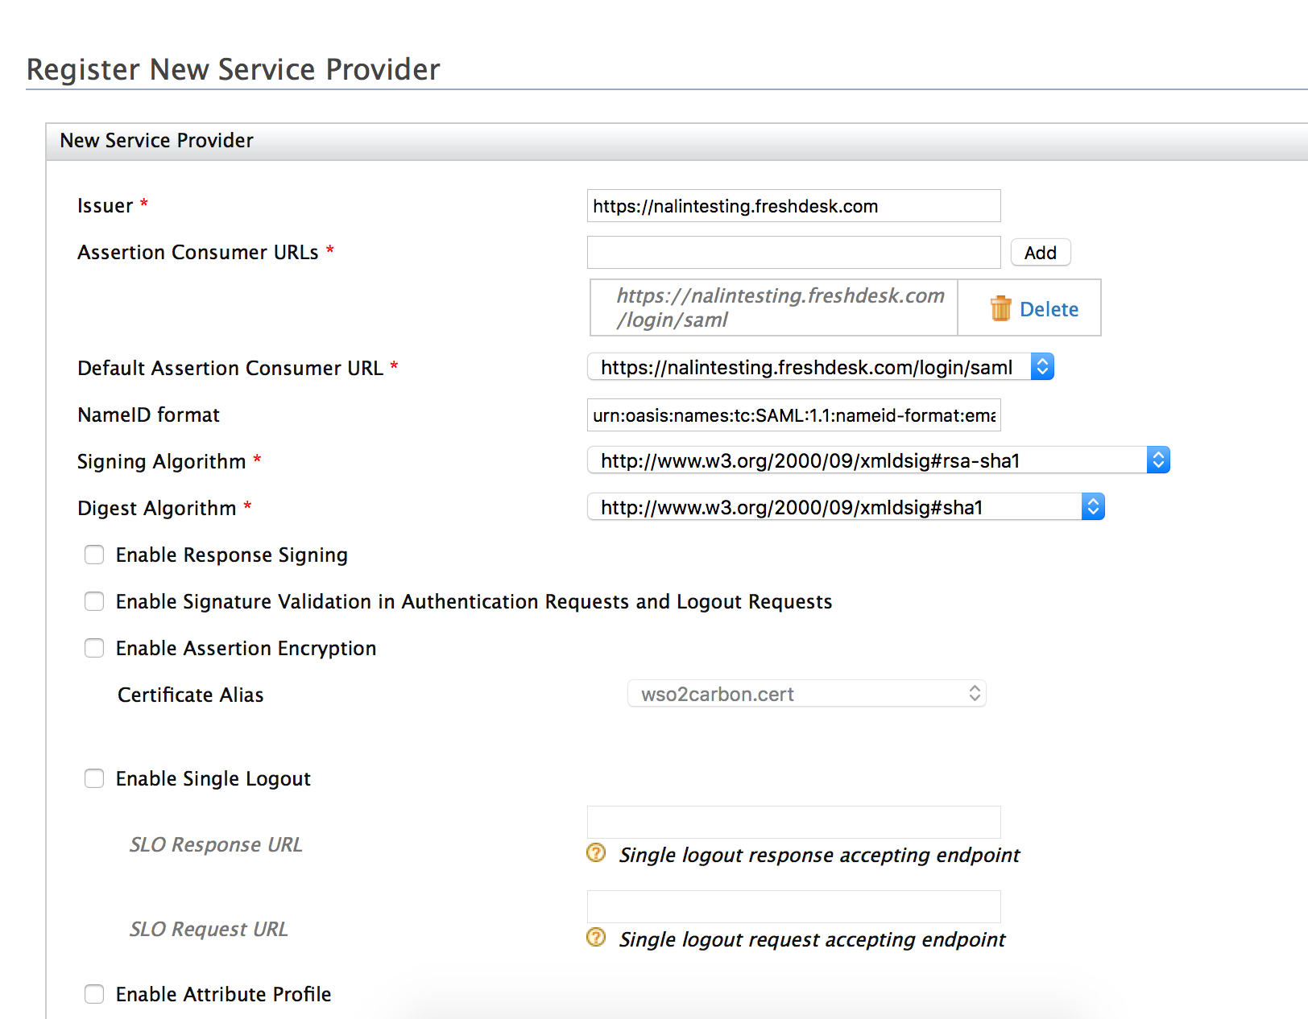

1. Apply the changes.

Enable SSO for Salesforce

**Configuring Salesforce**

1. Create an account in<http://developer.force.com/> using the same email address as used in creating an account for Freshdesk.
2. Go to force.com and log in to the account created above.
3. Go to **Home** > **Domain Management** > **My Domain** and create a domain (Eg:<https://yohanna­dev­ed.my.salesforce.com>)

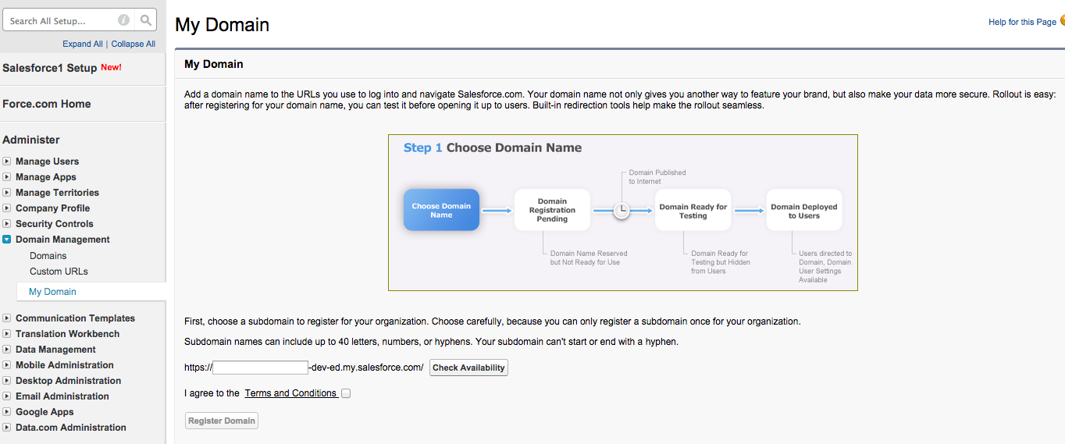

SalesForce takes some time to register the domain.

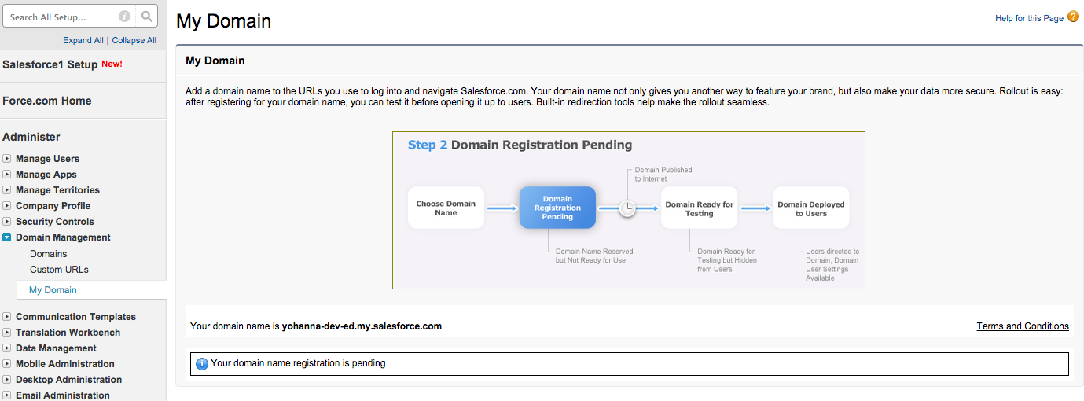

1. Click **Click here to log in**.
2. Go to **Home > Security Controls > Single Sign­On Settings** and click **Edit** and then select the check box and save to enable SAML SSO.

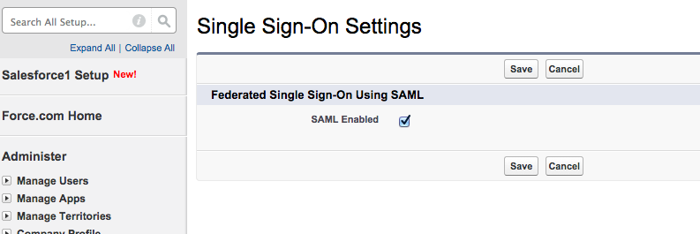

1. Click **New** under **SAML Single Sign-On Settings**. Configure the rest of the properties as given below.  
   To create the Identity Provider Certificate, open a Command Line Interface, traverse to the folder <IS_HOME>/repository/resources/security/ and execute the command given below.

Keytool -export -alias wso2carbon -file wso2.crt -keystore wso2carbon.jks -storepass wso2carbon

|  |  |
| --- | --- |
| **Field** | **Value** |
| Name | **SSO** |
| API Name | **SSO** |
| Issuer | **localhost** |
| Entity Id | https://saml.salesforce.com |
| Identity Provider Certificate | Select the wso2.crt certificate from the folder [IS_HOME]/repository/resources/security/. |
| Request Signing Certificate | Default Certificate |
| Request Signature Method | **RSA_SHA1** |
| Assertion Decryption Certificate | Assertion not encrypted |
| SAML Identity Type | Assertion contains User's salesforce.com username |
| SAML Identity Location | Identity is in the NameIdentifier element of the Subject statement |
| Identity Provider Login URL | **https://localhost:9443/samlsso** |
| Identity Provider Logout URL | **https://localhost:9443/samlsso** |
| Custom Error URL |  |
| Service Provider Initiated Request Binding | HTTP POST |
| User Provisioning Enabled | Not Selected |

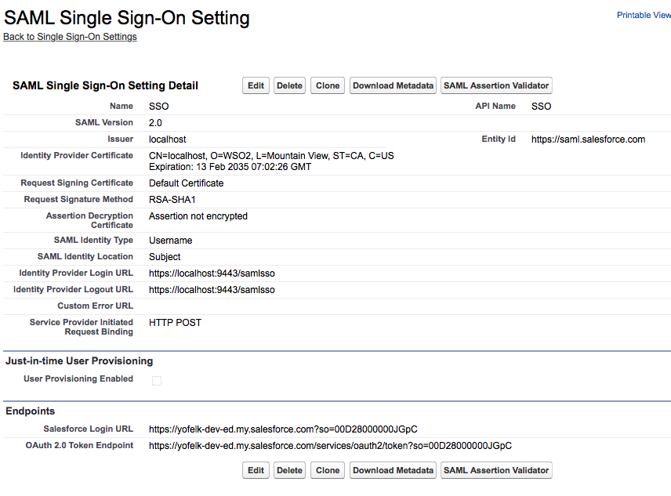

1. Go to **Home > Domain Management > My Domain**.
2. Click **Login** and then click **Deploy to Users**.
3. Click **Edit** in the **Authentication Configuration** section.
4. Select **SSO** and clear **Login Page** and save.

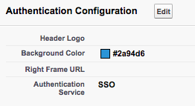

**Configuring WSO2 IS**

1. Start the IS.
2. Log in to the IS.
3. Click **Main > Service Providers > Add**.
4. Enter Salesforce as the service provider name.

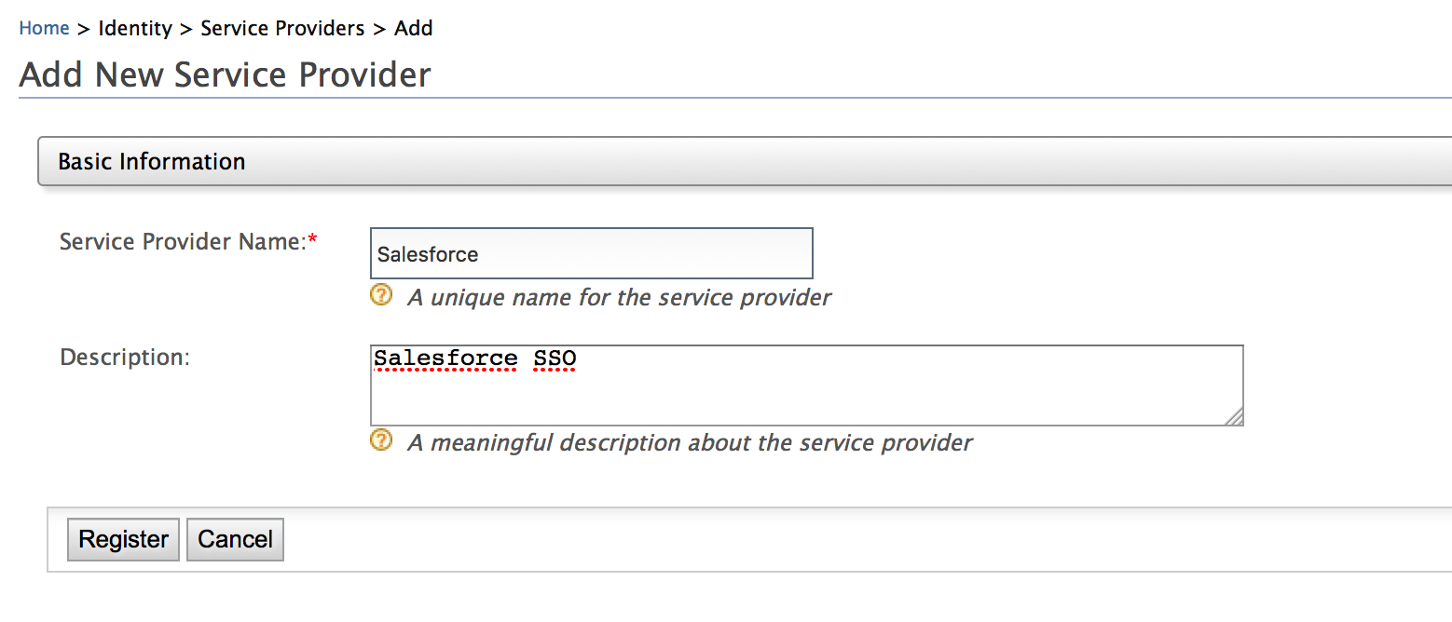

1. Click **Register**.
2. Under **Claim Configuration** set the **Subject Claim** to http://wso2.org/claims/emailaddress

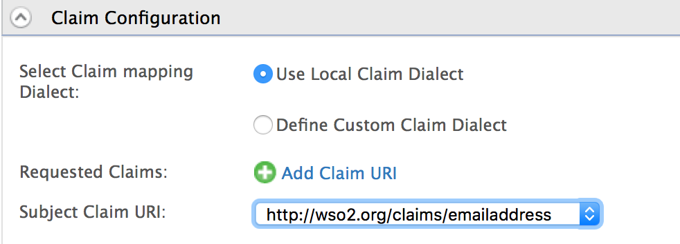

1. Under **Inbound Authentication Configuration > SAML2 Web SSO Configuration**, click **Configure** in order to configure single sign on.

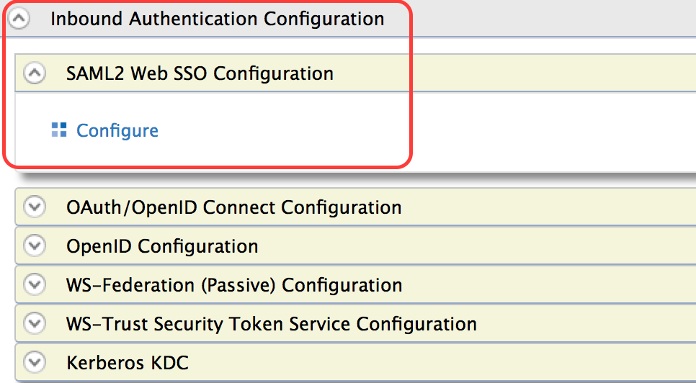

1. Use the following when filling out the above form.

*Issuer*: https://saml.salesforce.com

*Assertion Consumer URL*: Use the Salesforce Login URL (in **Home > Security Controls > SAML Single Sign­On Settings**).

Eg: https://nalin-dev-ed.my.salesforce.com?so=00D28000000IuS7

Select the checkboxes for **Enable Response Signing**, **Enable Assertion Encryption** and **Enable Attribute Profile** with its sub-option of including the **Include Attributes in the Response Always** as shown below.

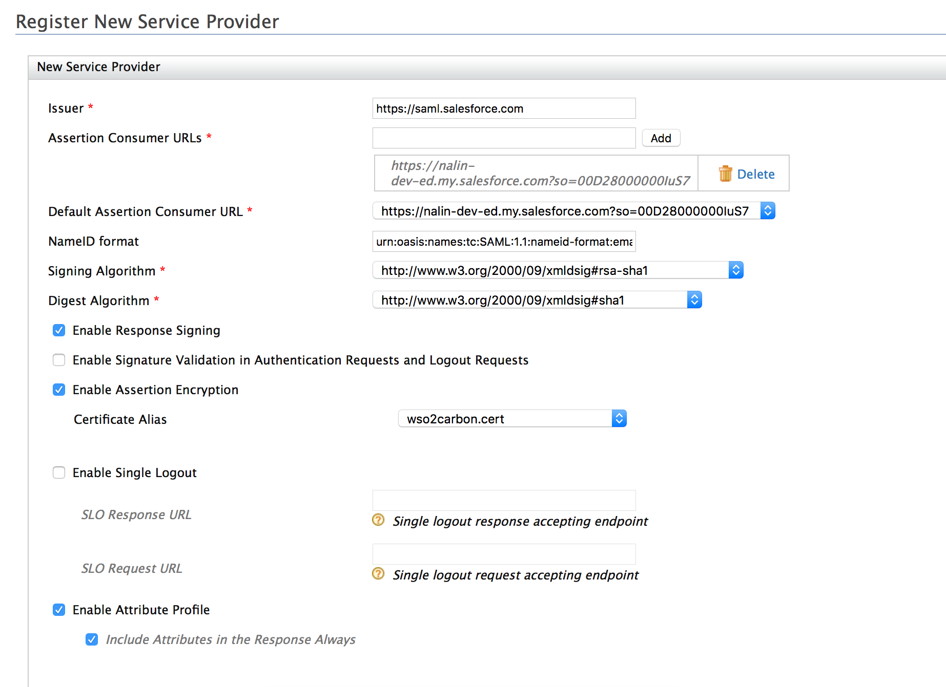

1. Click **Register**.

Expected Outcome

It is now possible to use WSO2 IS to authenticate the user for both Freshdesk and Salesforce.

1. Create a user in WSO2 IS.
2. Set the email attribute’s value to the email address used to create the accounts for both Freshdesk and Salesforce.
3. When trying to access the Salesforce domain (i.e., https://<domain_name>.my.salesforce.com?so=<salesforce_id>) or the Freshdesk domain (i.e. https://<domain_name>.freshdesk.com/login) authentication will take place via WSO2 IS.
4. If the user is already logged in to either Salesforce or Freshdesk, the user is automatically logged into the other account when trying to access the account

Note: This is the single sign on concept in action.

# Lab: Federated Authentication for a Service using Social Media Integration

Training Objective

Federate authentication to Google.

Business Scenario

Experia Travels’ technical team wishes to allow their users to be authenticated via Google if they wish when attempting to access Salesforce.

High Level Steps

* Configuring a Google Project
* Register the Google Project as an identity provider in WSO2 IS
* Reconfigure Freshdesk to use federated authentication
* Reconfigure Salesforce service provider to use either federated authentication or local authentication

Detailed Instructions

In order to allow federation, the IS needs access to an identity provider. When using Google as the identity provider, it is necessary to create a project within Google’s Developer Console that can act as an endpoint to the identity server to federate authentication.

Configure a Google Project

In order to configure a Google project, a Google Developer account is needed. The simplest way to gain an account is to:

1. Create a Google account.
2. Browse to the Google Developer Console https://console.developers.google.com/start and sign in using the Google account created in step 1.
3. Use this account as is.

To create a new Google Project:

1. Browse to the Developer Console.

https://console.developers.google.com/start.

1. Select the option to create a new project.

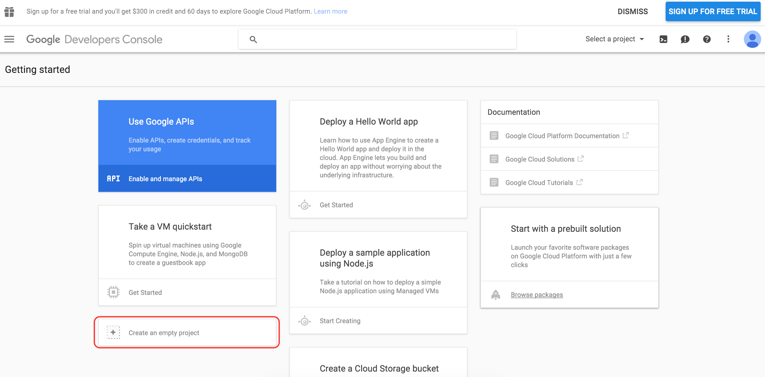

1. Enter a name for the project and click **Create**.

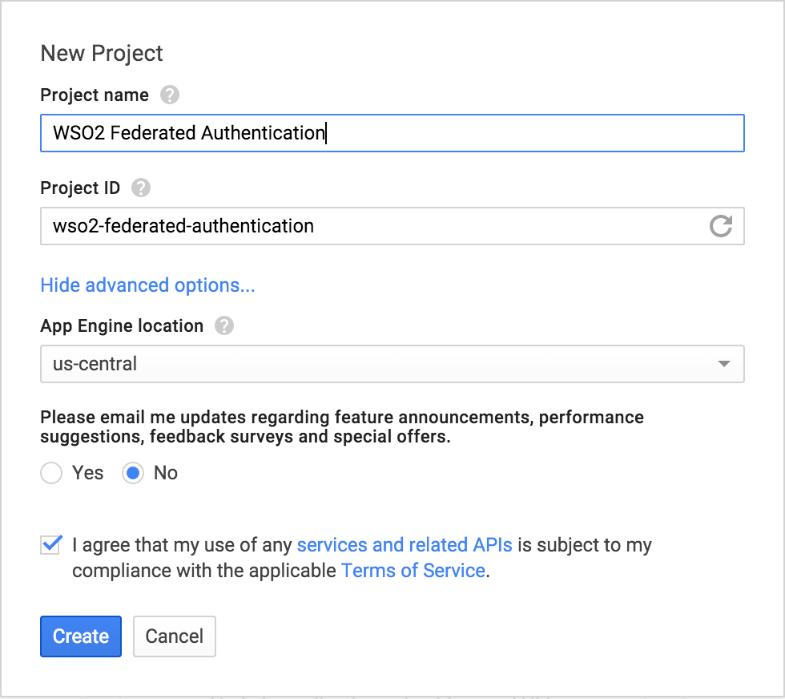

1. In order to add credentials navigate to the **API Manager**>**Credentials** section.

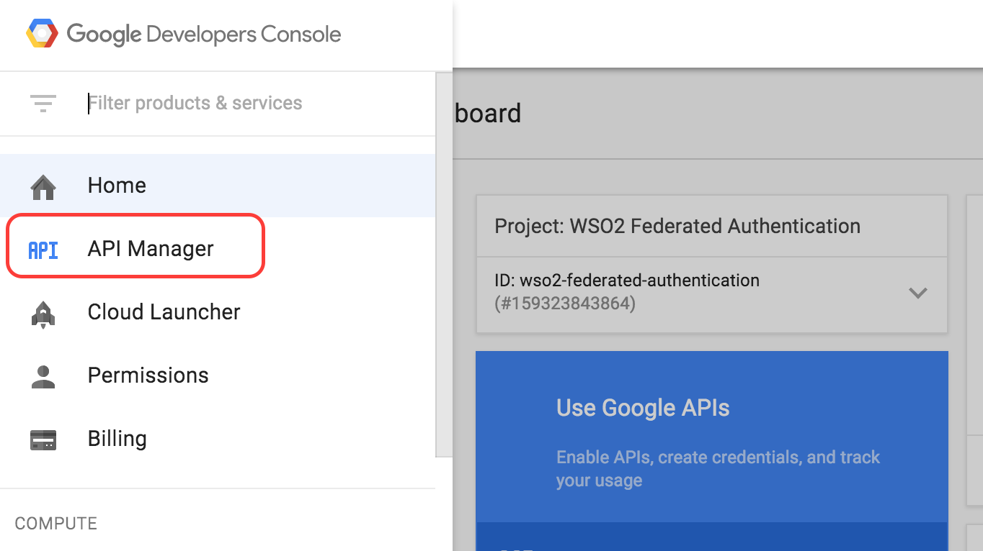

We will configure OAuth 2.0 to utilize Google’s OpenID connect authentication mechanism. In order to use OAuth, OAuth consent needs to be configured.

1. Browse to **Credentials** > **OAuth consent screen**.

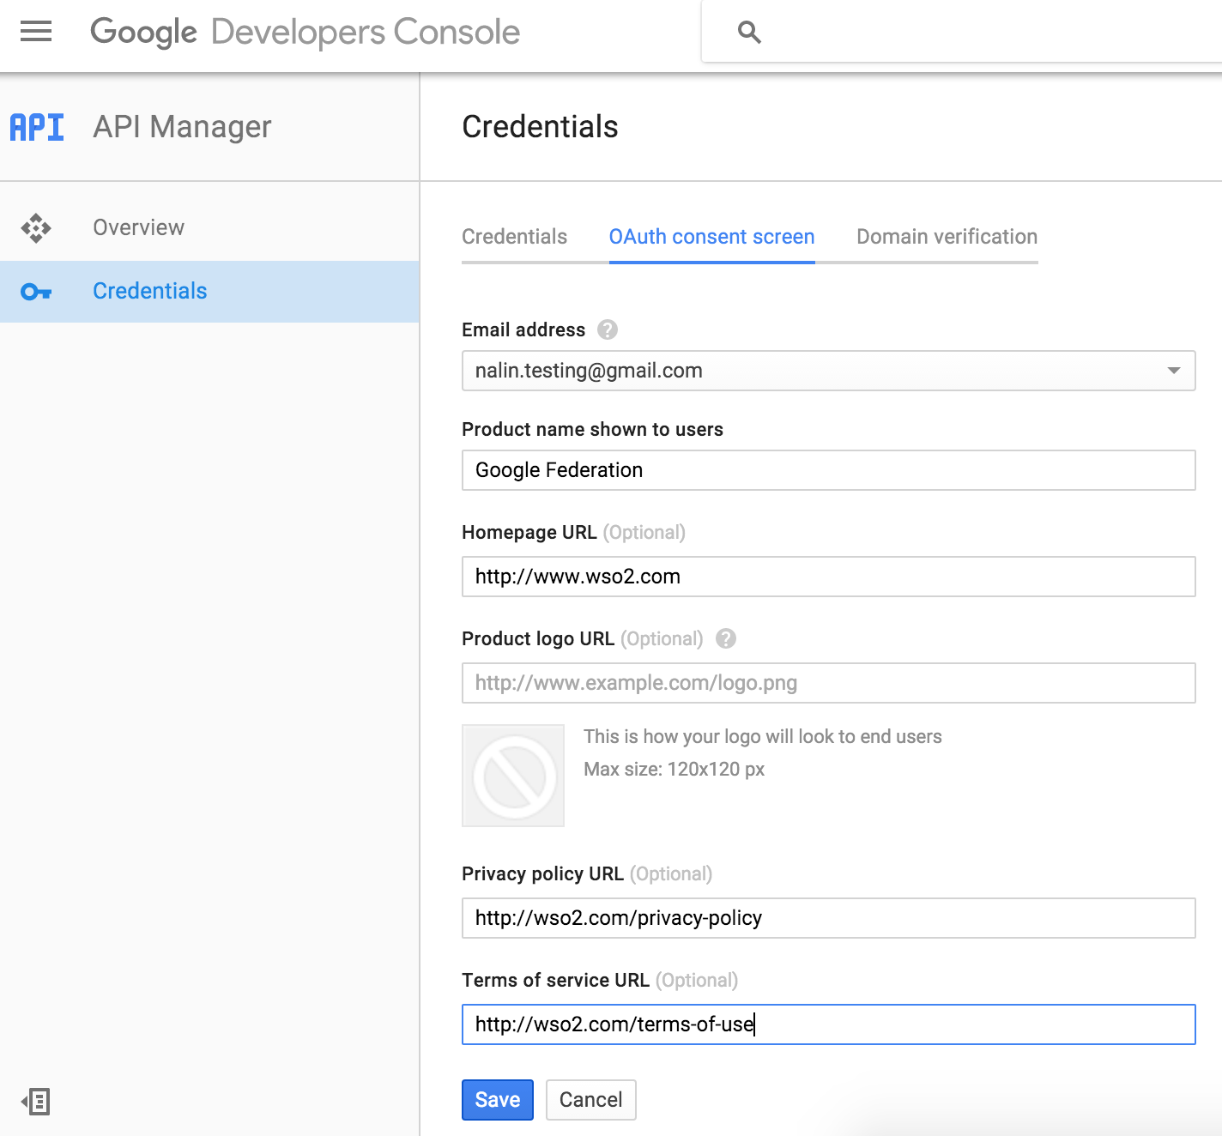

1. Once saved, create the client ID for web applications.

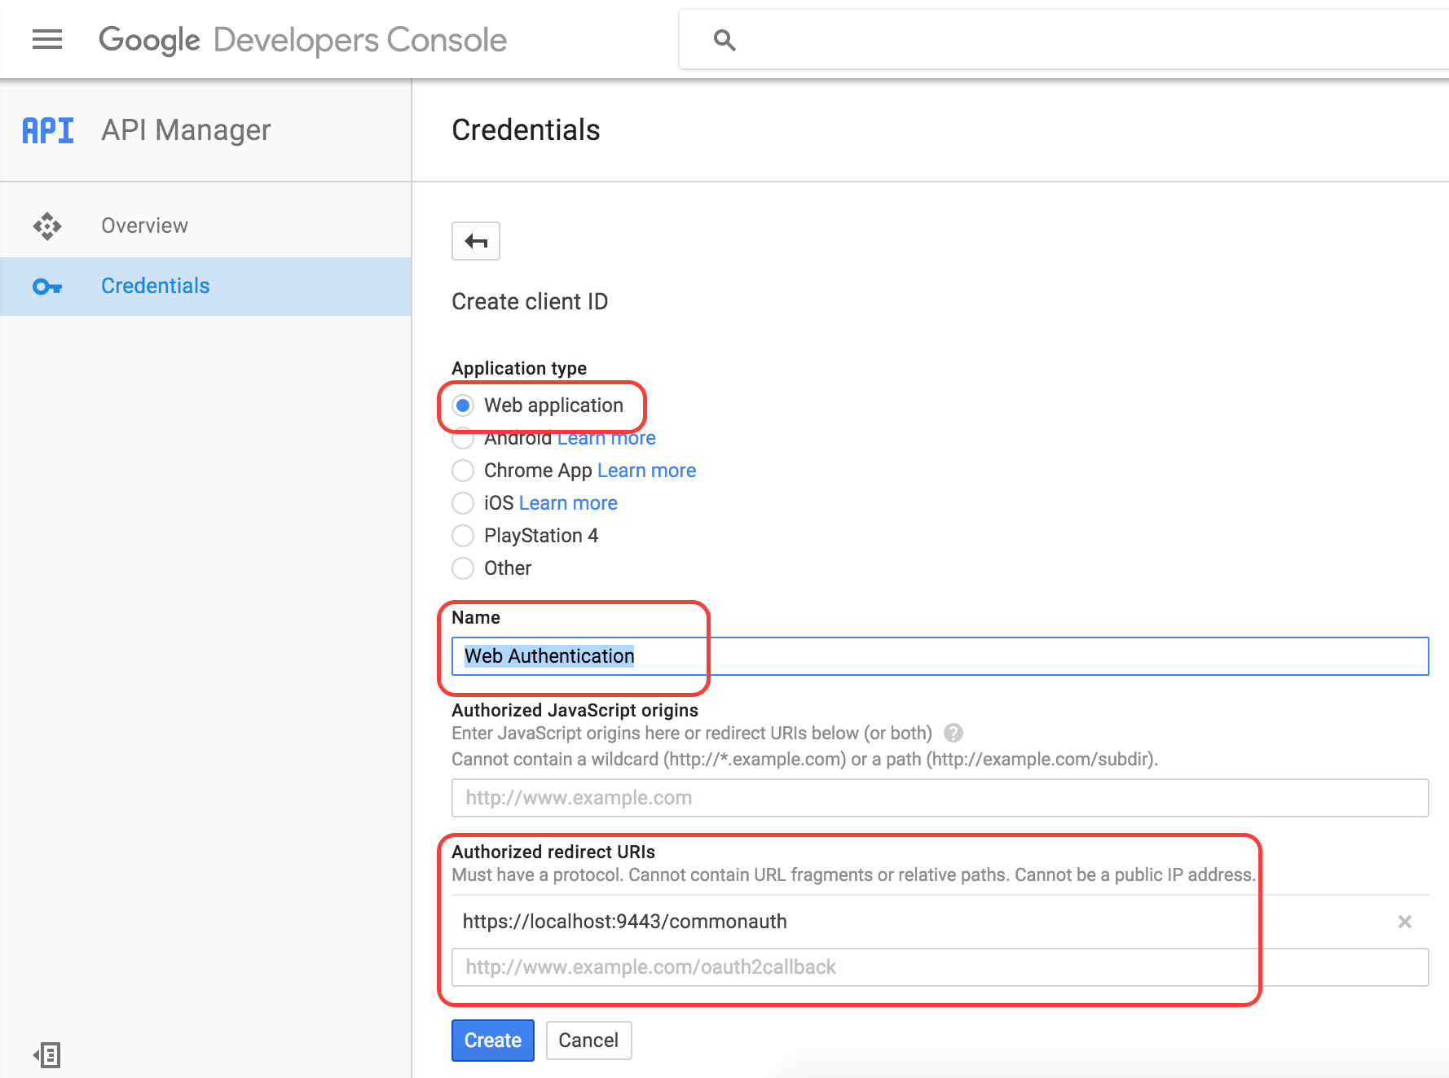

1. To configure OAuth browse to **Credentials**>**Credentials**>**Add credentials**>**OAuth 2.0 client ID**.



The **Authorized redirect URL** should point to https://localhost:9443/commonauth

1. The client ID and the secret of the app can be found as shown below.

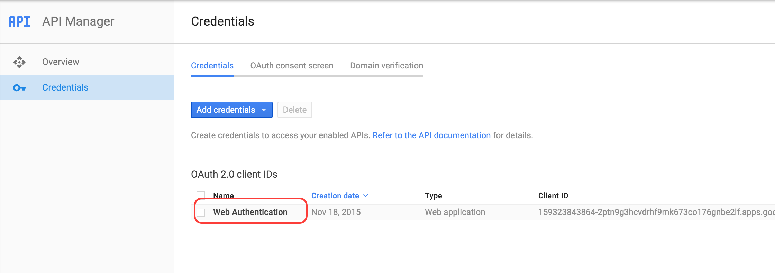

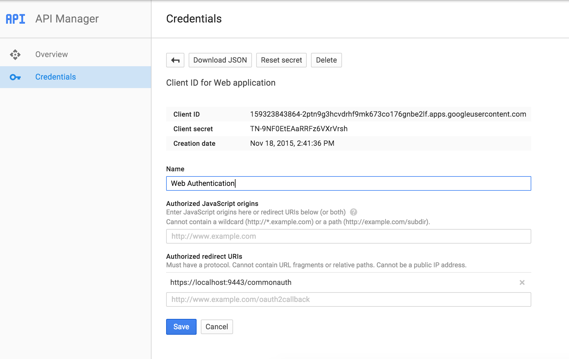

Register the Google Project as an Identity Provider in WSO2 IS

1. Register a new identity provider in the IS by going to **Main** > **Identity** > **Identity Providers** > **Add**.

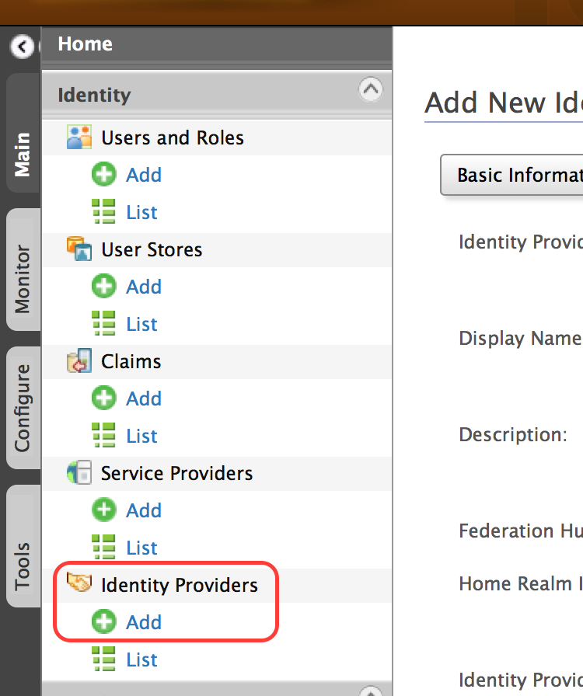

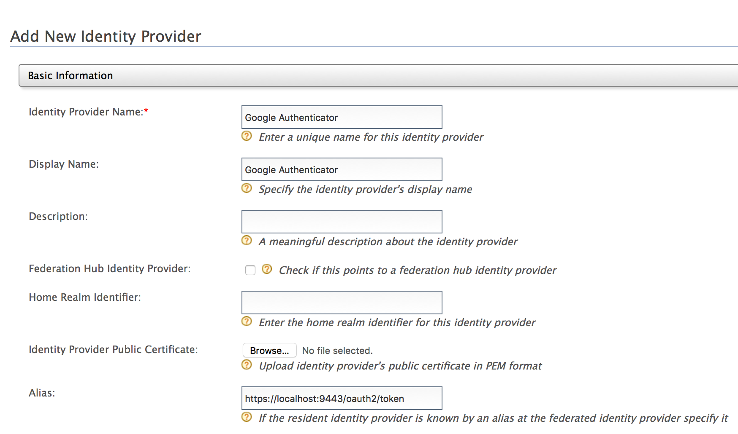

1. Add the email address as the **User ID Claim URI** under **Claim Configuration**>**Basic Claim Configuration**.

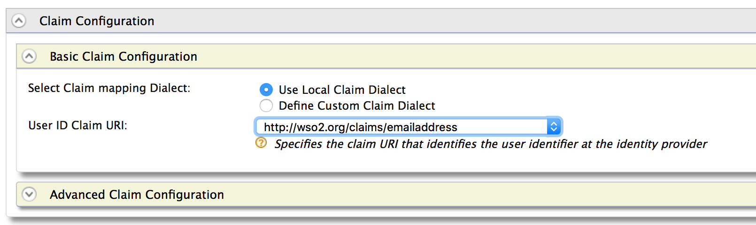

1. For Google, the authentication protocol used is OAuth2/OpenID Connect.
2. Configure **Federated Authenticators** > **OAuth2/OpenID Connect**

Authorization Endpoint URL for Google is

https://accounts.google.com/o/oauth2/auth

Token Endpoint URL for Google is

https://accounts.google.com/o/oauth2/token

The Callback URL to be sent is

https://localhost:9443/commonauth

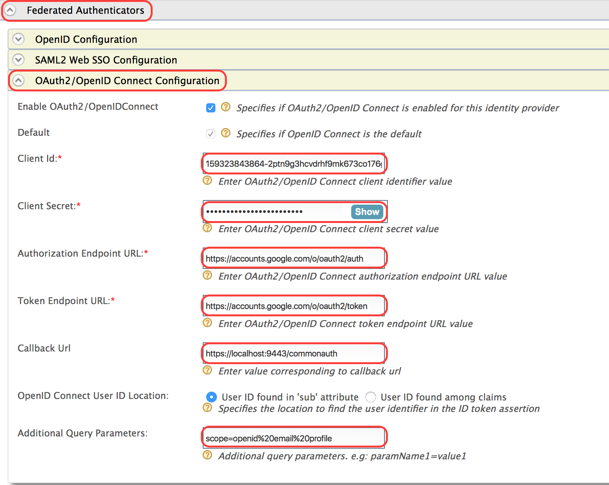

Value for the Additional Query Parameters, needs to be set to “scope=openid%20email%20profile” in order for the request to be OpenID compliant and for the user's email id to be returned.

The client ID and client secret are available in the Google Project.

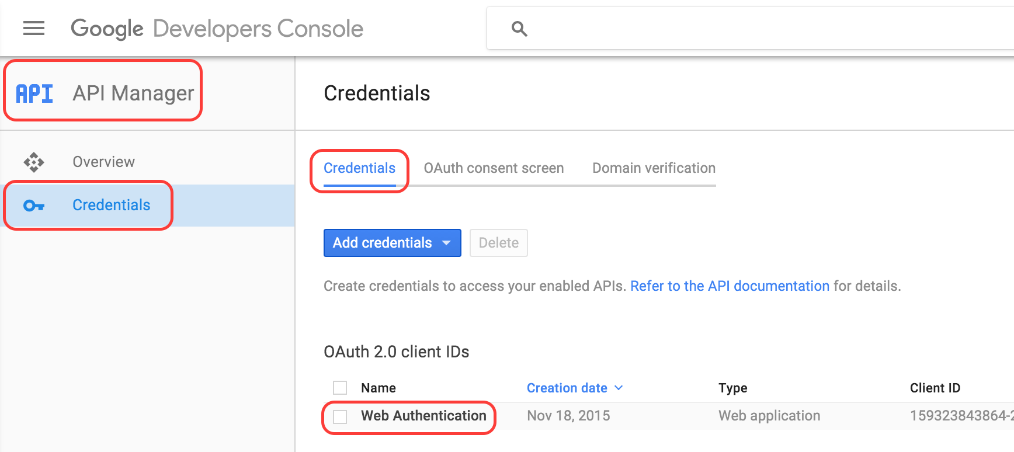

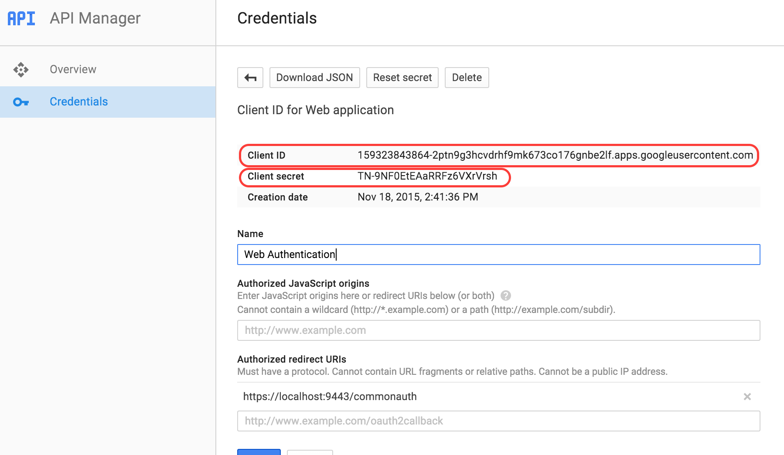

1. Register the provider with the information given.

Reconfigure Freshdesk to use Federated Authentication

In order to offer authentication via a federated option, all modifications needed are configuration changes in IS.

1. Edit the Freshdesk service provider within the IS.
2. Change **Authentication Type** of **Local & Outbound Authentication Configuration** to **Federated Authentication**.

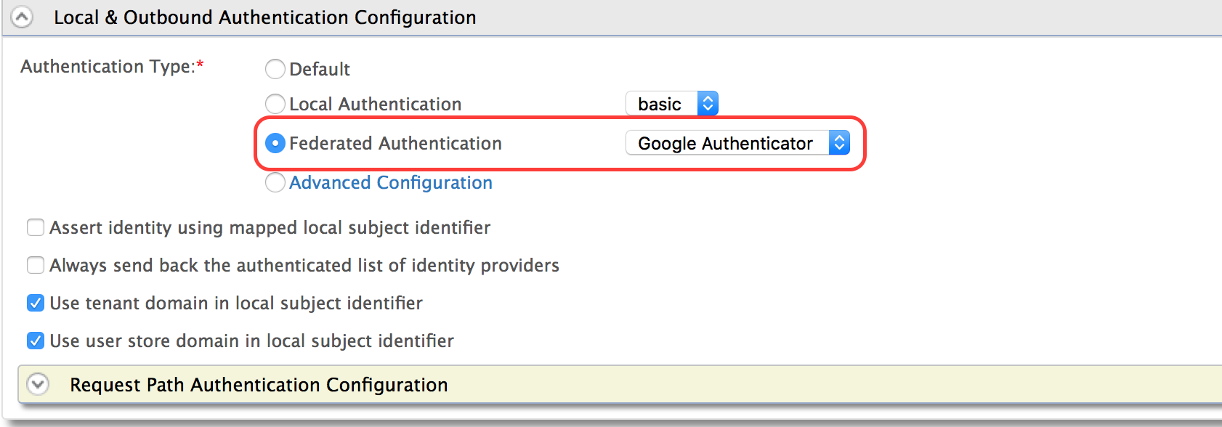

1. Update the settings.

Reconfigure Salesforce Service Provider to use either Federated Authentication or Local Authentication

In order to offer authentication via a federated or local option, all modifications needed are configuration changes in IS.

1. Edit the Salesforce service provider within the IS.
2. Change **Authentication Type** of **Local & Outbound Authentication Configuration** to **Advanced Configuration**.

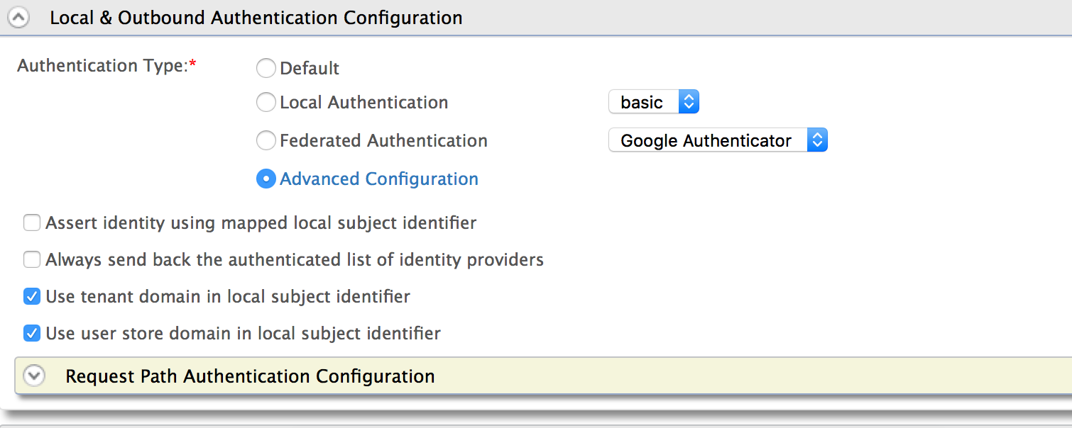

1. Add a single step and add both local and federated authentication options.

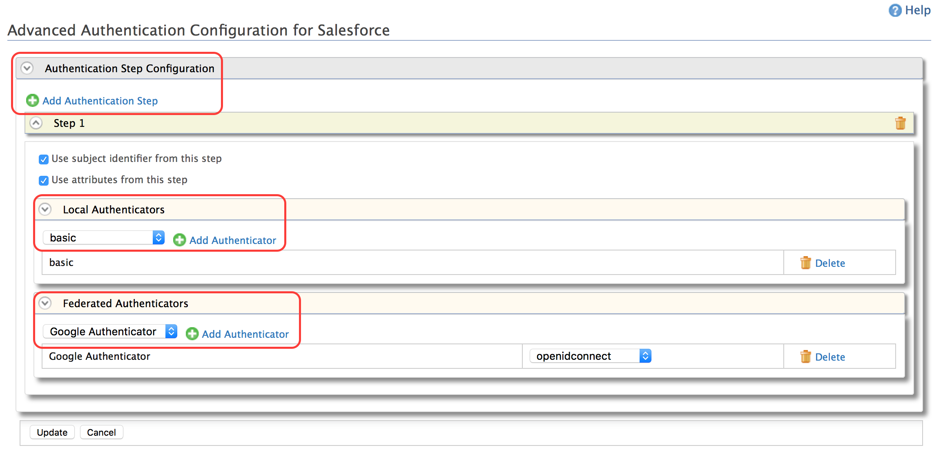

1. Update the settings

Expected Outcome

* Logging into Freshdesk should offer authentication via Google.
* Logging into Salesforce should now offer 2 options of both IS or Google.
* If the user logs into Salesforce using Google authentication, he/she will be automatically logged in when logging into Freshdesk.

# Lab: Inbound Provisioning

Training Objective

Learn how to use inbound provisioning to add users to a user store.

Business Scenario

Experia Travels needs to provision users to their user store using the SCIM endpoints exposed in WSO2 IS server. They will do this using a service that they will write, but wish to test the possibility first.

High Level Steps

* Configure SCIM Inbound Provisioning
* Add user to user store

Detailed Instructions

Configure SCIM Inbound Provisioning

1. Click **Service** **Providers** > **List**-> **Resident Service Provider**

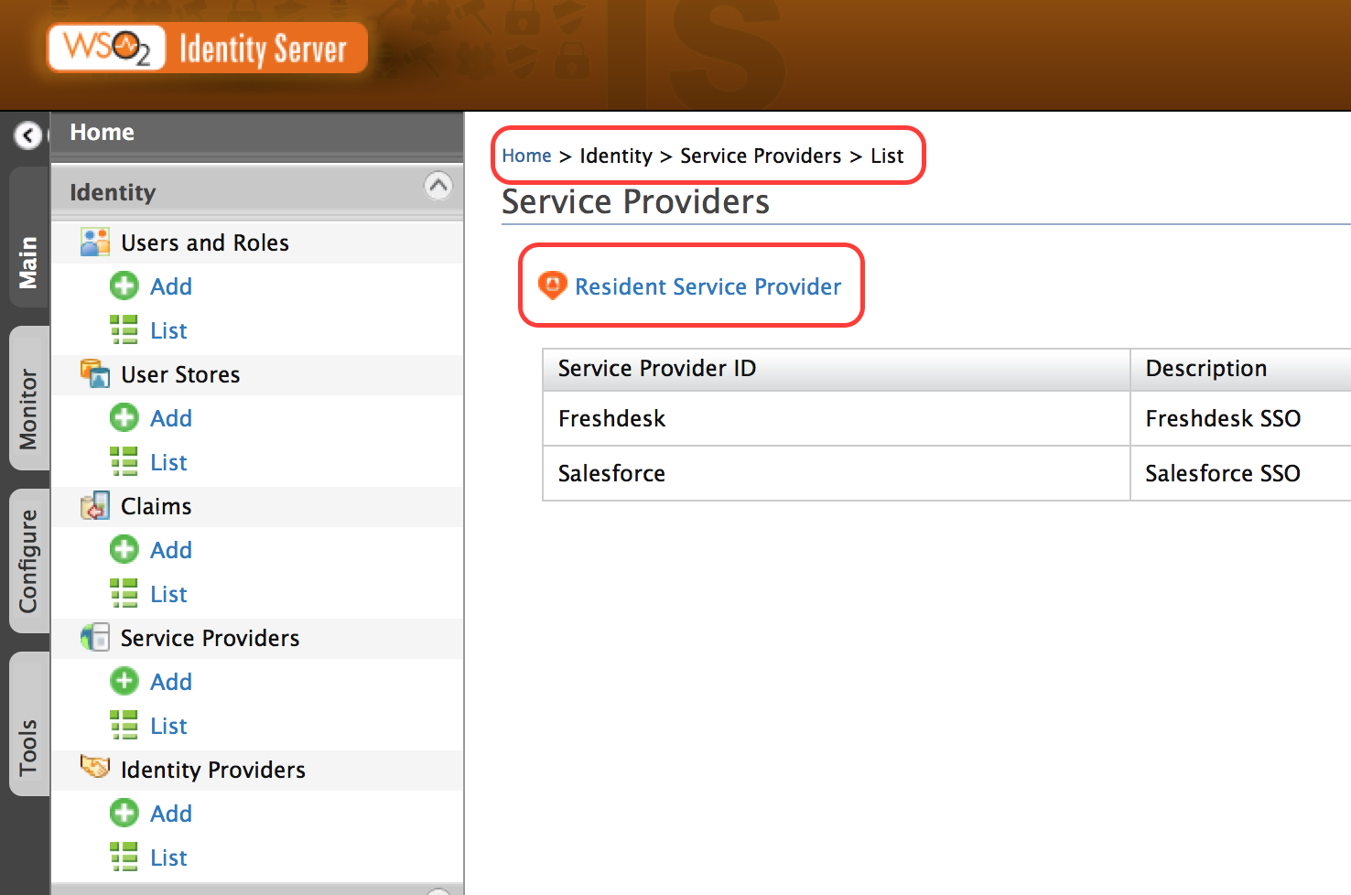

1. Click **Inbound Provisioning Configuration** and select **Experia** under **SCIM/SOAP Configuration**.

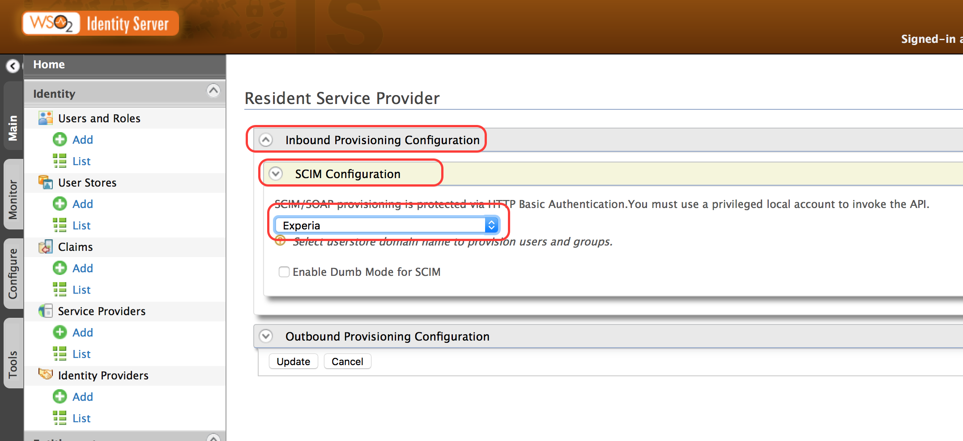

1. Click **Update**.

Add User to User Store

1. Open the Command Line Interface.
2. Use curl command to add user to user store.

curl -v -k --user admin:admin --data "{"schemas":[],"name":{"familyName":"Fernando","givenName":"Yohanna"},"userName":"yohanna","password":"letmein"}" --header "Content-Type:application/json" https://localhost:9443/wso2/scim/Users

Expected Outcome

When running the curl command, the output should look as follows:

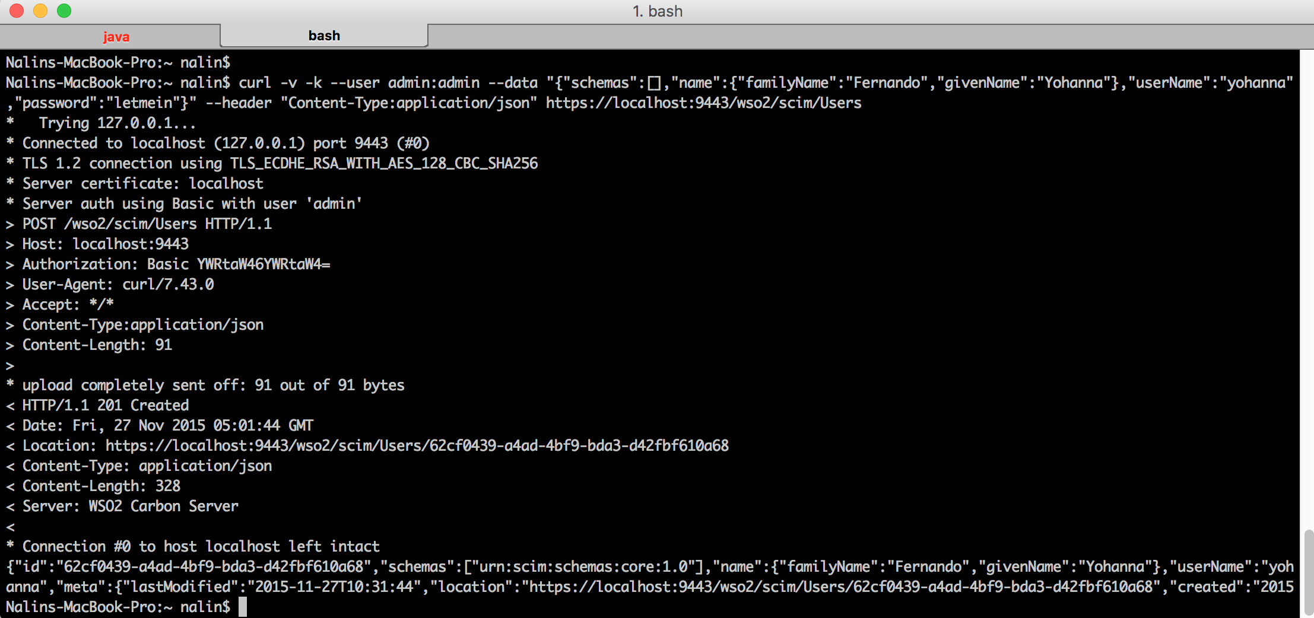

# Lab: Building a XACML Policy through the IS Wizard

Training Objective

Access control is a basic requirement of securing a system and this lab will provide the basic instructions for securing the system using WSO2 Identity Server provisioning of fine-grained access control via XACML version 3.0.

Business Scenario

Experia Travels wishes to create a site with restricted access. Portions of the site should be visible to all users whereas other parts of the site will be restricted based on the user name. For the portion of the site that is visible for authorized access, successful and unsuccessful login attempts should be logged.

High Level Steps

* Building the XACML policy
* Testing the XACML policy
* Update XACML policy
* Add Obligation for Deny Access
* Test Obligation
* Advanced Modifications to XACML Policy
* Test Modifications

Detailed Instructions

Building the XACML Policy

The proof of concept policy to be built will contain 3 areas:

1. Public
2. First Secure Area
3. Second Secure Area

In order to test the POC, we will create 5 users within the Experia user store in the Identity Server with the names: Laurence, Philip, Elizabeth, Frederick and Margaret.

The POC will test the following rules:

* /Entitlement_Lab_WebApp/protected/ - Both Laurence and Philip will be allowed to access the Protected Access Area and all successful attempts to log in will be logged with the user’s email address.
* /Entitlement_Lab_WebApp/secured/ - Only Elizabeth is allowed access to the Secured Access Area and all unsuccessful access is logged with a message.

Follow the instructions below to build a new XACML policy using the **Standard Policy Editor** provided in IS.

1. Log in as admin (admin/secret) to WSO2 Identity Server. Click **Main** > **Entitlement** > **PAP** > **Policy Administration**.

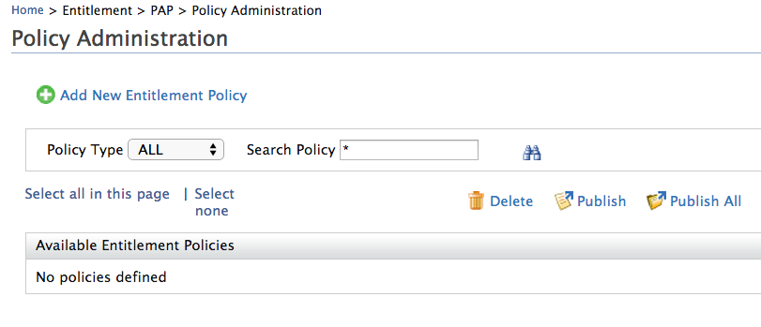

1. Click **Add New Entitlement Policy**.
2. The **Add New Policy**  page appears.

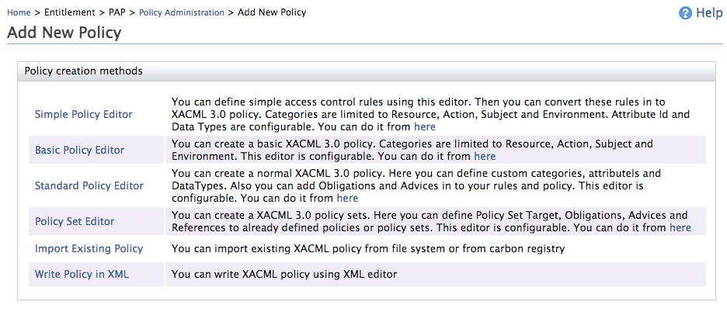

1. Select the **Standard Policy Editor**
2. On the **Create XACML Policy** page, specify the initial condition to be matched.

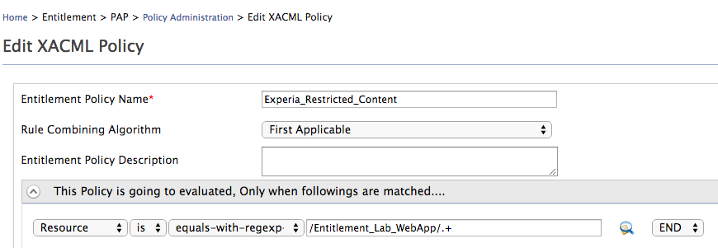

1. Under **Define Entitlement Rule(s)** add two rules to allow access as shown below.

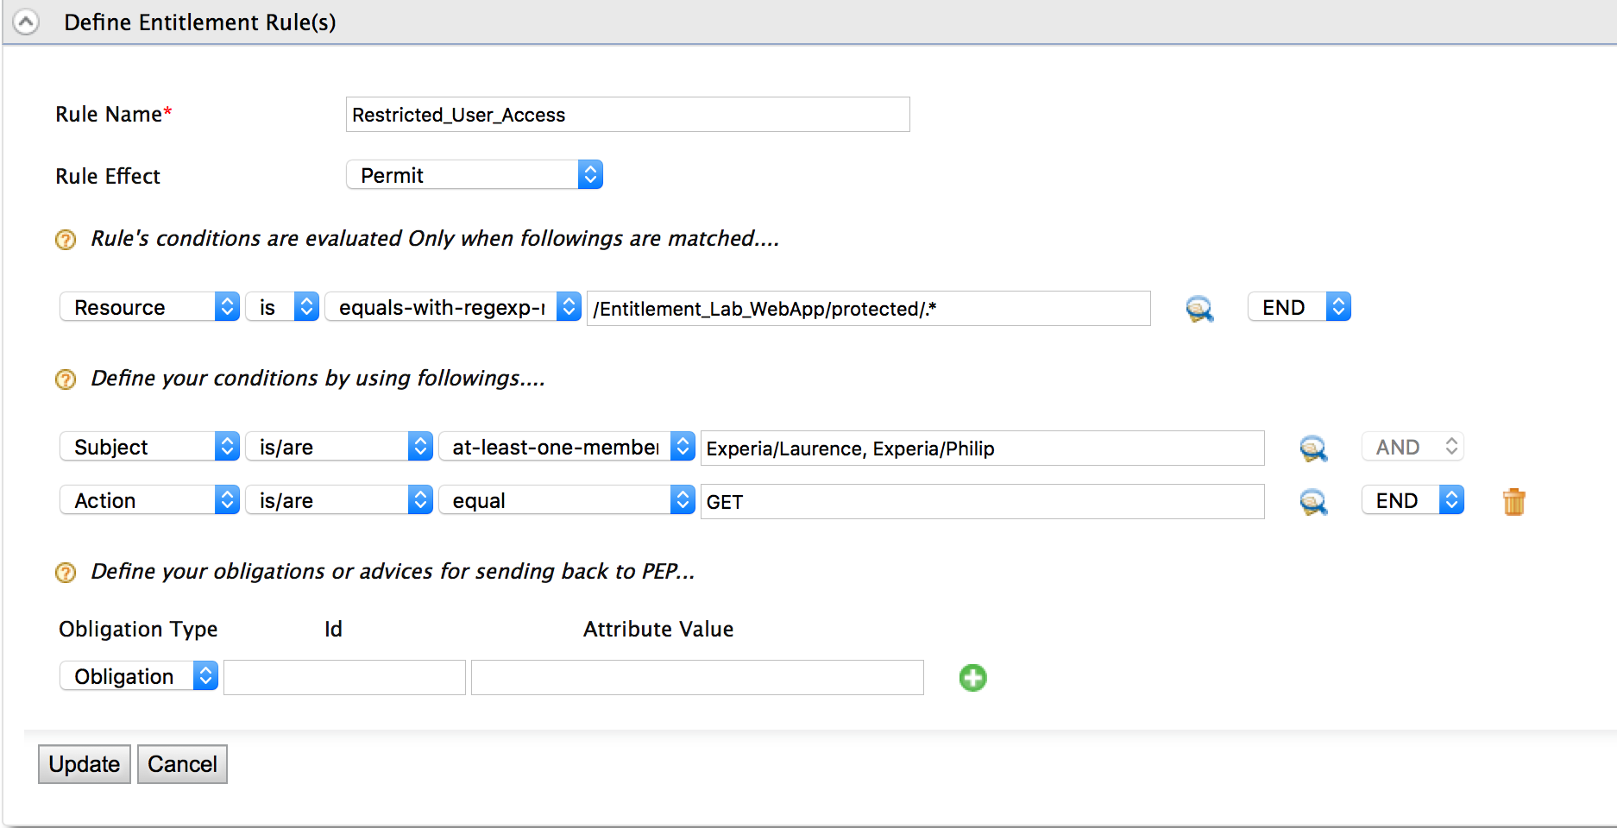

1. Add another rule in order to deny all other access.

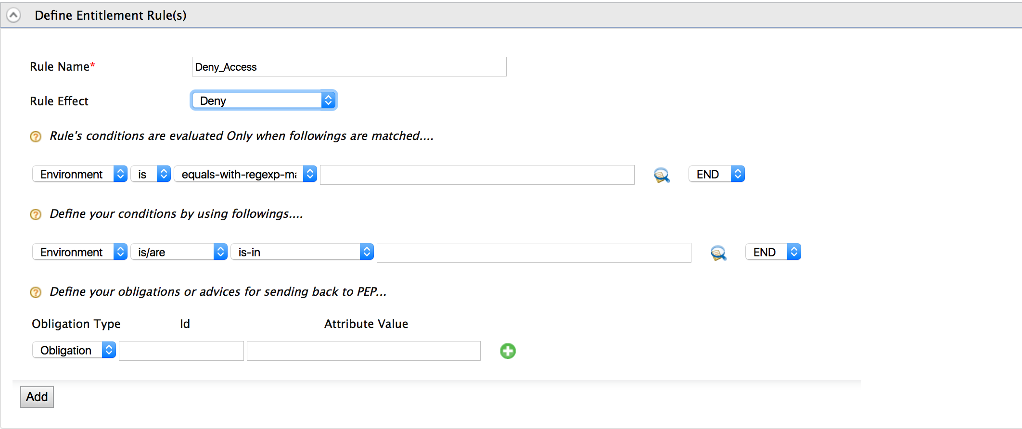

1. Click **Finish** to save the policy

Testing the XACML Policy

The **Try** feature in the Identity Server can be used to test the policy. The policy will either permit or deny access to the link based on the rules given in the policy.

1. Click **Try** on the entitlement policy.



1. Using a valid set of values, test the policy for accuracy.

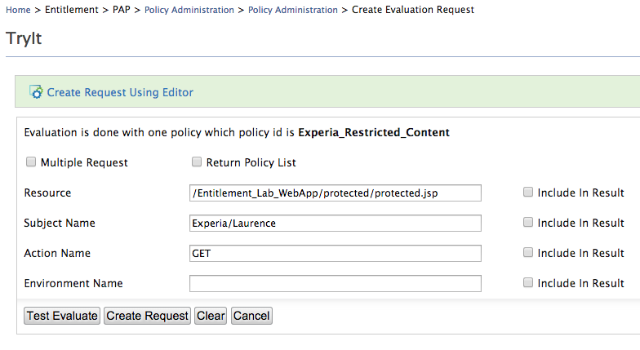

Resource /Entitlement_Lab_WebApp/protected/protected.jsp should be accessible to Laurence from Experia on action GET.

1. Click **Test Evaluate**.

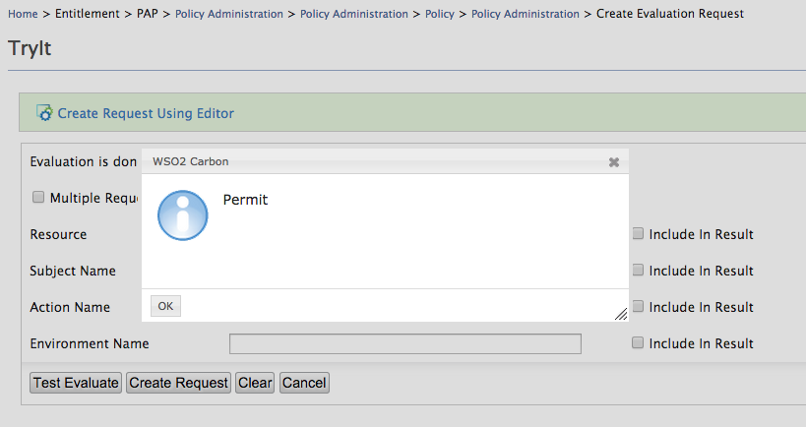

1. Replace the subject name with Philip and click **Test Evaluate** to see the same result.
2. Finally, test if the policy will deny entry for incorrect argument values. Replace the subject name with Margaret and click **Test Evaluate** to see the following result.

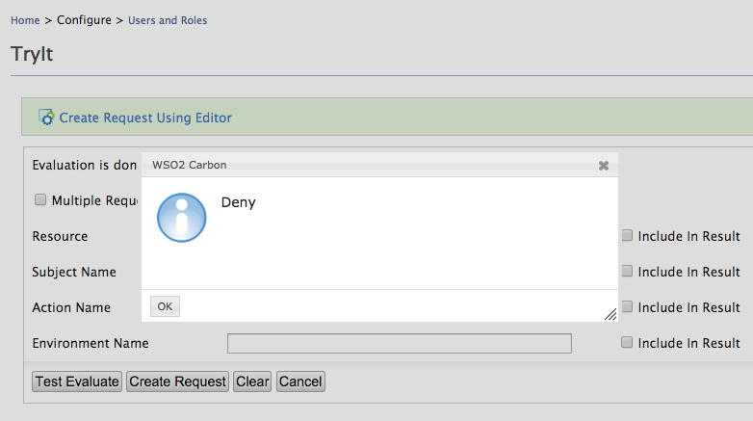

Update XACML Policy

Modify the policy to include a new rule. Use the instructions given below and the knowledge gained from above to add to the existing rules.

1. Click **Main** > **Entitlement** > **Policy Administration**.
2. Click **Edit** on the policy.



1. Enter a new entitlement rule **Super_User_Access** where the user Elizabeth is allowed GET access to the /Entitlement_Lab_WebApp/secured/.* resource.
2. Use the half arrows to move around the entitlement rules so that the following order is given to the rules. This is the order in which the rules will be evaluated.

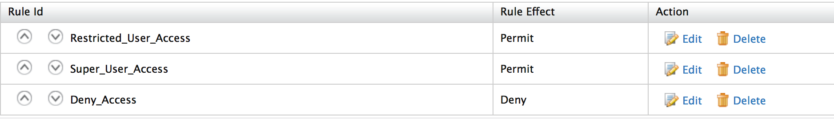

1. Test the new entitlement rule using valid and invalid values.

Add Obligation when Denying Access

Obligations are directives from the Policy Decision Point (PDP) to the Policy Enforcement Point (PEP) on what must be carried out before or after an access approval. During this exercise, we will add an obligation to the policy.

1. Click **Main** > **Entitlement** > **Policy** **Administration**.
2. Click **Edit** on the policy.



1. Click **Edit** on the **Deny_Access** rule.
2. Enter an obligation with an attribute value **Illegal login attempt** and click **Update**.

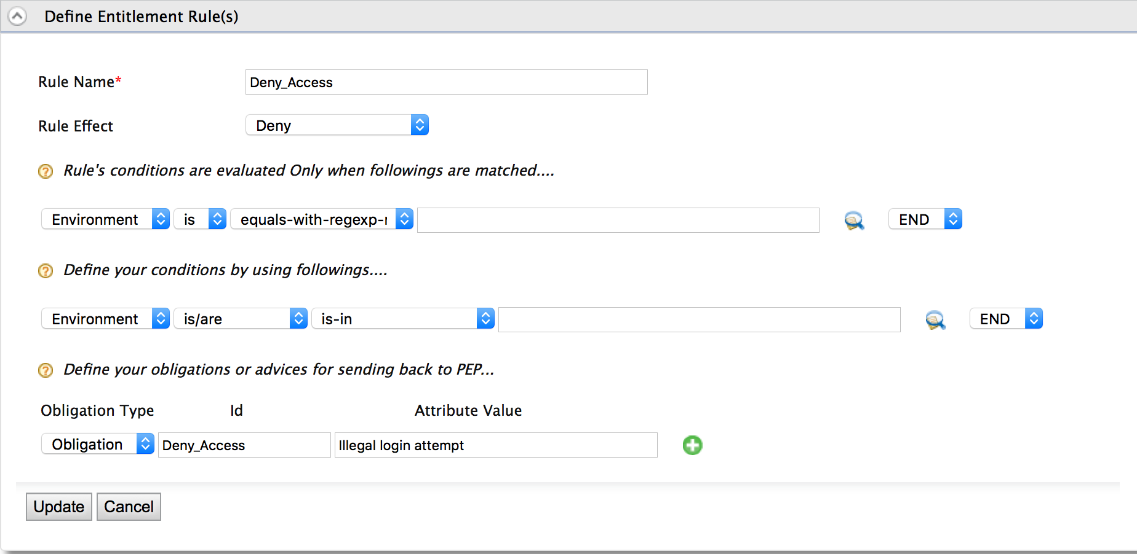

1. Click **Finish**.

Test Obligations

1. Click **Try** on the entitlement policy.

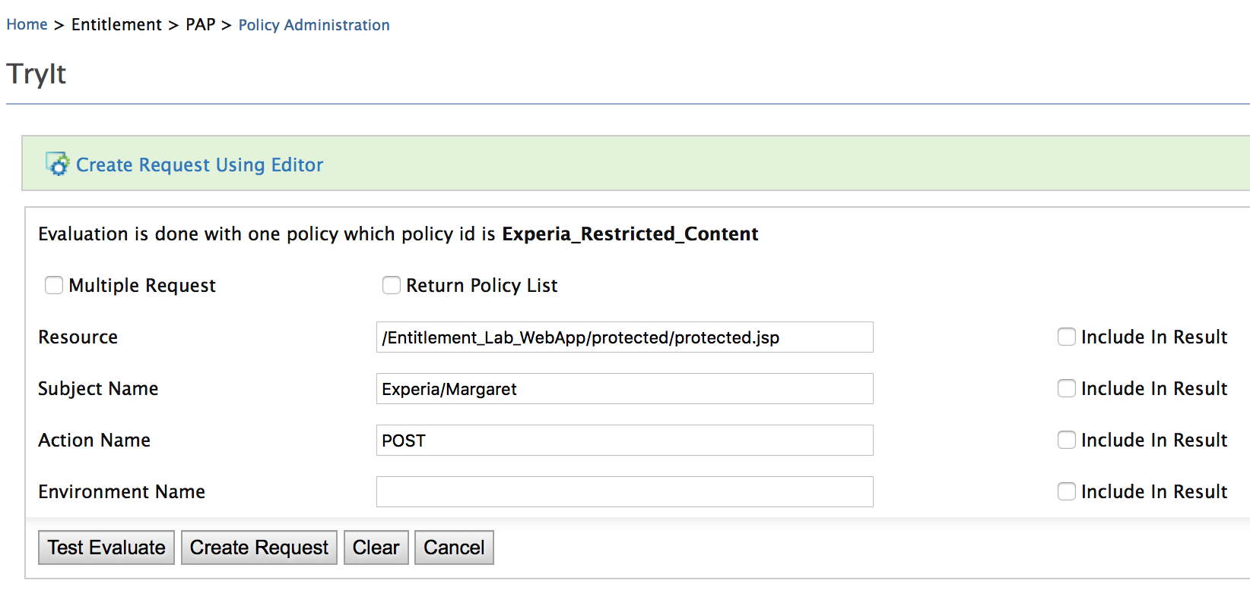

Enter values that will fail the policy in order to test the obligation.

1. Click **Create Request**.

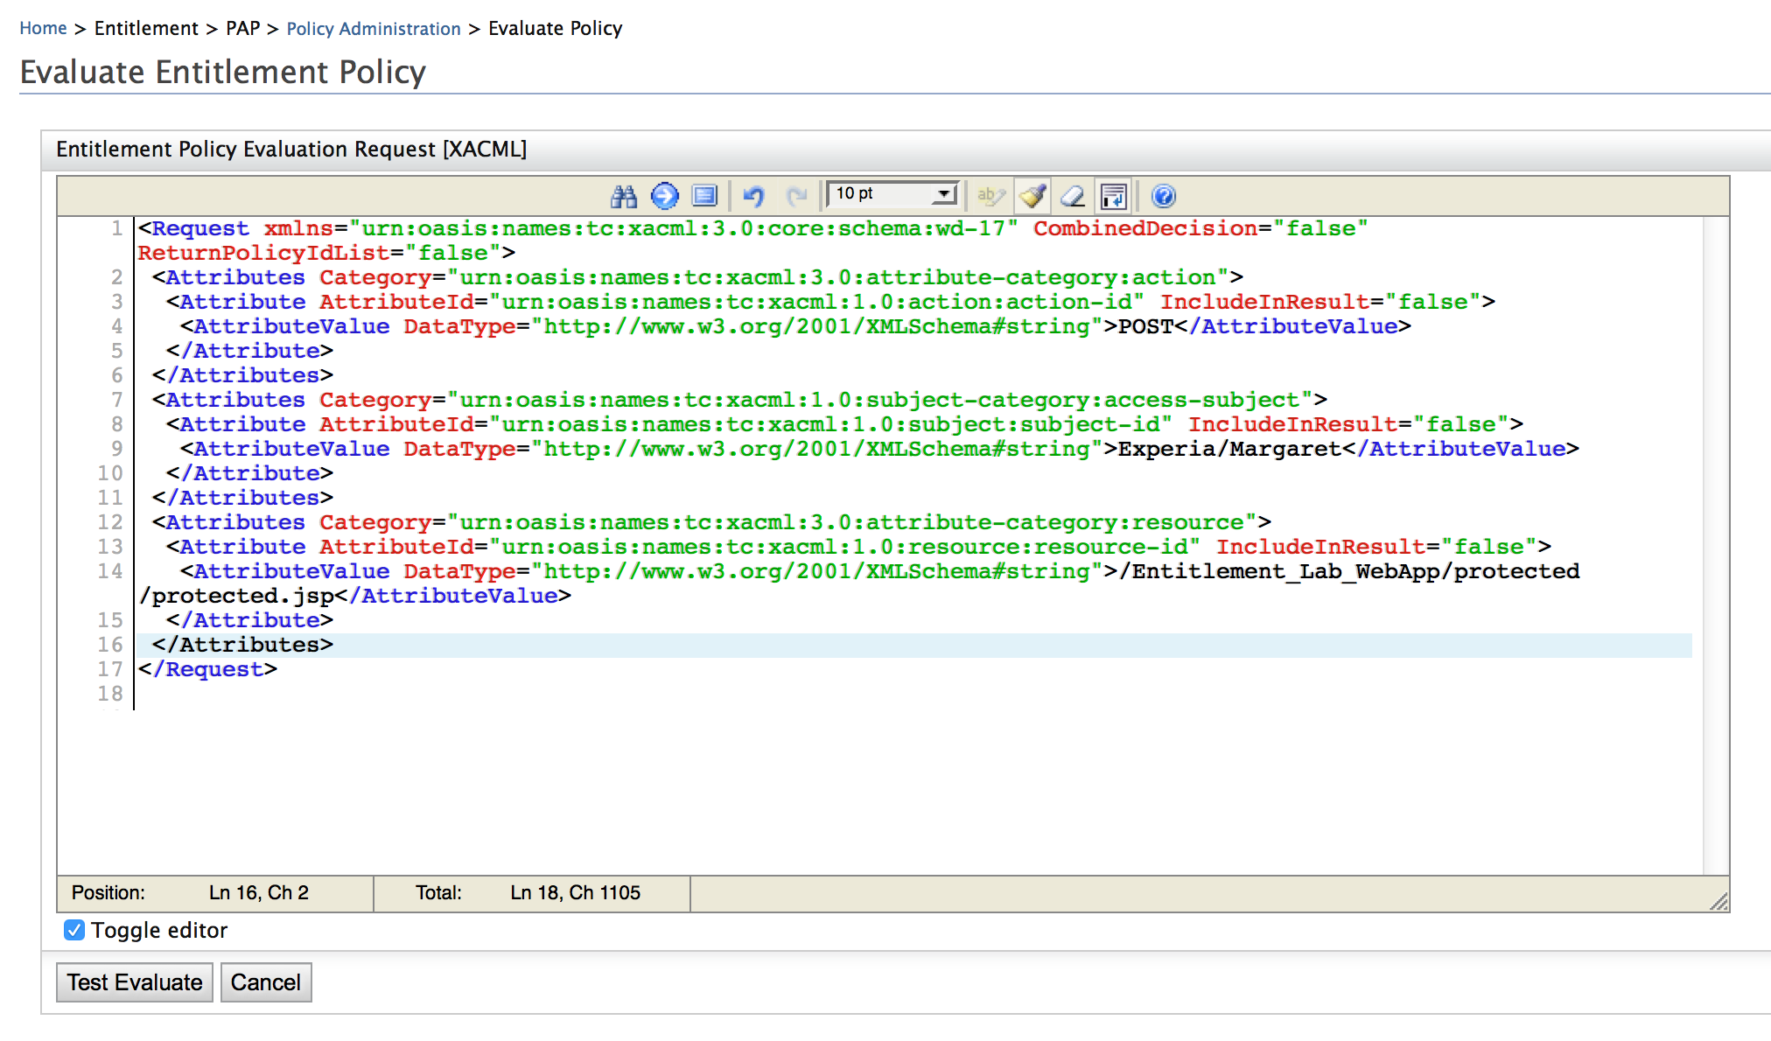

The TryIt tool will show the obligation response as XML and this XML response can only be seen when the request is executed as an XML request from inside the feature.

1. Click **Test Evaluate**.

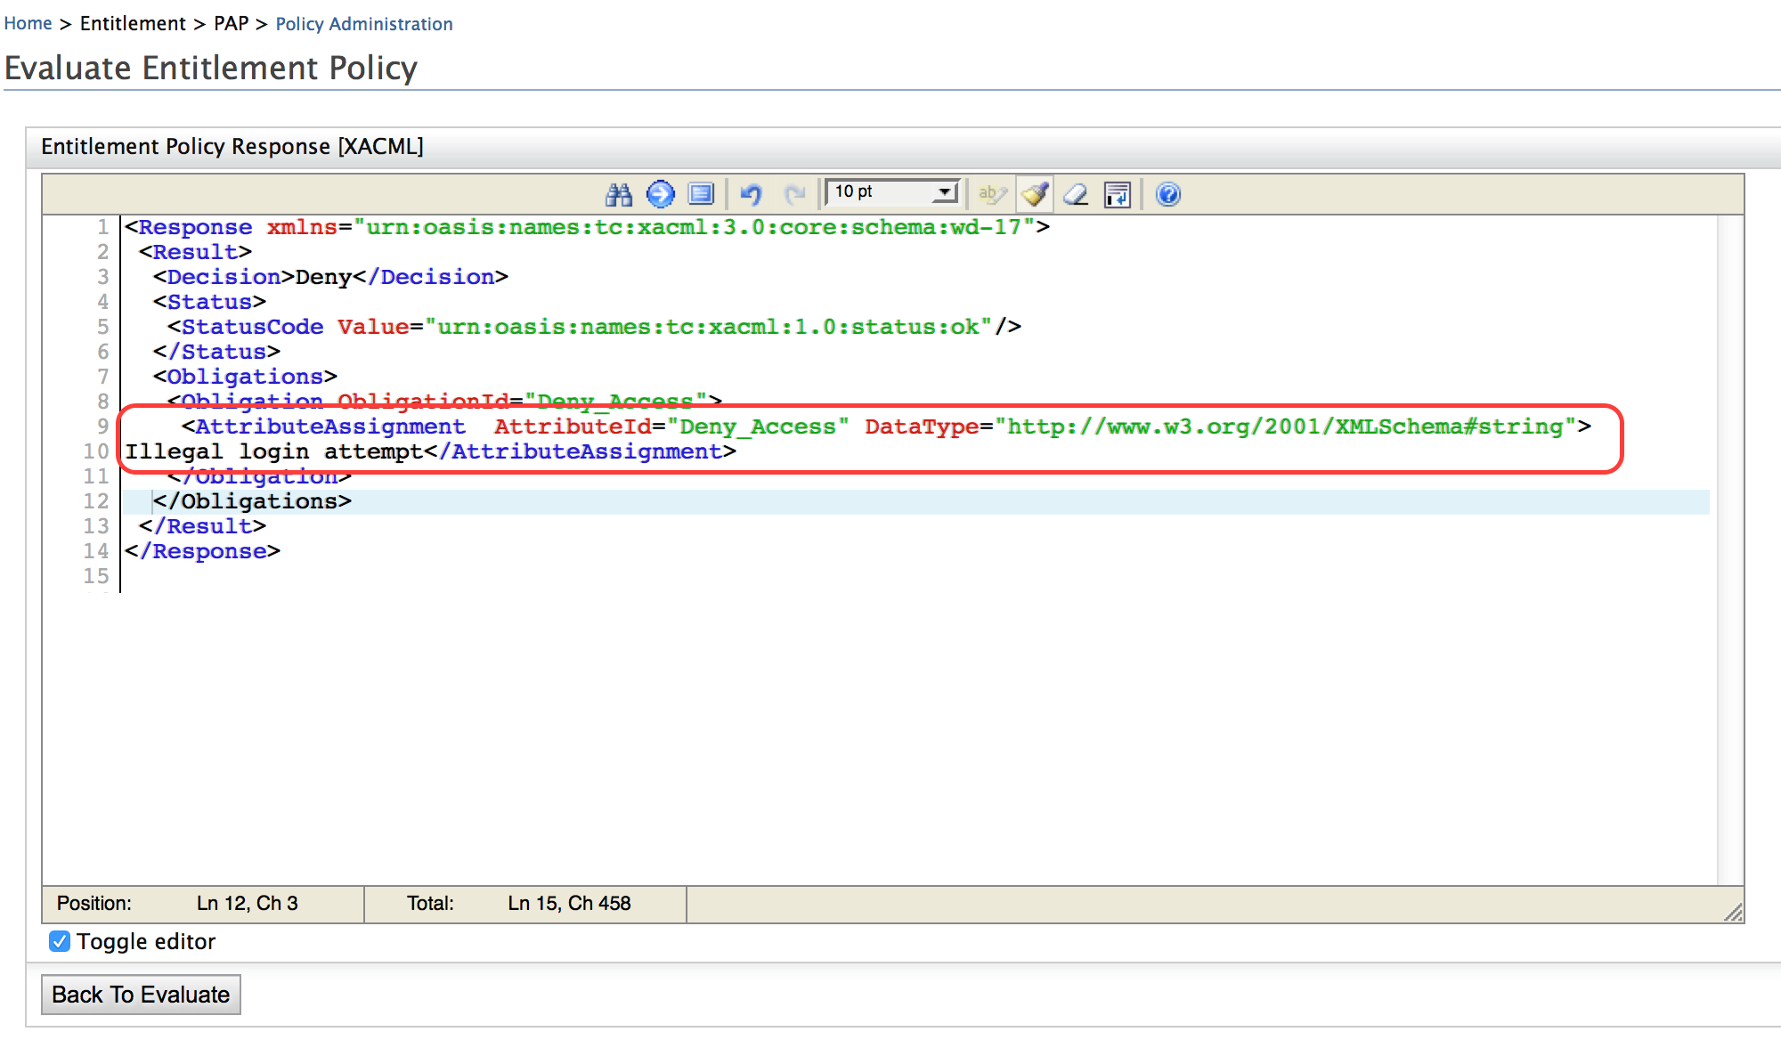

Advanced Modifications to XACML Policy

By editing the XACML in XML, the limitations imposed to simplify the development of a XACML policy via a graphical tool can be avoided. In the following exercises, editing the XACML in XML will expose powerful features of XACML. This portion of the exercise will embed the current allowed user’s email address to be added to the Obligation request.

1. Click **Main** > **Entitlement** > **Policy Administration**.
2. Click on the policy name.

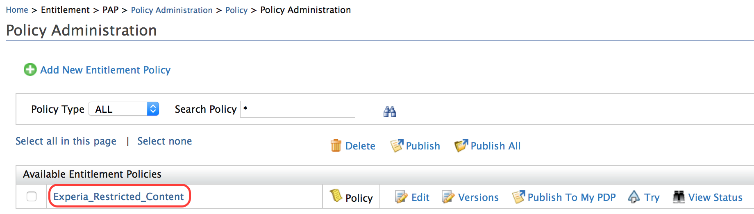

1. Modify the PolicyId to Experia_Restricted_Content_1.

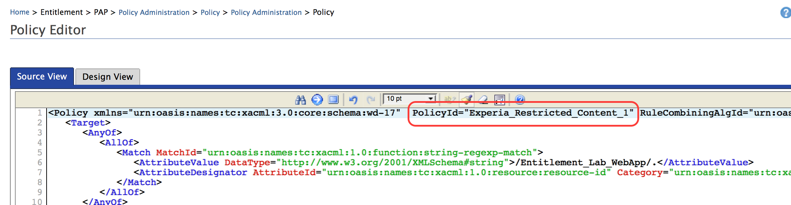

Once the XACML policy is edited in XML, it will no longer open in the Graphical Editor. In order to maintain a copy of the policy that can be edited using the Graphical Editor, we will use the copy created in this step to add the advanced functions.

1. Click **Save Policy** and note that a new policy is created.
2. Click on the policy and modify the <ObligationExpressions> code in the **Deny** rule.

Enter the following obligations for Restricted_User_Access rule and save changes.

<ObligationExpressions>

<ObligationExpression FulfillOn="Permit" ObligationId="Log_Access">

<AttributeAssignmentExpression AttributeId="http://wso2.org/claims/emailaddress">

<AttributeDesignator AttributeId="http://wso2.org/claims/emailaddress" Category="urn:oasis:names:tc:xacml:1.0:subject-category:access-subject" DataType="http://www.w3.org/2001/XMLSchema#string" MustBePresent="false"></AttributeDesignator>

</AttributeAssignmentExpression>

</ObligationExpression>

</ObligationExpressions>

Note: The Attribute Id is the claim URL found in **Configure** > **Claim** **Management** >http://wso2.org/claims > **Email**.

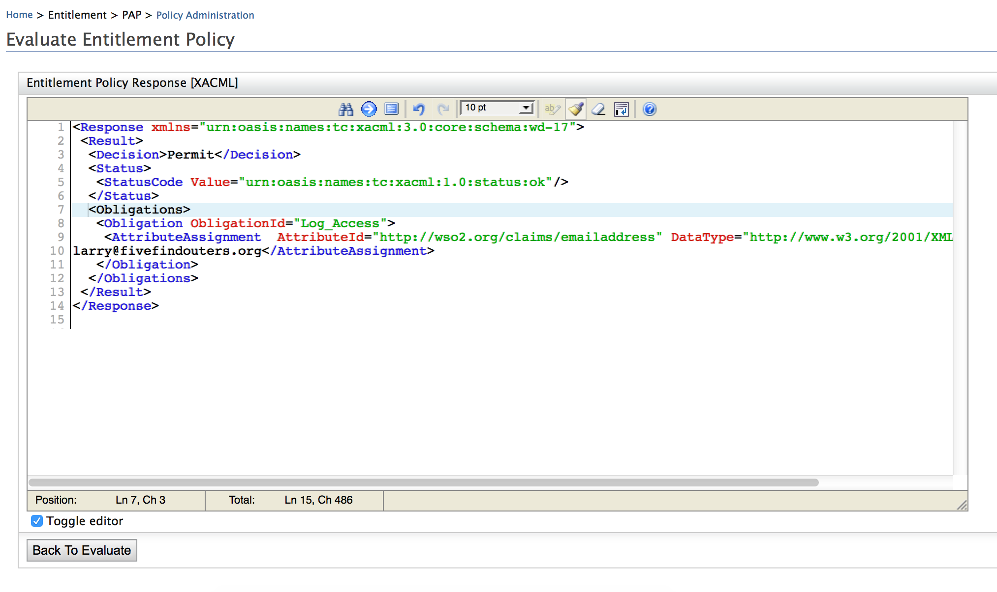

Test Modifications

1. Click **Main** > **Entitlement** > **Policy** **Administration**.
2. Click **Try** on the Restricted_Content_1 entitlement policy



1. Enter the values that adhere to the policy and click **Create Request**.

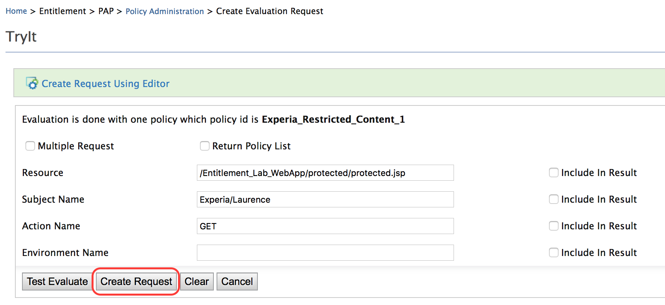

When the request is executed using the XML editor, the result will also be visible as XML. In order to see the obligation in action, it is necessary to see the response in XML.

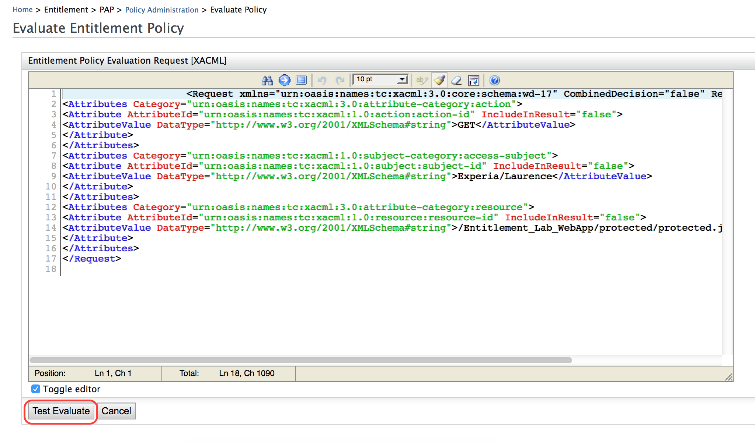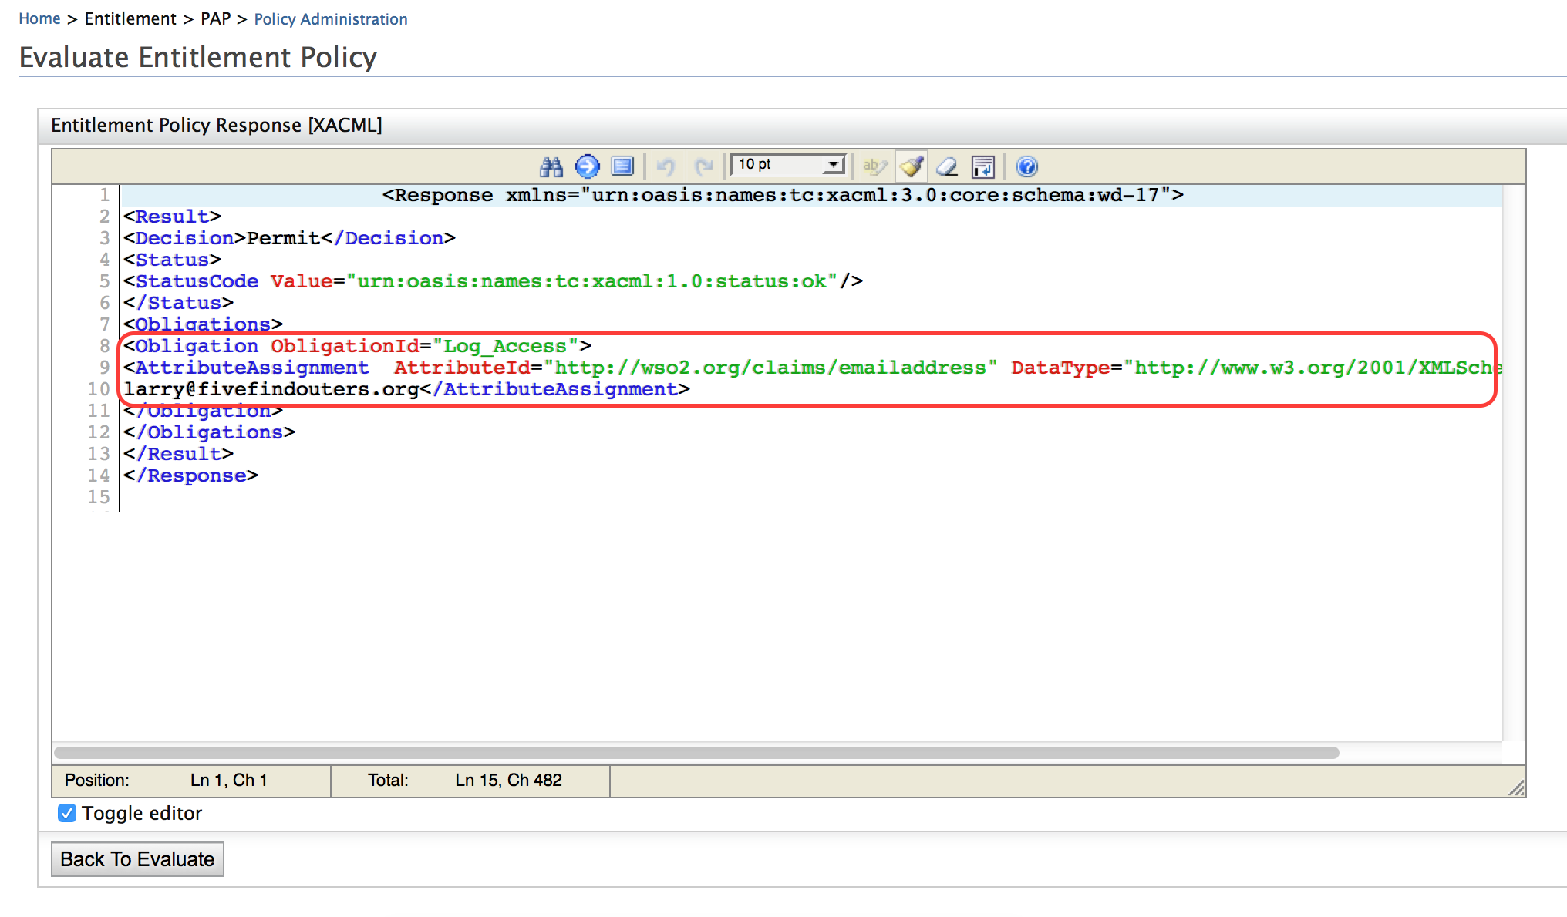

Working with Obligations

Create an obligation for the Super_User_Access entitlement rule using a different claim and test out the functionality.

# Demo: Secure an API in WSO2 APIM

Training Objective

Study the mechanisms of securing an API in WSO2 API Manager using the Identity Server.

Business Scenario

Experia Travels wishes to provide federated authentication in accessing APIs using WSO2 API Manager.

High Level Steps

* Install WSO2 API Manager
* Install Apache Tomcat
* Set up the Playground sample app as explained in <https://docs.wso2.com/display/IS520/Setting+Up+the+Sample+Webapp>
* Configure the Identity Server to work with WSO2 API Manager as explained in <https://docs.wso2.com/display/IS520/OAuth+2.0+Grant+Types+with+WSO2+API+Manager+Implicit>

# Demo: Saving Access Tokens in Separate Tables

Training Objective

Study the process for saving access tokens in a separate table, i.e., user token partitioning.

Business Scenario

Experia Travels relies on multiple user stores to store the identity of its users. In order to ensure higher levels of security for the user tokens stored, user token partitioning is the prefered technique in storing user tokens.

High Level Steps

* Demonstrate the steps used in configuring the Identity Server to save the user tokens in separate tables allocated for the different domains as shown in <https://docs.wso2.com/display/IS520/Saving+Access+Tokens+in+Separate+Tables>

# Lab: Changing the Default Keystore

Training Objective

Learn how to change the default keystore that is shipped with the Identity Server to a keystore with a private key that is unique to the company.

Business Scenario

The default keystore provided with WSO2 Identity Server is a generic key store and as such shares a private key that is public knowledge. It is recommended that the users of the Identity Server change the default key store for production environments.

High Level Steps

* Create a new private key
* Create a certificate signing request
* Create a self-signed certificate
* Create a new keystore using the certificated
* Adding the public key to the client-truststore.jks

Detailed Instructions

Create a New Private Key

1. Using a Command Line Interface traverse to <IS_HOME>/repository/resources/security where all the certificates and keystores are stored for the Identity Server.
2. Use openssl to create a new private key.

openssl genrsa -des3 -out experia.key 2048

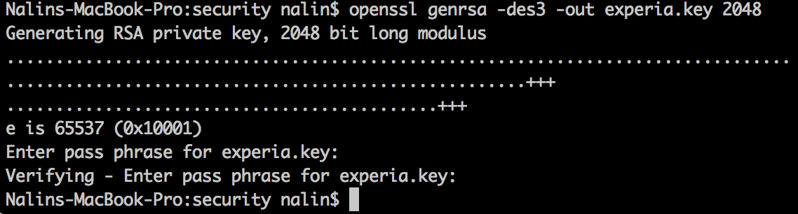

1. Make note of the pass phrase as this will be needed when using the key.
2. a new private key named experia.key will be created in <IS_HOME>/repository/resources/security.

Create a Certificate Signing Request

Ideally the Certificate Signing Request (CSR) will be used to request a certificate from a certificate issuing authority (CA). For the sake simplifying the labs, instead of submitting the CSR to a CA the CSR will be used to self sign the certificate.

1. Use openssl to create the CSR.

openssl req -new -key experia.key -out experia.csr

On executing the command the pass phrase for experia.key will be requested. This is pass phrase given when creating the key.

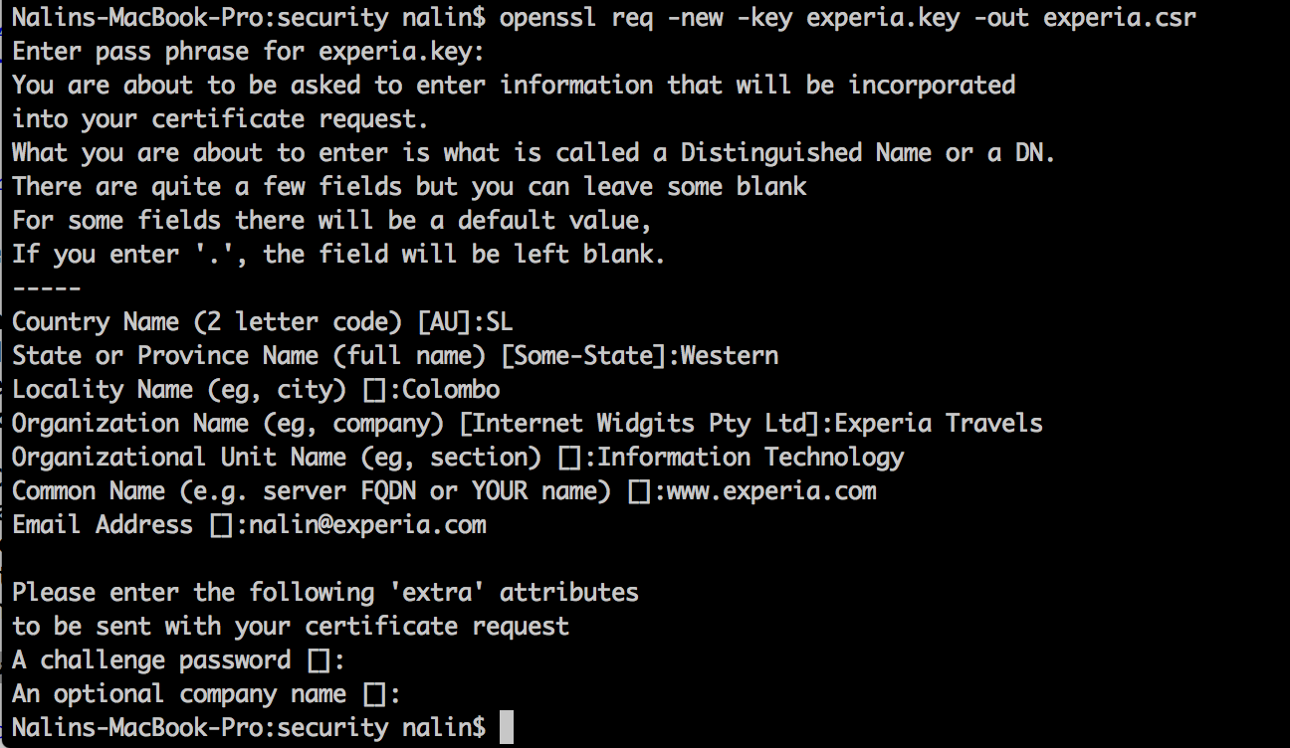

Create a Self-Signed Certificate

1. In order to create a self-signed certificate valid for 30 days the command is

openssl x509 -req -days 30 -in experia.csr -signkey experia.key -out experia.crt

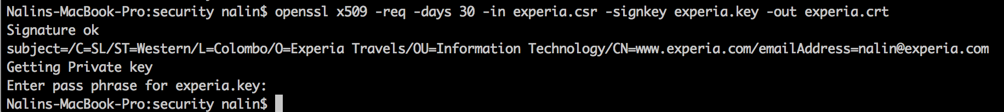

Create a New Keystore Using the Certificate

1. Use openssl to export the certificate to PKCS12/PFX format. This is the format that will be used by the keytool utility to create a new java keystore. The command will look as follows:

openssl pkcs12 -export -in experia.crt -inkey experia.key -name "ExperiaAlias" -out experia.pfx

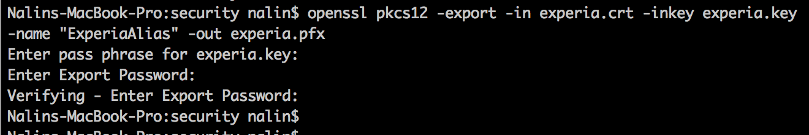

1. Convert experia.pfx to a java keystore using the following command:

keytool -importkeystore -srckeystore experia.pfx -srcstoretype pkcs12 -destkeystore experia.jks -deststoretype JKS

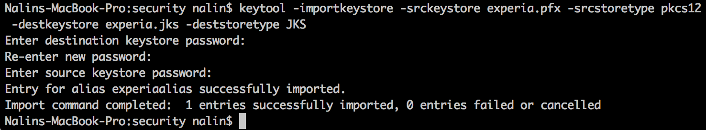

The keystore password should be the same as that of the key file for the Identity Server.

Adding the Public Key to the client-truststore.jks

All WSO2 products are shipped with the trust store named client-truststore.jks, which resides in the same directory as the keystore. <PRODUCT_HOME>/repository/resources/security/.

For our keystore to be usable, the public key from the keystore needs to be loaded into client-truststore.jks.

1. Get a copy of the client-truststore.jks file from <IS_HOME>/repository/resources/security/.
2. Export the public key from experia.jks file using the following command:

keytool -export -alias ExperiaAlias -keystore experia.jks -file experia.pem

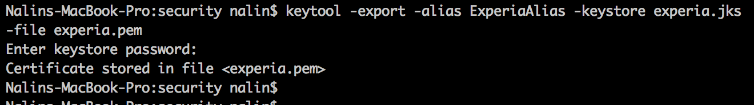

Use the keystore password given when creating the keystore.

1. Import the public key into client-truststore.jks with the command:

keytool -import -alias ExperiaAlias -file experia.pem -keystore client-truststore.jks -storepass wso2carbon

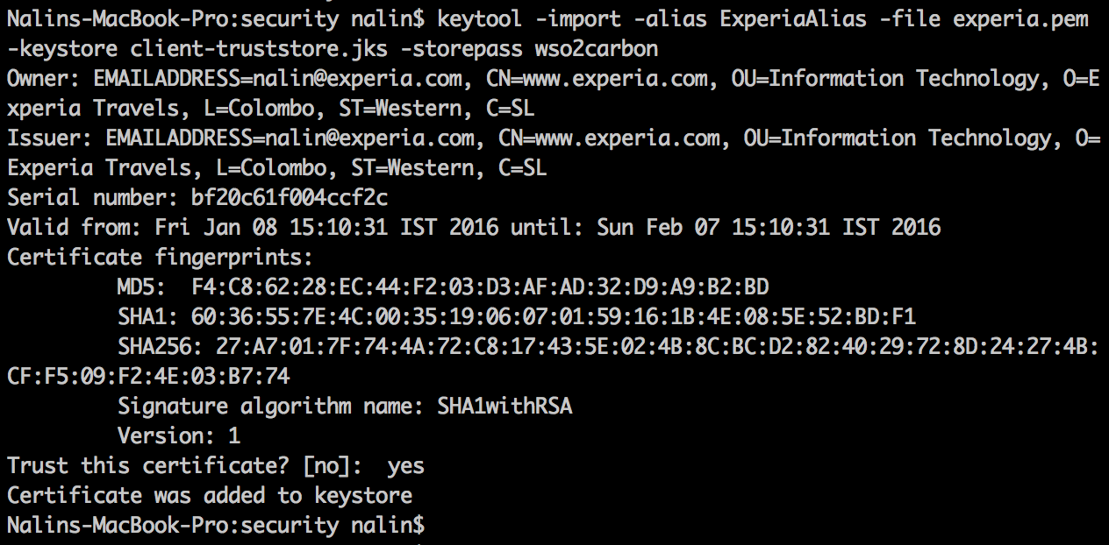

The password for the keystore client-truststore.jks is wso2carbon.

Expected Outcome

The new keystore can be used within the product to sign as needed. For further reading refer to the documentation.

<https://docs.wso2.com/display/IS520/Configuring+Keystores+in+WSO2+Products>

# Demo: Viewing Audit Logs

Training Objective

Observe the functionality of the **Audit Logs** for the WSO2 IS.

High Level Steps

* Start the Admin Console
* View the **Application Logs**
* View the **System Statistics**
* View the **System Logs**
* Working with the **SOAP Tracer**
* View the **Workflow Requests**

# 

# 

# Demo: Viewing Analytics for the Identity Server

Training Objective

Learn how to view analytics for the WSO2 Identity Server.

Business Scenario

Experia Travels needs to analyse the login and session details of the Experia Travels workforce so that upper management and system administrators can make informed decisions on patterns identified.

High Level Steps

* Access the analytics dashboard
* View and analyze statistics for overall, local and federated login attempts
* Analyze statistics for sessions

Detailed Instructions

<https://docs.wso2.com/display/IS520/Analyzing+Statistics+for+Authentication+Operations>

<https://docs.wso2.com/display/IS520/Analyzing+Statistics+for+Overall+Login+Attempts>

<https://docs.wso2.com/display/IS520/Analyzing+Statistics+for+Local+Login+Attempts>

<https://docs.wso2.com/display/IS520/Analyzing+Statistics+for+Federated+Login+Attempts>

<https://docs.wso2.com/display/IS520/Analyzing+Statistics+for+Sessions>